PLAE web app enables powerful searching and multiple visualizations across one million unified single-cell ocular transcriptomes

Vinay Swamy1, Zachary Batz3, and David McGaughey2,✉

February 18, 2023

PURPOSE: To create a high performance reactive web application to query single cell gene expression data across cell type, species, study, and other factors. METHODS: We updated the content and structure of the underlying data (single cell Eye in a Disk, scEiaD) and wrote the web application PLAE (<https://plae.nei.nih.gov>) to visualize and explore it. RESULTS: The new portal provides quick visualization of over a million individual cells from vertebrate eye-and body transcriptomes encompassing four species, 60 cell types, six ocular tissues, and 23 body tissues across 35 publications. To demonstrate the value of this unified pan-eye dataset, we replicate known neurogenic and cone macula markers as well as propose six new cone human region markers. CONCLUSION: The PLAE web application provides the eye community a powerful and quick means to test hypotheses related to gene expression across a highly diverse, community-derived database.

1 Department of Biomedical Informatics, Columbia University  
2 Bioinformatics Group, Ophthalmic Genetics & Visual Function Branch, National Eye Institute, National Institutes of Health  
3 Neurobiology, Neurodegeneration & Repair Laboratory, National Eye Institute, National Institutes of Health

✉ Correspondence: [David McGaughey <[mcgaugheyd@mail.nih.gov](mailto:mcgaugheyd@mail.nih.gov)>](mailto:mcgaugheyd@mail.nih.gov)

# Introduction

The outer layer of the eye consists of the cornea and sclera. Beneath the sclera is the uvea which is made of the iris, ciliary body, and the choroid. The inner most layer of the eye is the retina, which is backed by the retinal pigmented epithelium (RPE). Distinct cell types are used to compose each of these layers. The retina alone is composed of six major cell populations: the photoreceptors, horizontal, bipolar, amacrine, ganglion, and non-neuronal cells.1 These six populations can be subdivided into dozens of cell types.2 Furthermore, human disease of the eye can derive from damage to specific cell types.

Damage to some of these cell types has been implicated in human eye disease. For example glaucoma is characterized by damage to the retinal ganglion cells while cone and cone-rod dystrophies are characterized by photoreceptor degeneration. Efforts to untangle the gene expression patterns of these diverse cell types with single cell transcriptomics date to the early 2000s when researchers3–7 used RT-PCR approaches to amplify select transcripts in small numbers of cells. Later, researchers used microarray platforms to analyze a broader array of transcripts8–14.

The modern era of single cell transcriptomics started with the introduction of droplet-based technologies, which enabled quantitation of thousands of cells in a single experiment.15 This approach was pioneered by Macoksko et al. and enabled the profiling of gene expression in 44,808 single cells in the adult mouse retina.16 Commercialization of the droplet technology has enabled broad access and the ocular community has responded by using single cell RNA sequencing in several dozen ocular studies.An incomplete list of how the ocular community has used single cell technology would include studying developmental transcriptomic dynamics, identifying genes to distinguish cell types, proposing finer gradations of cell types within existing categories, comparing and contrasting ocular transcriptomes between organisms, and identifying differences in spatially distinct cells.

Unfortunately manuscripts can only present a sliver of the underlying data. Further data exploration can be laborious, technically challenging, and computationally expensive. Briefly, one would have to identify the relevant publication, find the associated data deposit, download the cell by gene count matrix, find the cell label table (and optionally the t-SNE or UMAP coordinates) with the matching fields to align them, and then load the data into R or python to run the desired queries. If one desired to compare across publications, then one would also have to align the cell type label schema and ideally should re-create the count quantification with consistent bioinformatic tooling. It is desirable, perhaps even necessary, to use multiple datasets to assess gene expression to confirm whether a gene expression pattern is consistent and reproducible. Reliance on a single dataset can be problematic as there can be technical issues - for example the large consortium dataset GTEx has persistent contamination from highly expressed genes across tissues.17

Web-based resources to query gene expression can democratize access to large datasets as the computationally intensive steps above can be run once and then shared to anyone with a internet connected device. Single cell RNA-seq web resources that contain ocular tissues include the UCSC Cell Browser, Tabula Sapiens, PanglaoDB, and the Protein Atlas.18–21 However, ocular focused queries are challenging as these resources have incomplete and inconsistent cell type labels and sample metadata. In contrast to there general purpose resources, Spectacle (<http://singlecell-eye.org>) is an ocular specific web app which contains over a million cells from dozens of independent resources.22 However each data deposit is independently and inconsistently processed, which makes cross study queries impossible.

We recently created a unified ocular data resource which placed dozens of independent single-cell RNA-seq ocular and non-ocular datasets in a single batch corrected space, the Single Cell Eye in a Disk (scEiaD).23 To broaden the usage of this powerful meta-atlas dataset, we restructured the data into a custom sqlite-based database and built a reactive web application to access it. As many new studies were published since our last data build, we re-ran the scEiaD pipeline in March of 2022. In aggregate we have collated 44 datasets across 35 publications, four species, and 29 tissues. We hand-curated 60 published cell type labels, totaling 606612 cells and used those ground-truth labels as the basis for a machine learning-based algorithm which labels the 500018 previously unannotated cells. Quality control metrics were tuned and applied to remove lower quality cells. In the end, the single cell Eye in a Disk (scEiaD) database contains 1136041 cells and 1,509,179,347 non-zero gene/cell expression values. We demonstrate how this unified resource can be used to identify genes that consistently distinguish cell types across studies and species, find genes which have species-specific expression cell type patterning, demonstrate how our pre-computed differential testing can identify markers between similar progenitor cell types, and finally provide a R-based analysis document which end-to-end demonstrates how we use scEiaD to run a custom differential gene expression test to validate and propose new genes that distinguish macula from peripheral cones in humans.

# Methods

## scEiaD pipeline upgraded and the database re-built

Our full scEiaD pipeline was published previously in Swamy et al.23 It was composed of two Snakefiles that run the workflows.24 The “SnakeQUANT” workflow takes the raw fastq input and produces a gene by cell count matrix with kallisto and bustools.25,26 This matrix is used in the “SnakePOP” pipeline to identify the optimal parameters for the scANVI based batch correction process (Supplemental Figure 1). Outputs from this pipeline include the batch corrected lower dimensional space, the UMAP coordinates, cell cluster assignments, and the cell type predictions. The outputs from this pipeline are used in a our new Snakefile “SnakeSCEIAD” which performs differential gene testing across multiple conditions and wraps the various data types into the scEiaD sqlite database for use in the plae app (Supplemental Figure 2).

## Quality Control

To decide whether a droplet is considered a viable cell, we use the “barcodeRanks” algorithm from DropletUtils to automatically identify empty droplets.27 We then kept cells with the following criteria: less than 20% of the counts were in mitochondrial genes, a cell had more than 600 total counts, at least 300 unique genes quantified, and fewer than 100,000 total counts. To identify likely doublets we used Scrublet28 and doubletCells (from scran)29 to generate per cell doublet probability scores. To identify cells for removal we used the scores in two ways. First, if an individual cell had a Scrublet score greater than 0.8 (where 1.0 is 100% probability of doublet) and a doubletCell score greater than 1,000,000 (unitless measure where higher value is more likely to be doublet) the cell is labelled as a doublet. Second, if a cluster has an average Scrublet score greater than 0.2 or an average doubletCell score greater than 12 the entire cluster was marked as doublets. All of these cutoff values were selected by hand inspecting density distributions of the Scrublet and doubletCell scores.

## Alterations from Swamy et al. to increase stringency of the dataset

The following alterations were made to the Swamy et al. pipeline: First, the cutoff to retain a cell was raised from 200 quantified unique genes to 300. Second, we use the DecontX algorithm30 from the celda R package (version 1.9.2) to automatically remove ambient RNA contamination on a per-study basis to produce a updated count matrix. Third, we altered the procedure for aligning gene names across species (see below for details). Fourth, we use the scANVI (scvitools based) batch correction method, which leverages information from the known cell type labels in the batch correction process.31

A custom cutoff for the minimum required number of unique genes identified per cell were used for the SRP362101 cornea dataset as an abnormally high number of cells were returned from our default value of 300. We set the cutoff for this study to 800 as this value resulted in approximately the same number of cells being returned as the authors reported in their paper.

## Optimal parameter choices for scANVI batch correction

We found in Swamy et al. that scVI had the best batch integration performance relative to other tools like Seurat’s CCA, fastMNN, harmony, ComBat, scanorama, and others. We previously found that adjusting the number of latent dimensions, highly variable genes, and epochs had substantial effects on the integration performance. For this update of scEiaD we ran integration with 3000, 4000, 5000, and 6000 highly variable genes, 5 and 15 epochs, and 6, 8, 10, 15, and 20 scANVI outputted latent dimensions. After evaluating the performance of the new scEiaD dataset with our scPOP package we selected the following parameters for the integration: 15 latent dimensions, 4000 highly variable genes, and 5 epochs.23 The UMAP was built with a min_dist of 0.1 and the clustering used 50 nearest neighbors.

While nearly all datasets we curated could be integrated as a whole, a small number either did not integrate with other data (clusters were formed which were entirely composed of one study) and/or nearly all cells from a study were machine labelled as a single cell type. These studies were hand-removed from the resource. The metadata for these samples is made available as supplementary file “samples_hand_removed.csv.”

## Cross species gene alignment

As we have four species in scEiaD (*Gallus gallus*, *Macaca fascicularis*, *Mus musculus*, and *Homo sapiens*) that we unify, we must identify shared genes. We found homologs and orthologs by downloading from the BioMart database “Ensembl Genes 105” and using *Homo sapiens* as the reference. We then selected orthologous gene names from *Gallus gallus*, *Macaca fascicularis*, and *Mus musculus*. This generates a table linked by Ensembl gene IDs and gene names. We then use a full join on non-duplicated Ensembl IDs between mouse and human. As we noticed a small number of gene names failed to be linked in this manner we ran another join on the remaining non-aligned genes, using gene name. This procedure gave us 17,769 shared human and mouse genes. To align the other species we again joined on Ensembl gene ID, removing genes where one chicken or macaque gene aligned to multiple human/mouse genes. In cases where multiple chicken or macaque genes aligned to one human/mouse gene, then we aggregated the counts by sum. In cases where there was no corresponding chicken or macaque gene, we filled in zeros. After these steps we had, as expected, 17,769 genes.

## Metadata curation

Every study brought into scEiaD was hand curated to identify the unique biological samples, published paper ID (where available), organ, tissue (e.g. Cornea), source (iPSC based or tissue), single cell platform (e.g. 10Xv2, DropSeq, etc.). We also, where possible, annotated retina region (e.g. macula), sex, and age or developmental stage. Samples with perturbations (genetic or treatment) were not included. To import individual cell type labels (e.g. Rod, Muller Glia), we wrote custom code for each study that made this table available to link their cell type assignments back to the matching barcoded cell. We curated two types of cell type labels: “CellType” and “SubCellType” where the former is our normalized cell types taken from the published labels and the later are the original cell type labels. We normalized names for CellType, for example changing “MG” to “Muller Glia” and also dropping more detailed cell type assignments like off and on bipolar cells for Bipolar Cells (as few studies went into this level).

## Differential gene testing

We used a “pseudo-bulk” based approach where the counts for a category (CellType, Cluster, or CellType (Predict)) were summed for each category - organism - study grouping using the aggregateAcrossCells function from the scuttle R package.32 This created a counts matrix which has statistical properties approximating “bulk” RNA seq experiment matrices. This allowed the use of the more mature bulk RNA-seq tooling. This approach has also been found to be more specific in identifying differentially expressed genes in single cell RNA-seq experiments.33 If there were fewer than 50 cells in organism - study accession - category combination, they were discarded for the differential test. Any genes with a sum of 0 counts after aggregation were removed. The aggregated matrix was imported into DESeq2 using the DESeqDataSetFromMatrix function with the design given as “~study_accession + category.” Contrasts were extracted either with the target category (e.g. “Cone”) against all remaining or in a pair wise manner (“Cone” vs “Rod”) with the DESeq2 “results” function.34 We tested each species (Human, Macaque, Mouse) separately.

## PubMed Citation Search

The R package easyPubMed was used to search for 1000 randomly chosen genes present in scEiaD for both gene name alone and gene name plus “AND Retina” with the get_pubmed_ids function . We then used the returned Entrez identifier to pull the abstract with the fetch_pubmed_data function so we could extract the PubMed ID (PMID). This was repeated with the the genes identified as being well supported differentially expressed for ocular cell types. To assess whether the difference in distributions was statistically different, we used the base R t.test function.

## scEiaD structure and web app optimization

The web app at plae.nei.nih.gov can display gene expression across over a million cells in only a few seconds. This speed is only possible due to custom data structures that were optimized for data query efficiency. Like eyeIntegration’s EiaD database,35 scEiaD is a sqlite database with tables for the core categories. This allows the app to initialize in about 30 seconds on a cloud server with memory usage under 8 GB. For the gene by cell expression matrix, the data was transformed into a “long” format where there are three columns: gene, cell barcode, and gene count value. This allows for cell - gene level queries to be completed, again with minimal memory usage, in under 0.5 seconds. To generate the aggregated information (in the Dot Plot, Expression Plot, and tables) we pre-calculated all queries by running a dplyr “group by” operation on all column fields. On user given query, the data is further aggregated to the user request. This allows for complicated queries to complete in seconds rather than minutes. To compare web app loading times for useful tasks we queried <https://plae.nei.nih.gov>, <http://singlecell-eye.org>, and <http://tabula-sapiens-portal.ds.czbiohub.org>, on 2022-08-24. For Spectacle, we used the “Single-Cell RNA-Seq Analysis of Retinal Development…” 10X dataset from Clark et al. for all timings. Timings are accurate to the second. If the functionality tested was not available for a certain web app, it was represented by a blank space.

## Data reproducibility and availability

The code base for scEiaD is available at github.com/davemcg/scEiaD; the commit corresponding to this manuscript is #a99dced. There are three relevant Snakemake pipelines which were used to create scEiaD: SnakeQUANT, which was used to quantify the gene / cell expression from the raw fastq files, SnakePOP, which runs the multi-parameter integration methods, and SnakeSCEIAD, which uses the optimal parameters identified in SnakePOP to run the cell type machine learning and differential gene testing that is incorporated into the scEiaD sqlite database for the app. The code base for the web app (along with local installation instructions) is available at github.com/davemcg/scEiaD/plaeApp. Data is available for download at plae.nei.nih.gov (click “Data”) and the Seurat object and metadata for the resource has been deposited at Zenodo with accession 10.5281/zenodo.7071682.

# Results

## New studies and processing improvements enhance the scEiaD database

Our first version of the single cell Eye is a Disk (scEiaD) database contained 34 datasets, three species, 766615 cells, and 31 curated cell types.23 We updated the scEiaD database for the PLAE v0.93 web app in six important ways. First, we added a new species, chicken (*Gallus gallus*).36 Second we added two ocular outflow tract datasets, one brain choroid plexus, and three cornea datasets to enhance coverage across the eye.37–42 Third, we added a human pan-body reference scRNA dataset to allow for non-ocular comparisons.43 Fourth, we used an *in silico* method to remove background gene contamination as we noticed persistent Rhodopsin expression in many non-photoreceptors cells (Supplemental Figure 3). Fifth, we increased the stringency of the cell retention cutoff for detected unique transcripts per cell from 200 to 300. Sixth, we carried over and harmonized several common cell type labels from the Tabula Muris project to more easily provide non eye cell type comparisons.44 As before, the pipeline’s scVI integration parameters were chosen rigorously by testing integration performance across a wide range of latent dimensions and number of highly variable genes in our scPOP framework23 (Supplemental Figure 1).

Of the 931538 ocular cells, only 465281 had cell type labels we could recover from the publications or data deposits. To label most of the remaining cells we used our xgboost approach from Swamy et al. which we previousy found performed well when compared to other cell type transfer approaches. The overall accuracy is 96% and the confusion matrix shows the predicted cell type to published cell type recall is very high for most cell types (Supplemental Figure 4). We also see that the cell type labelling works well across the different species (Supplemental Table 1). The cell types with lower labelling performance tended to be ciliary, limbal, and corneal cells (which were often labelled as fibroblasts). There are fewer unique datasets for these cell types and we expect that future runs with more data will improve this performance

After the dataset and quality control updates the scEiaD v2022-03-21 dataset now contains 44 studies, four species, 1136041 cells, and 60 curated cell types (Supplemental Figure 5). The scEiaD database contains 23 non-ocular human and mouse tissues and 6 ocular tissues across human, chicken, macaque, and mouse (Figure 1). This resource is only possible due to the publication of 35 single cell resources that scEiaD draws from (Supplemental Table 2). To recognize these papers, we prominently feature each of these studies along with a direct link to their citation, where possible, on the loading page of plae.nei.nih.gov.

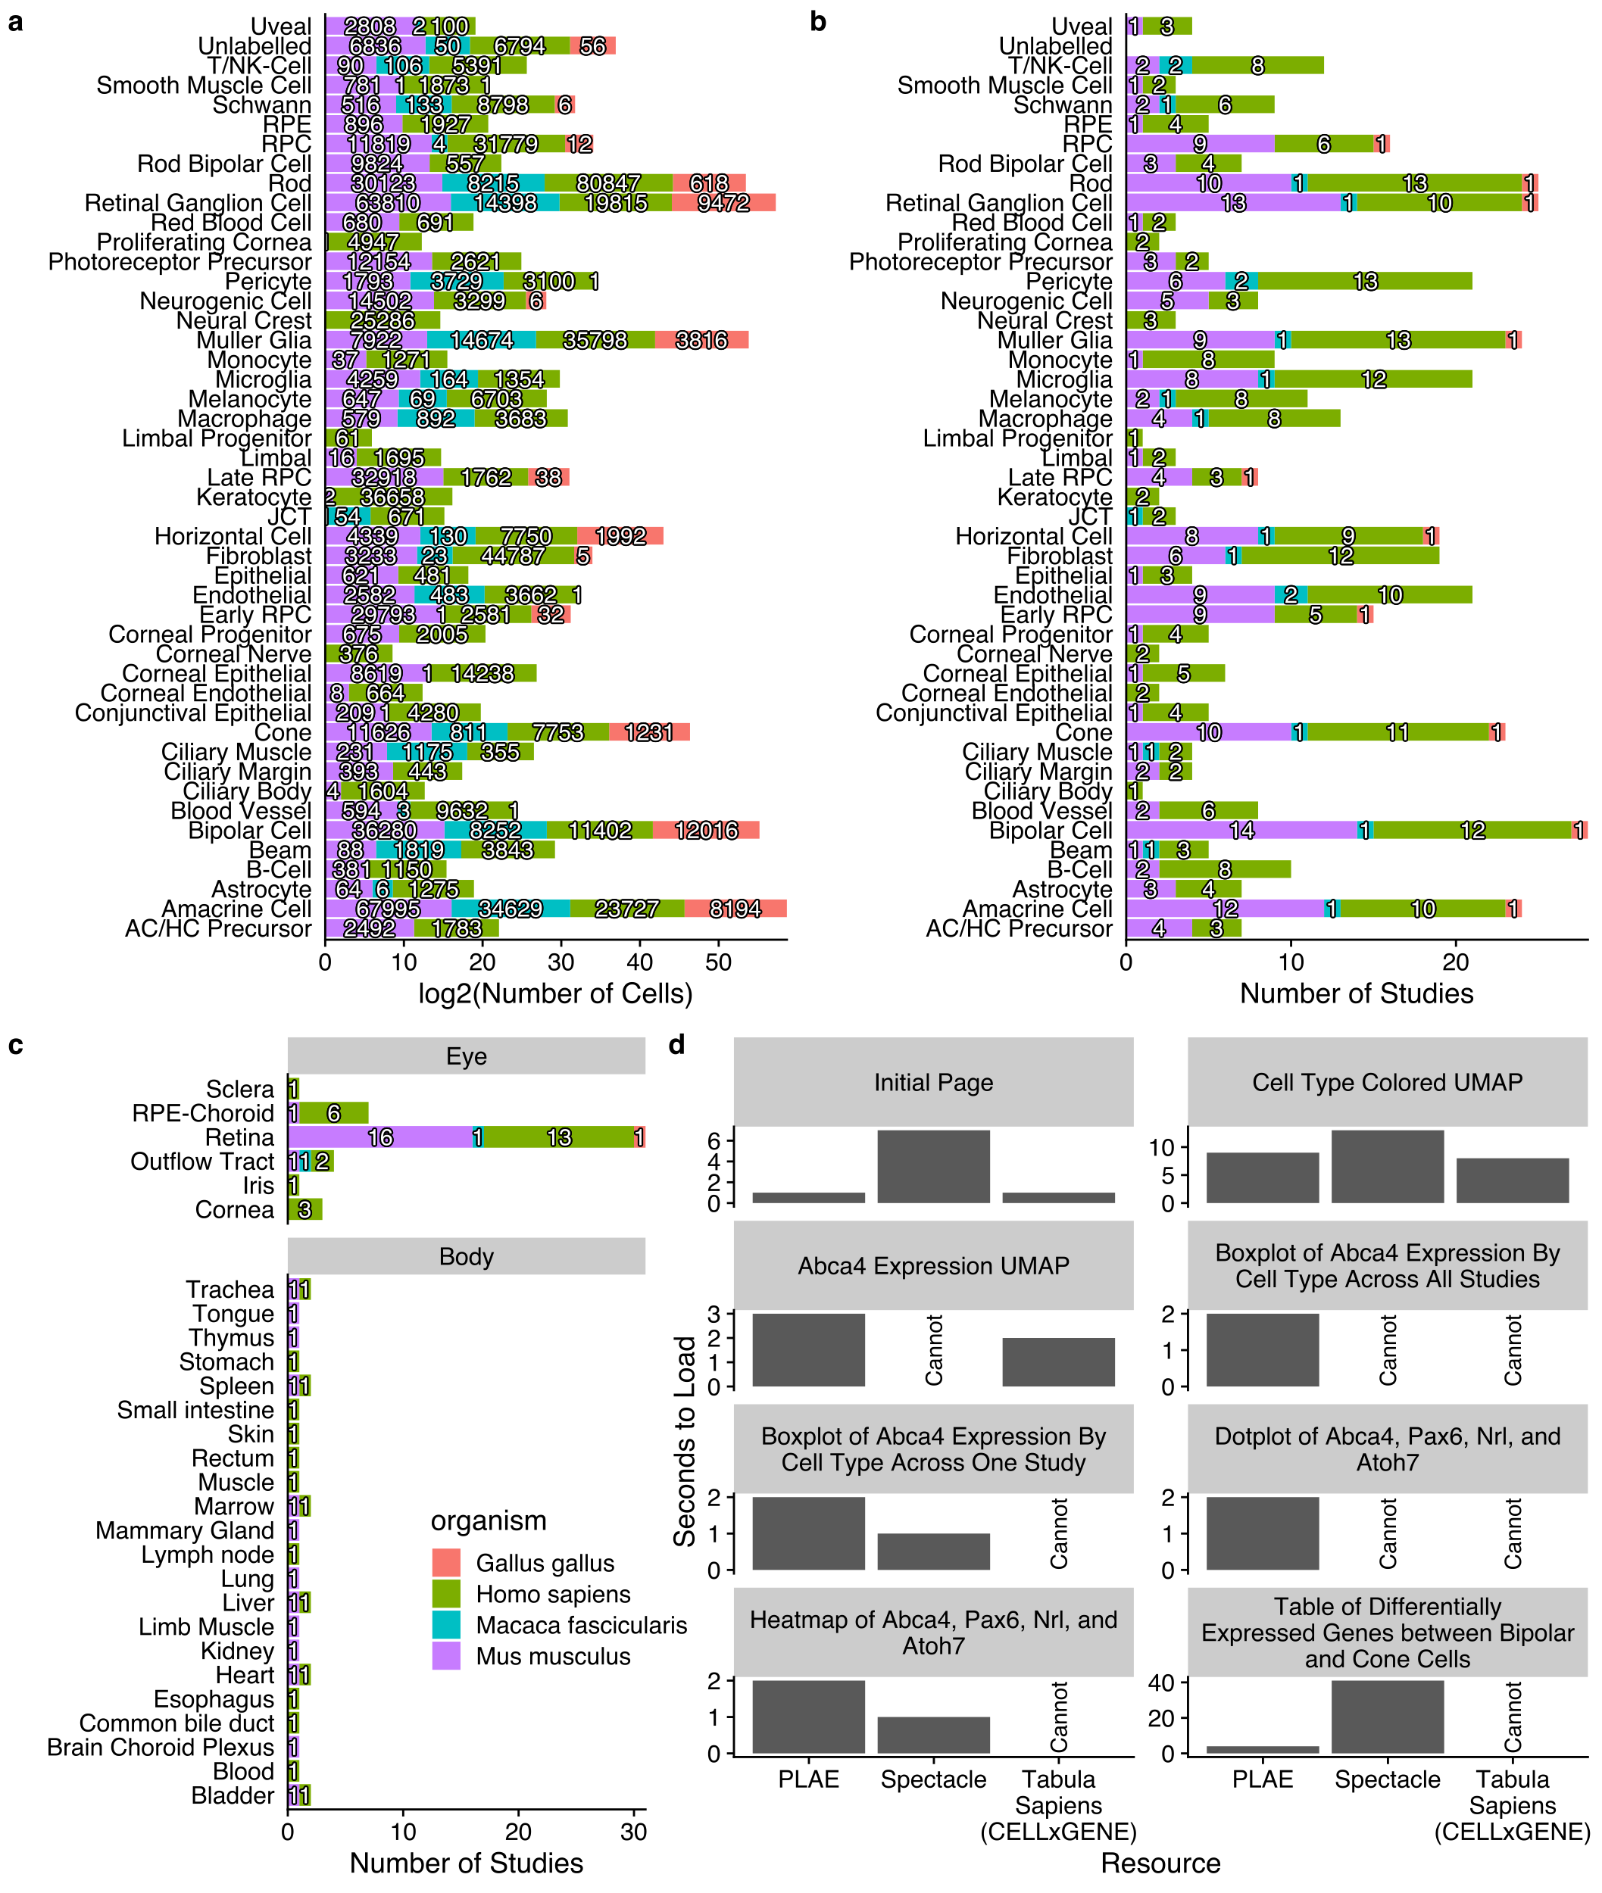

Figure 1: Distribution of tissues and cell types in scEiaD. A. Number of cells for each ocular cell type. B. Number of studies for each ocular predicted cell type (over 10 cells), colored by species. C. Tabulation of the number of studies present across 6 ocular and 23 non-ocular tissues, D. Web app timings (lower is better) for important functions compared between PLAE, Spectacle, and Tabula Sapiens (see methods for more details).

## PLAE resource contains several crucial features relative to other single cell resources

Several single cell RNA-seq web-based resources contain ocular data (Table 1). The UCSC Cell Browser, Tabula Sapiens portal, PanglaoDB, and Protein Atlas are general purpose single cell repositories that contain some ocular data. The PanglaoDB and UCSC resources have ingressed a large number of published single cell datasets. As of late 2022, the UCSC Cell Browser had around sixty thousand ocular single cell transcriptomes while the PangloaDB has about forty-seven thousand. However, these resources do not curate and normalize metadata terms. This means that cell types have inconsistent naming which makes cross study comparisons very challenging. The Tabula Sapiens project is an effort to sequence all cell type transcriptomes in humans; while it only contains around around ten thousand ocular cells it can be more readily cross compared to non-ocular tissues / cells. A downside is that the ocular cell type labels can be insufficient - for example rods and cones are together labelled as photoreceptors. The Protein Atlas resource has used only one retina single cell RNA-seq paper to provide cell type label focused information for gene queries (e.g. one can see whether a gene of interest is enriched in Cones). Protein Atlas’s use of only one study is problematic as it is unclear whether signal found is specific to the one dataset they use or is common across independent species and datasets.

The Spectacle web resource is the closest comparison to PLAE, as it is a ocular focused resource which has collated a large number of ocular single cell RNA-seq resources (both organoid and tissue based datasets total well over a million cells) and made them available on a web app. PLAE is distinguished from these resources by hand curation of the cell and sample level metadata, re-processing the raw sequence data in a consistent framework, batch correcting the independent studies, and, crucially, providing full availability of the underlying data for outside usage.

| Resource Name | Independent Datasets | Batch Corrected | Exportable | Species | Ocular and non-Ocular Data | Ocular Cell Count (thousands) | URL |
| --- | --- | --- | --- | --- | --- | --- | --- |
| PLAE | Yes | Yes | Yes | 4 | Yes | 1136 | https://plae.nei.nih.gov |
| Spectacle | Yes | No | No | 5 | No | 1500 | https://singlecell-eye.org |
| UCSC Cell Browser | Yes | No | Yes | 2 | Yes | 62 | https://cells.ucsc.edu |
| Tabula Sapiens | No | N/A | Yes | 1 | Yes | 10 | https://tabula-sapiens-portal.ds.czbiohub.org |
| PanglaoDB | Yes | No | Yes | 2 | Yes | 47 | https://panglaodb.se |
| Protein Atlas | Yes* | No | No | 1 | Yes | 5 | https://www.proteinatlas.org/humanproteome/celltype |

*Table 1: Comparison of PLAE with other web resources that contain single cell ocular datasets, as of 2021-03-15. The Protein Atlas is asterisked as while it contains independent datasets, it only has one ocular study. Exportable means whether a resource allows bulk downloads of the count matrices and metadata. Species refers to the number of ocular species with ocular data*

While PLAE and Spectacle (<https://singlecell-eye.org>) both contain large numbers of ocular-related scRNA datasets, they are structured differently22. PLAE is built around the scEiaD database, which use a multi-stage pipeline to build and identify a high performing scVI-based single cell RNA eye model that is used to integrate all datasets together.23 This allows for gene queries to be constructed and analyzed across studies. In contrast, Spectacle, as of August 2022, is a compilation of study-level datasets and which makes queries across studies impossible. Spectacle does not contain any non-ocular datasets and the cell type labels have not been curated or harmonized between studies (for example different studies can use MG, Mueller, Müller Glia, or other variations to refer to the same cell type). Spectacle does contain more cells than PLAE because it also contains organoid and perturbed studies. Finally, unlike the PLAE resource, Spectacle does not make their datasets available for download in any form.

## Extensive optimization makes the PLAE web app highly responsive despite containing huge amounts of data

There are two interwoven reasons why the PLAE app is quick, despite the huge amount of data it contains. First, the data structure of scEiaD is a sqlite database with pre-calculated tests stored in tables. A sqlite database and its indexing functionality allows large amounts of data to be stored for quick retrieval with minimal loading time and memory usage. The major downside is that this approach requires a large amount of disk storage, which can make local (on a personal computer) usage difficult; the scEiaD v2022-03-22 sqlite database is about 368 GB. Second, the visualization code in PLAE (e.g. the UMAP view) pull from the custom database directly and use a highly optimized plotting system (scattermore) to reduce drawing time. In contrast, starting from the loading page of Spectacle, it takes approximately eleven seconds to plot the cell type metadata for a several thousand cells across across a single study (tested on 2022-08-26). Within the same time, PLAE can plot the cell type labels for over a million cells across 37 publications (Supplemental Figure 5d). The speed of the PLAE app is also comparable to the CELLxGENE browser serving the Tabula Sapiens resource while providing additional functionality.

## Rich web-available visualizations

PLAE has several ways to visualize the data: one being the 2D UMAP view which, side-by-side, shows gene - cell expression and metadata - cell values. So thus, a user can see *Crx* expression across over a million cells and dozens of studies and separately see cell type labels for those same million cells. The 2D UMAP view also has a zoom function, so a user can focus on a subset of cells by clicking and dragging to set a zoom in region. Clicking on the plot will show metadata for the five nearest cells to the click, which is useful to seeing what kind of cells are present in a small area (Figure 2a).

For users interested in seeing how expression of a gene relates to study or other covariates, the Expression Plot view displays expression by cell type, predicted cell type, or cluster. The values can then be split and colored by multiple covariates like study or organism. This allows a user to see whether a gene pattern is consistent across studies or species. We also offer a Dot Plot view which can display a large number of genes in a space efficient manner. This allows users to see whether a set of genes has related (or not) expression patterns across multiple cell types (Figure 2b and c).

While scEiaD does not have spatial scRNA seq datasets as of 2023, we do leverage existing knowledge of the structure of the retina to show *in silico* visualization of genes by cell type / layer in a cartoon cross section of the retina. The structure of the cartoon retina was based on the human retina. This unique visualization displays the major cell types of the retina and the RPE / choroid layer behind it. The cell types are colored by the relative amounts of expression in the user selected gene. Like all visualizations in PLAE, the user can use powerful filtering options to only display data from certain metadata characteristics, like species or publication (Figure 2d).

We have also added a Heatmap visualization which summaries the relative expression differences between user selected cell types or clusters across human, macaque, and mouse. This plot differs from the Dot Plot view as the expression values are relative instead of absolute. That is to say that while the Dot Plot view is proportionate to counts, the Heatmap view is showing the difference in expression between a given cell type (or cluster) and all other cells as calculated by DESeq2. This view is potentially useful if a user is especially interested in gene expression patterns across a variety of cell types. One downside is that because we currently only have one *Gallus gallus* dataset, we cannot use that data in this visualization because you cannot calculate a meaningful differential expression with only one sample.

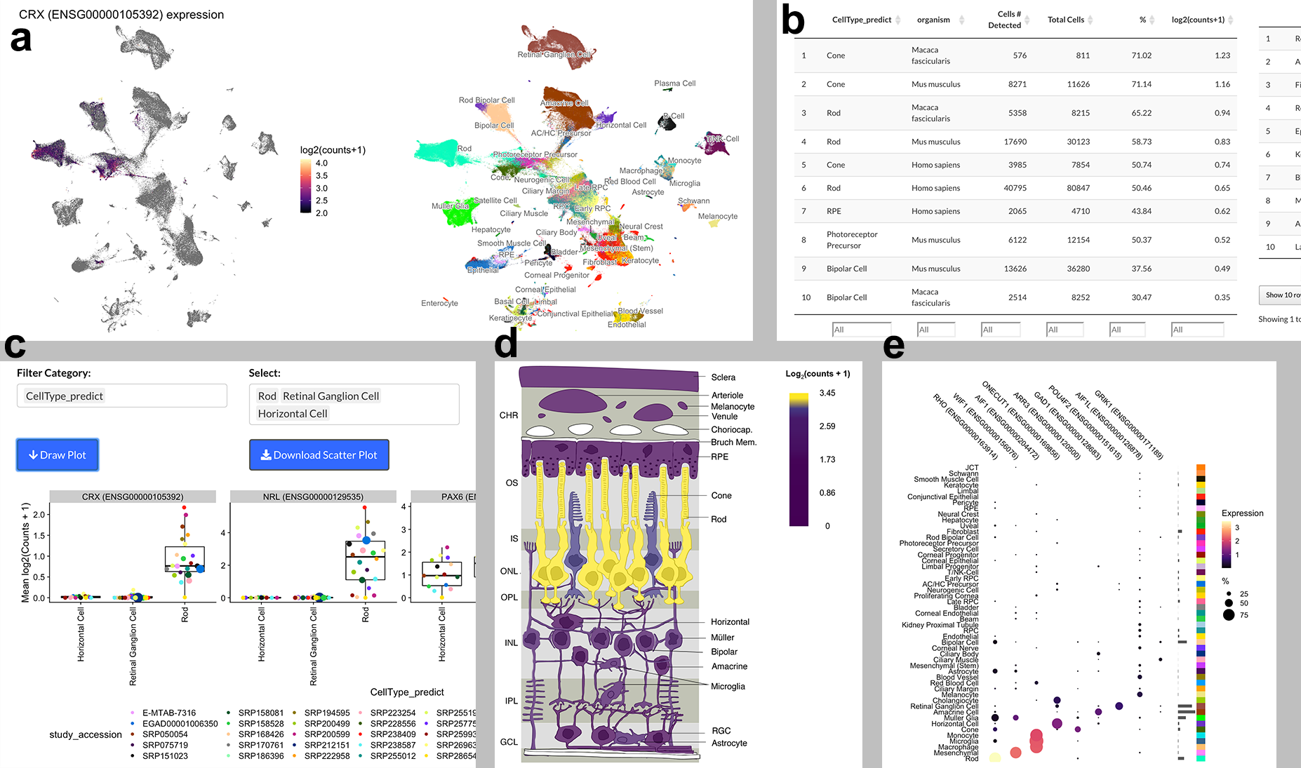

Figure 2: Screenshots from PLAE app. A. UMAP view showing Crx expression with cell type labels, B. Information table showing expression of Crx across celltypes and organism. C. Box plot of selected genes in a user selected cell types across different studies. D. In silico in-situ of Rho. E. Dotplot demonstating efficient display of gene expression across many cell types.

## Well supported ocular cell types identify high confidence cell type markers

Cell type marker genes can be proposed on the basis of existing knowledge about their function and on high expression differences when comparing to other cell types. We can further narrow down the list of markers by using the high diversity of studies and organisms in scEiaD to propose a set of community supported cell type markers. We first identify a set of well supported cell types which we define as cell types that are detected in two or more independent studies across both human and mouse (Supplemental Table 4). These cell types were then assessed to identify differentially expressed genes which met the following criteria across human, mouse, and macaque: 1. padj less than $1x{10}^{-}4$ in two or more species, 2. mean log2 fold change greater than 2, and 3. mean padj less than $1x{10}^{-}5$. A final filter was applied to remove genes as candidates if they were differentially expressed (using the criteria above) in more than three different cell types. This left us with 2790 gene - cell type markers, a substantial reduction from the 33927 we had initially. We provide a table of these genes as supplementary file “consistently_differentially_expressed_genes.csv.gz.”

To visualize these top markers we select up to eight genes (ordered by the mean log2 fold change across organisms) per well supported cell type for each and plot the log2 fold change of the gene expression relative to all other cell types (Figure 3). We see that human, mouse, and macaque have similar expression patterning of the proposed markers across the well supported cell types. The cell types are arranged by the columns by how related the expression patterns are. We see how the differentiated cell types of the retina are grouped together with the exception of the Müller glia, which are near the RPC from which they are derived.

To assess whether this marker selection was identifying known or potentially novel marker genes we ran several sets of queries against PubMed. We searched for the gene name or the gene name plus ” AND Retina” across all well supported genes against the PubMed database, counting how many citations were returned. In contrast we also selected 1000 random genes that were not considered differentially expressed and ran the same PubMed searches. We find a substantial enrichment of citations for our well supported differentially expressed genes (t test, p < 6.7x10-98 and p < 2.4x10-12) for the gene and gene ” and retina” PubMed searches when compared against the 1000 random genes, respectively. To display the results of this search for each individual gene we show visually whether the number of citations returned is less or equal than the median citation count for the random gene set (“few”), more than the median (“some”), or more than the mean (“many”). We see that nearly all genes in (Figure 3) reflect existing knowledge.

Genes with relatively few citations can be considered as novel markers. We see, for example, *Onecut3* appears to well separate the horizontal cells and has few PubMed citations. To assess whether there are any other good candidates with few citations, we produced another heatmap (Supplemental Figure 6). Most of these genes are differentially expressed across more than one cell type. We hand selected *C1ql2* and *Cartpt* (amacrine), *Frzb* and *Slitrk2* (Muller glia), and *Onecut3* (horizontal) and plotted these five genes in the boxplot view to confirm specificity across the full scEiaD database (Supplemental Figure 7). All five look to be specific to a cell type, except for *FRZB* which also is expressed in the RPE.

Other strategies for ranking genes are possible. We show in Supplemental Figure 8b and c how one can directly use our powerful web app to select candidate bipolar cell differentially expressed genes from the differential testing table and then quickly display the expression pattern of those genes in a compact heatmap visualization. The wealth of visualization options in plae allow for quick prototyping and hypothesis testing of gene expression patterning across many cells and studies.

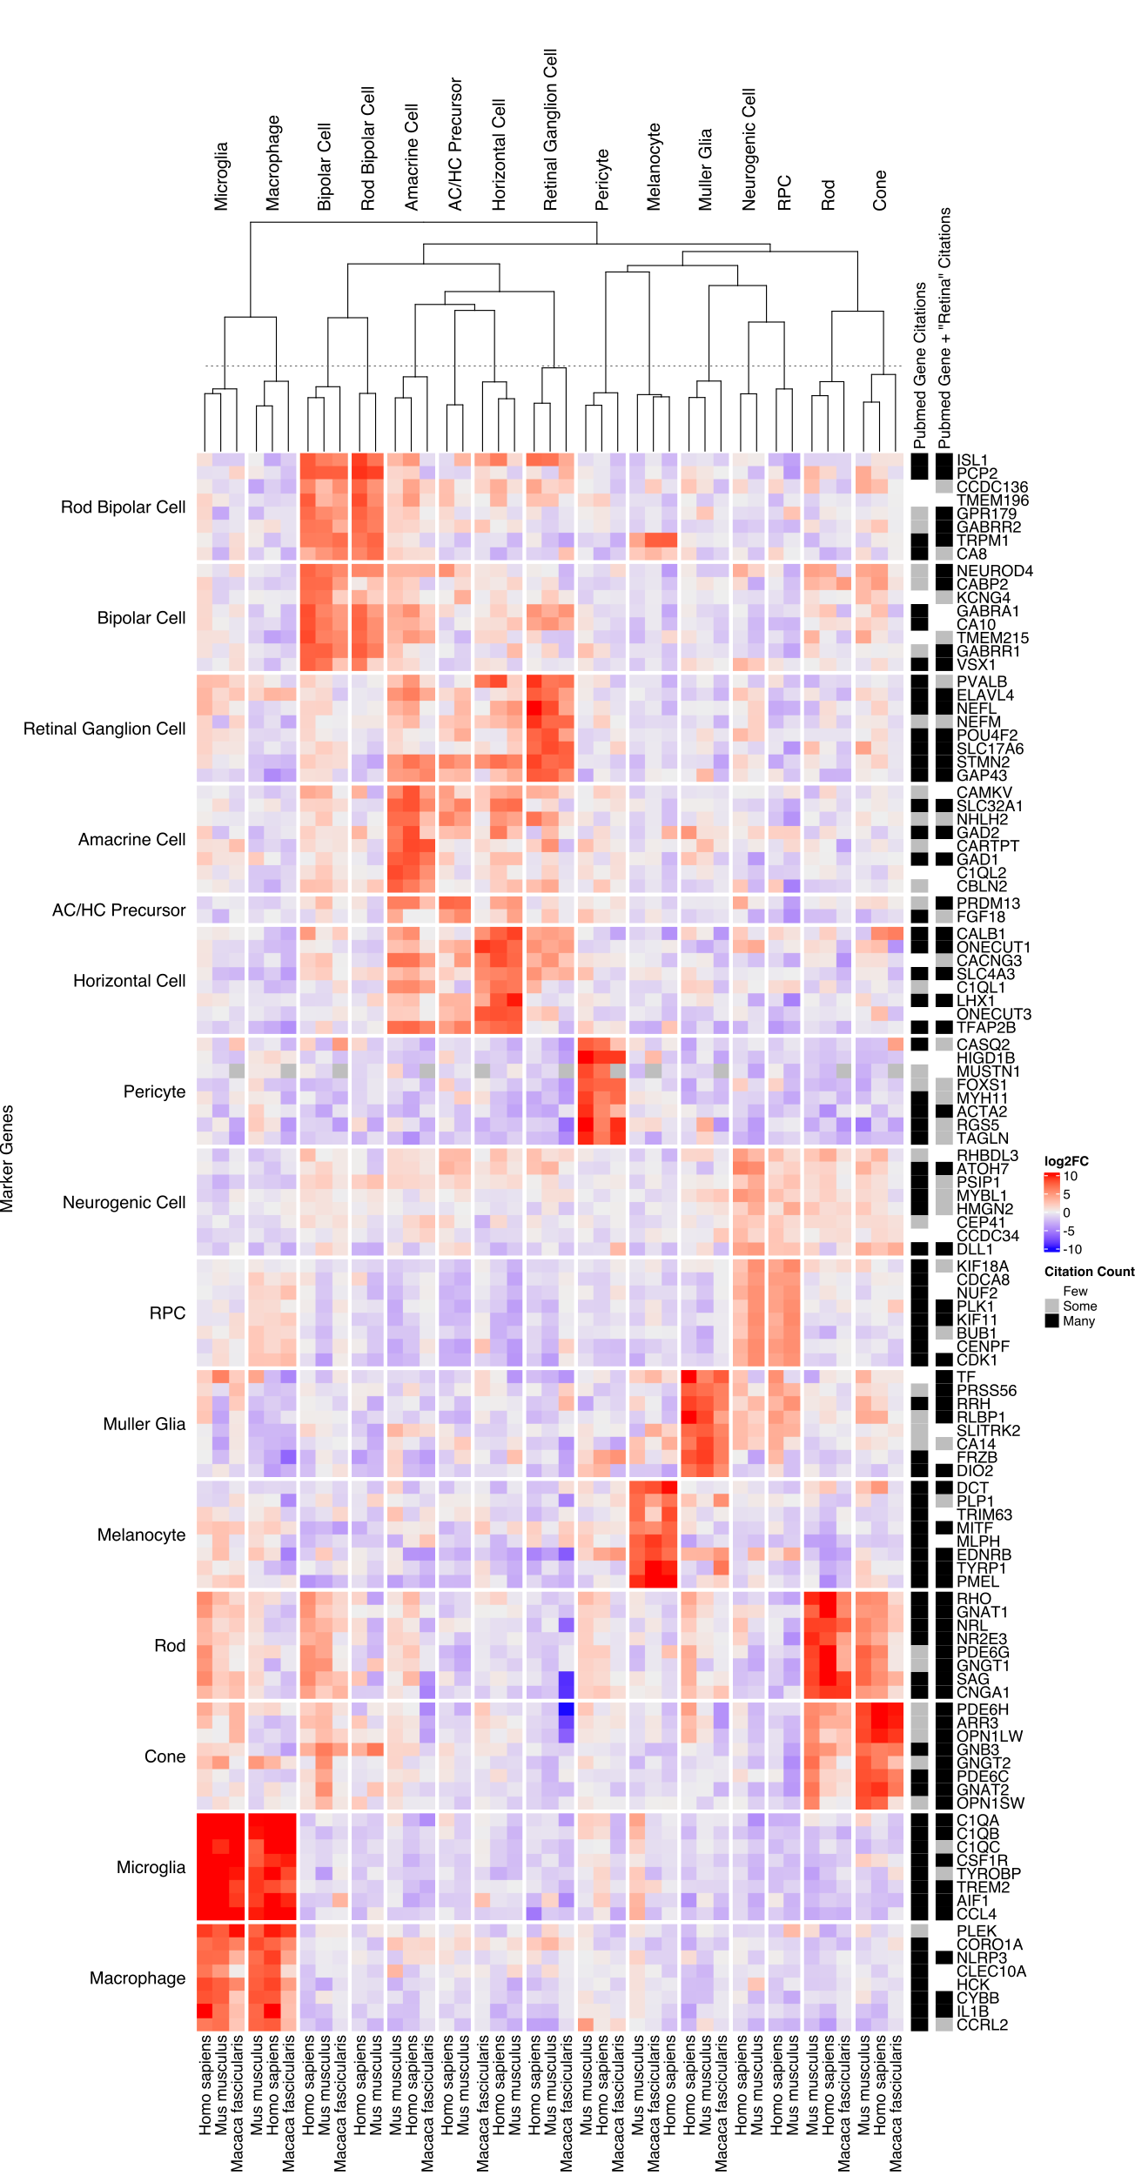

Figure 3: Rows are genes, columns are cell types and organisms. Rows are split by what cell type the gene is a marker for. Columns are split by the cell types. More intense red is a higher log2 fold change of the gene - cell type relative to all other cell types and blue is more negative. Relative number of citations are shown for the gene or gene ” and retina” when searching against PubMed compared to 1000 randomly chosen genes.

## Tease apart the similar neurogenic and RPC cell types

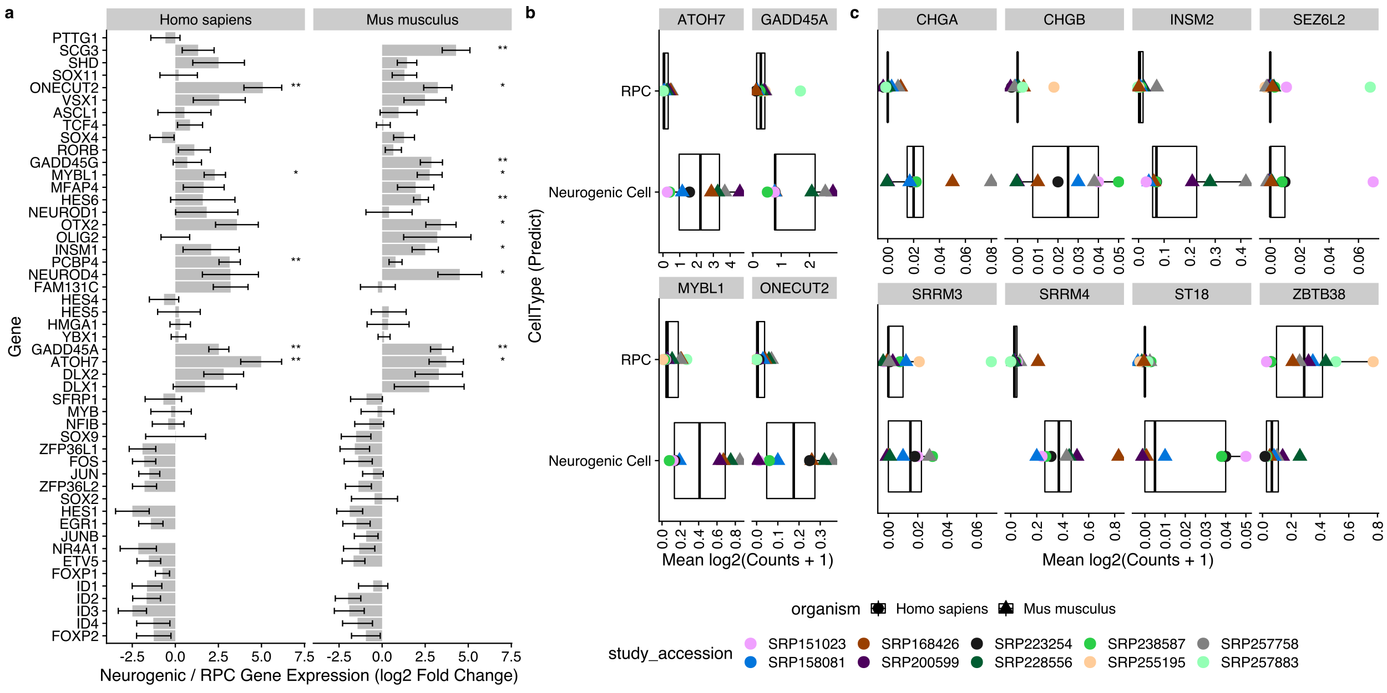

Figure 4: A. Genes proposed by Lu et al. as being significantly differentially expressed during the RPC to neurogenic differentiation in human. We plot the differential expression (log2(fold change) directly between RPC and neurogenic cells. The standard error (calculated by DESeq2) is plotted. Genes with a padj < 0.1 and padj < 0.01 are labelled with “*” and “**“, respectively. B. Genes from Lu et al. that we replicated with the scEiaD data. C. Novel genes we propose as being differentially expressed between RPC and neurogenic cells

While the well supported markers we propose clearly define most of the cell types, we see that the neurogenic cells and RPCs have very similar expression patterns across the gene sets. These cell types are closely related as the neurogenic cells are derived from the multi-potent RPC to later specify neural cell types. We first use the set of genes identified by Lu et al.45 in their study of human retinal differentiation to determine whether our scEiaD database retains the same trends (Figure 4A). As expected, we see several patterns. First, we see most of the gene expression changes between RPC and neurogenic are matched between human. We further show that these genes also show the same trends in mouse datasets. Next we see that the direction of the changes largely matches Lu et al (Supplemental Figure 9). Finally, we see a small number of genes are confirmed in our database as consistently differentially expressed with a padj < 0.1.

To determine whether we can propose any new genes that distinguish RPC and neurogenic states we use our DESeq2 differential expression contrast that directly compares these two cell types. We find 88 human genes and 91 mouse genes that have an absolute log2 fold change greater than two and a adjusted p-value below 0.05 (Supplemental Table 5). To identify candidate genes that are consistently differentially expressed at this transitional state in mouse and human we apply similar logic that we used in identifying well supported marker genes across the retina cell types. We filter to genes with a adjusted p value less than 0.05 in both human and mouse and a mean log2 fold change greater than two or less than negative one (Figure 4B and C). We find one gene, *ZBTB38*, that meets this criteria and drops in expression when comparing RPC to neurogenic. We find 11 genes that increase in expression from RPC to neurogenic, 7 of which are not previously identified by Lu et al (Figure 4C). We replicate *ATOH7, ONECUT2, GADD45A, MYBL1* from Lu et al (Figure 4B) as differentially expressed between neurogenic and RPC. Futhermore we show in Supplemental Figure 8a how this figure can be replicated directly in our web app.

## Our pan-study macula vs peripheral cone test replicates a published macaque finding and proposes six new markers

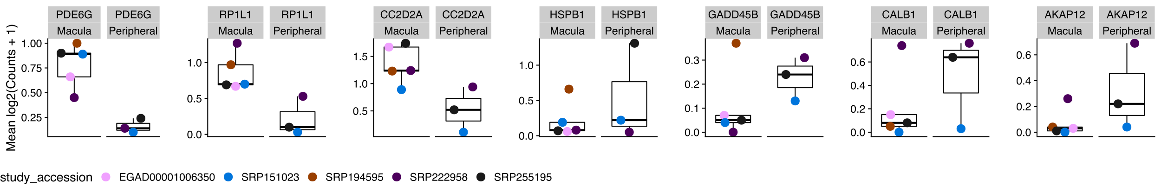

Figure 5: Plot of markers distinguishing human macula or peripheral punch derived cones.

While we have provided data in many forms via the web app at plae.nei.nih.gov, there are many more dissections of the data that can be performed. To facilitate custom testing with the scEiaD database we provide, as an example, a human-specific macula versus peripheral cone differential testing analysis document as supplementary file “pseudobulk_cone_region.freeze01.html.” In our analysis document we use the Seurat object containing the full scEiaD dataset we provide at plae.nei.nih.gov to build a custom pseudobulk counts matrix containing only cones from human studies that were taken in a region specific manner. This left us with 26678 cells across six studies. Yan et al. previously proposed *Prph2* and *Rs1* as markers to distinguish macula and peripheral located human cones2 and Peng et al. proposed *Calb1* and *Gngt1* as cone region markers in macaque.46

Our differential testing found that while *Prph2*, *Rs1*, and *Gngt1* had expression differences matching that the findings Yan et al. and Peng et al. published, they failed to replicate in our test with a p value being above 0.1 for all three. In contrast *Calb1* did replicate strongly with the sixth lowest padj (0.00721) across our entire test and a log2 fold change of 2.87. We find six more genes with a padj < 0.01: *Pde6g*, *Akap12*, *Hspb1*, *Gadd45b*, *Cc2d2a*, and *RP1l1* (Figure 6 and Supplemental Table 6). None of these candidate cone region marker genes display regionally different expression in rods (Supplemental Figure 10).

## Limitations of scEiaD

The longer term goal is to continue adding datasets to the scEiaD at plae.nei.nih.gov until we have three or more independent datasets per species and most ocular cell types. Earlier we proposed well supported cell types. Right now, most of these well supported cell types are in the retina. The RPE behind the retina, the cornea and lens in front, and the outflow tract and supporting musculature still could use more independent studies. Many common human diseases underlie the RPE (e.g. AMD) and the cornea (e.g. Keratoconus) and these tissues will remain a focus for the next update of our database. While we have curated a large number of cell types across the eye, many of these cell types have “sub” cell types. For example the human retina has three types of cones that are optimized for short, medium, and long wavelengths. More dramatically, Yan et al. have proposed over sixty different mouse amacrine cell types.47 While we have found it fairly straightforward to use machine learning to transfer the broad (e.g. rod, cone, amacrine) cell type labels across all datasets, we have found it very challenging to transfer the “sub” cell type labels. This is largely because while we have high diversity of studies for the broad cell types, this is not true for most of the sub celltypes. We believe more datasets that carefully dissect the sub-celltypes may be necessary to confidently propose the sub-celltypes of the retina. Finally, while our scVI based model can theoretically be used by an outside group to transfer their internal data into the scEiaD latent space, it is very challenging to implement as the the software landscape is still rapidly changing and it is very difficult to architect consistent outputs over time with regularly changing software versions. We are investigating simpler methods to enable transfer of knowledge from scEiaD to outside data.

# Conclusions

## High feature web app provides quick access to over one million transcriptomes across 44 datasets

We have improved on the scEiaD dataset we published in Swamy et al.23 by adding another species (*Gallus gallus*), new ocular tissues, and a human non-ocular reference set; in total 10 new single cell datasets. We re-structured the data into a custom database to enable our custom built high performance web app to quickly access the data. This democratizes access to over a million cells across 44 studies to anyone with a web browser. We recognize that while we have built a powerful visualization platform we cannot anticipate all uses and for those researchers who wish to make custom queries of the data, we provide the data underlying PLAE in a wide variety of formats, including anndata and Seurat objects for each study, count tables, cell level metadata, and the DESeq2 based differential testing across three species. We provide a short example of how a novel query could work by running a custom differential test between macula and peripheral derived human cones and demonstrate how this can both validate existing proposed genes and suggest new ones.

## Diversity of studies enables reproduction and extension of cell type gene expression findings

A great many groups have proposed cell atlases. These range from efforts focusing on a subset of cells from a single layer of a tissue48 to a huge consortium encompassing multiple organ.18 We propose a complementary approach wherein we use the research data from the community at large to create a meta-atlas. This strategy enables a small group to produce an atlas which rivals the size from massive multi-group consortiums. Furthermore, the inherent variability between the data from independent groups can be used as a feature to get insight into whether a gene-cell type signal is stable across an entire community’s datasets. We use this feature to demonstrate how the high study diversity in scEiaD can be used to validate proposed RPC to neurogenic gene expression changes in a R analysis document. Our community powered single cell ocular meta-atlas enables the entire ocular community to use the wealth of research it has generated.

# Acknowledgments

This research was funded by the National Institutes of Health (National Eye Institute) intramural program. This work utilized the computational resources of the NIH HPC Biowulf cluster (<http://hpc.nih.gov>).

# Supplementary Figures and Tables

## Warning: Removed 20 rows containing missing values (position_quasirandom).

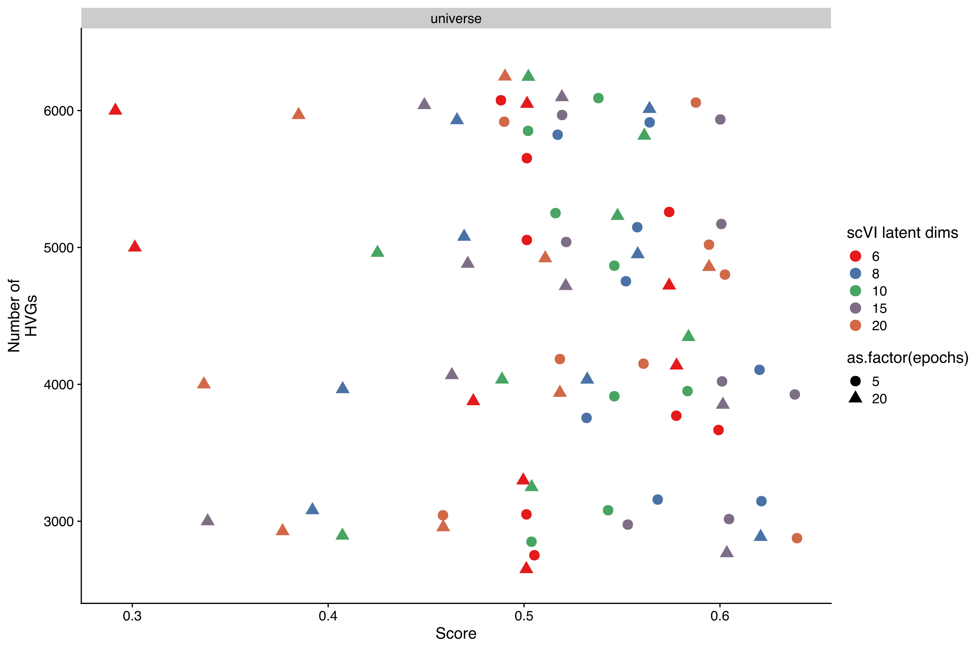

Supplemental Figure 1: scPOP based performance scoring (higher is better) across different numbers of highly variable genes, epochs of scANVI used, and number of outputted latent dimensions.

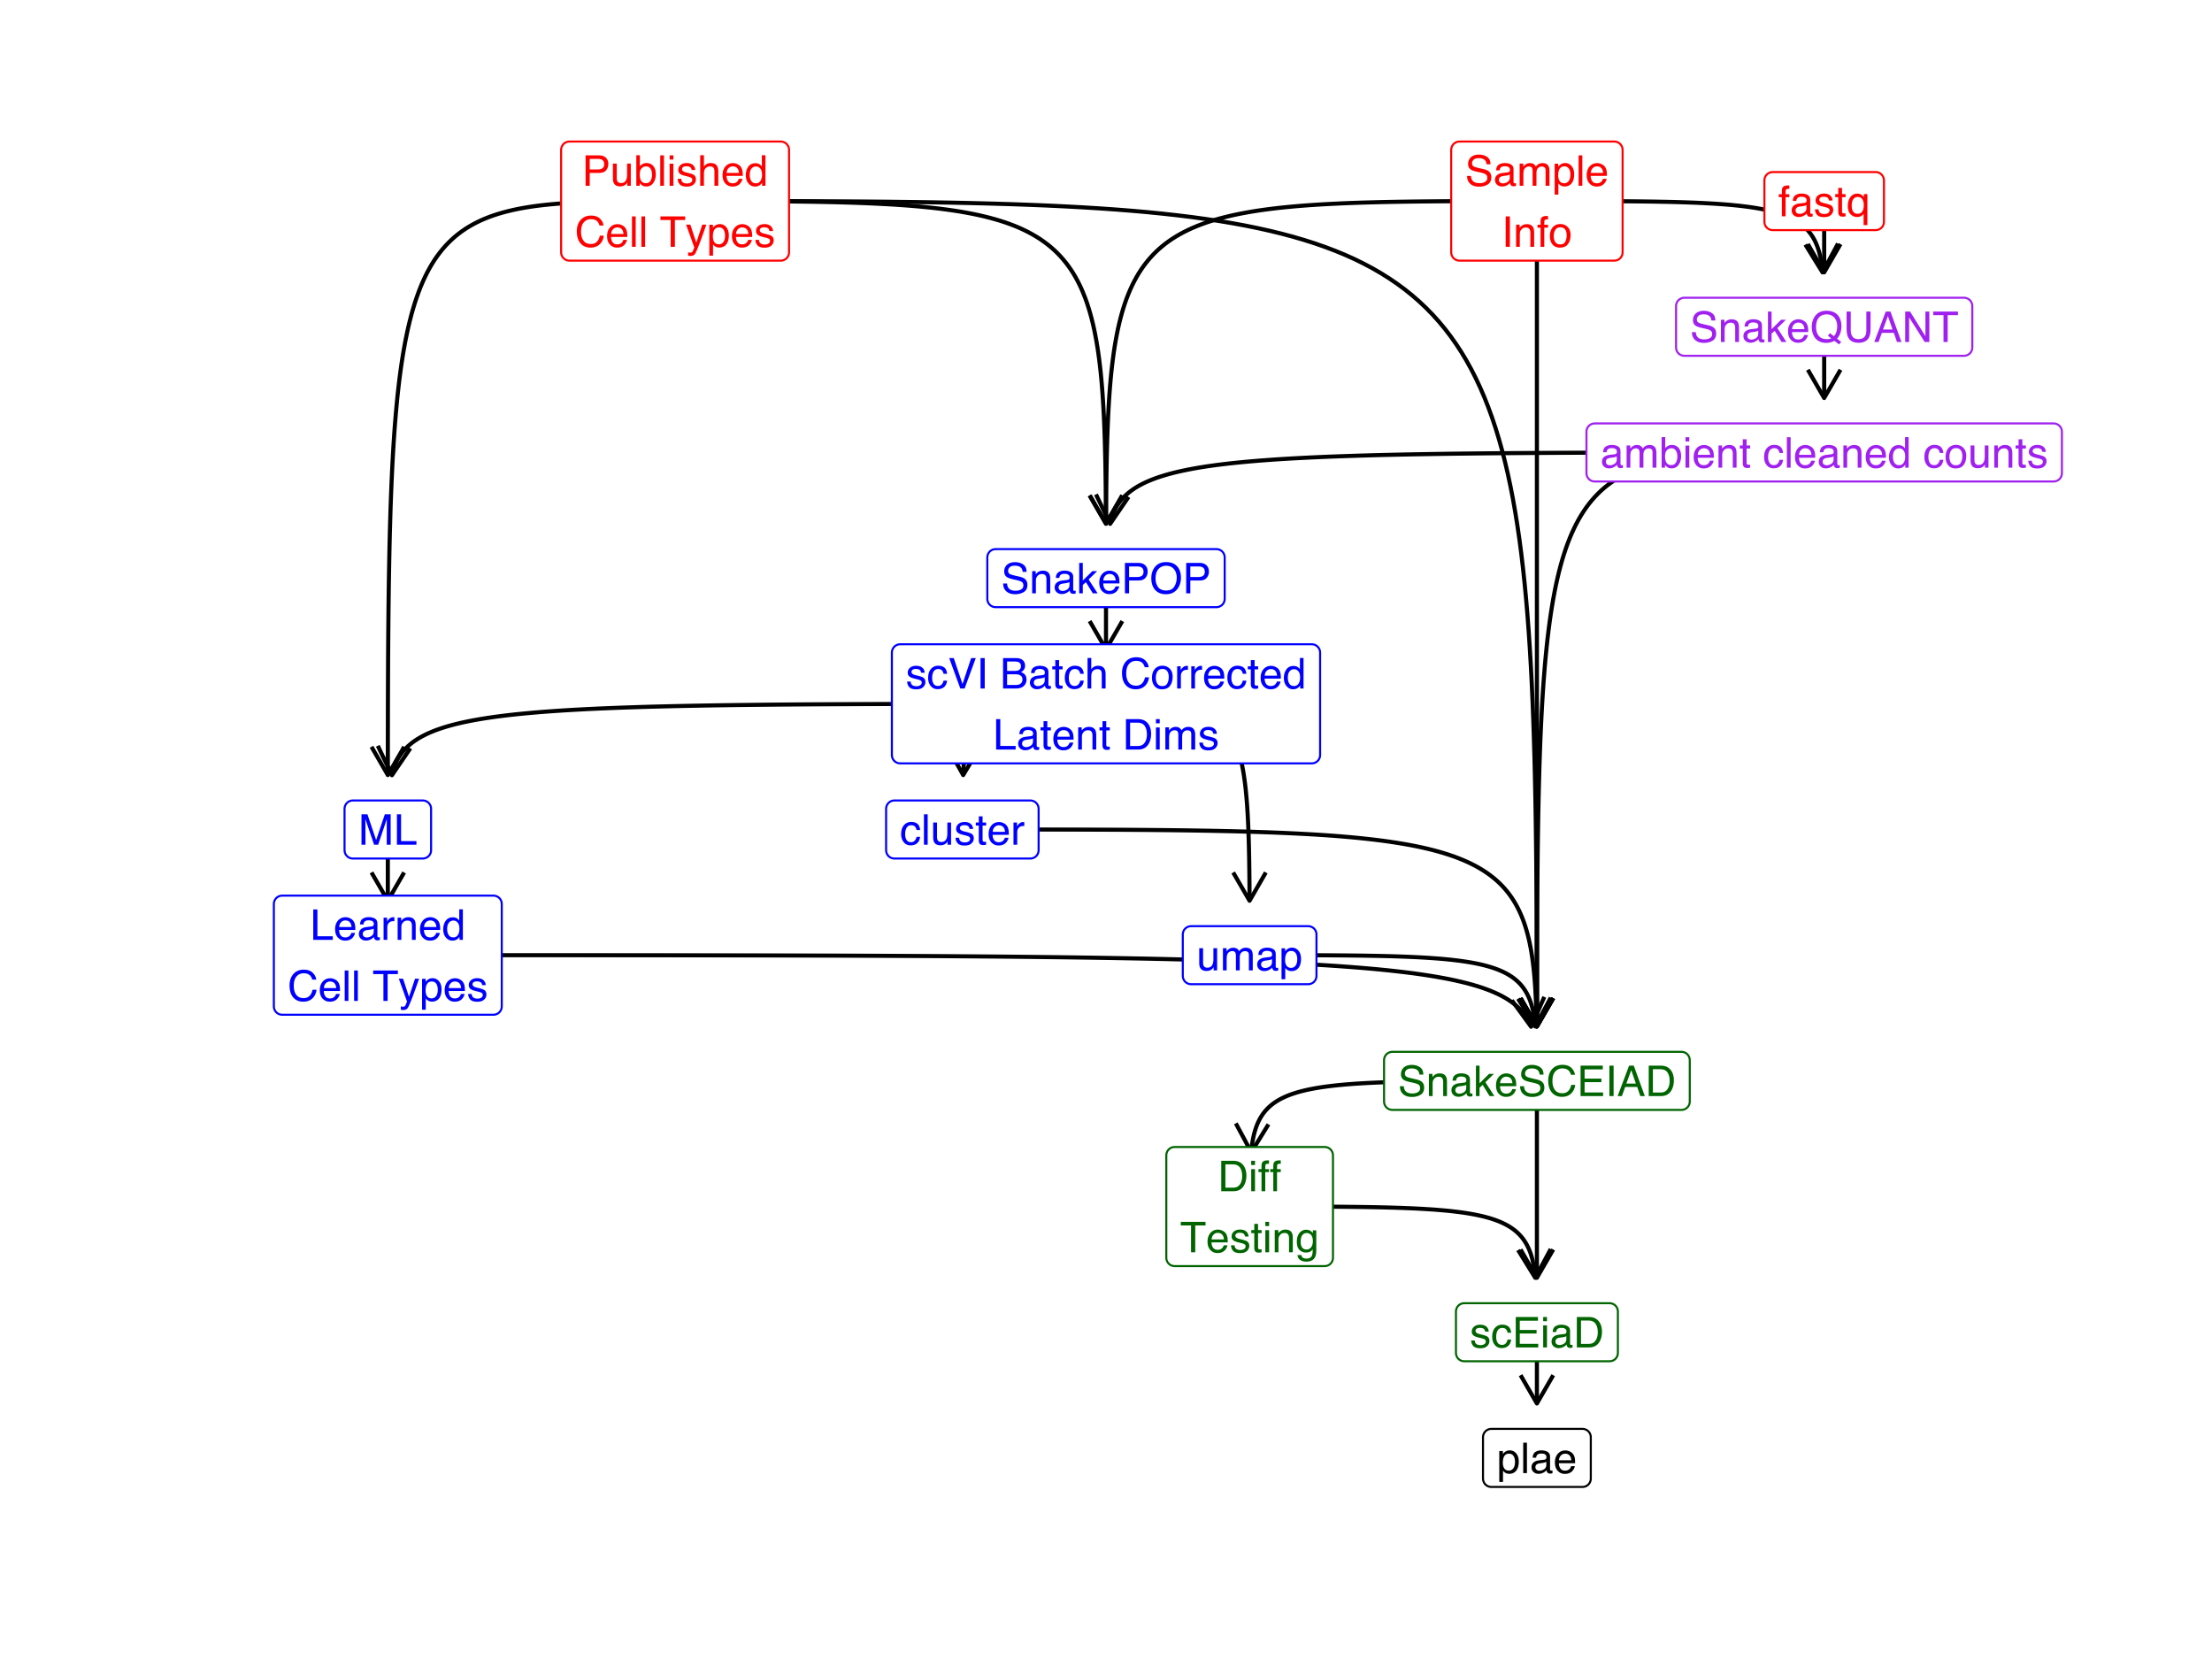

Supplemental Figure 2: Data flow overview from published cell types, sample information, raw fastq counts to produce the sqlite database used in plae.nei.nih.gov

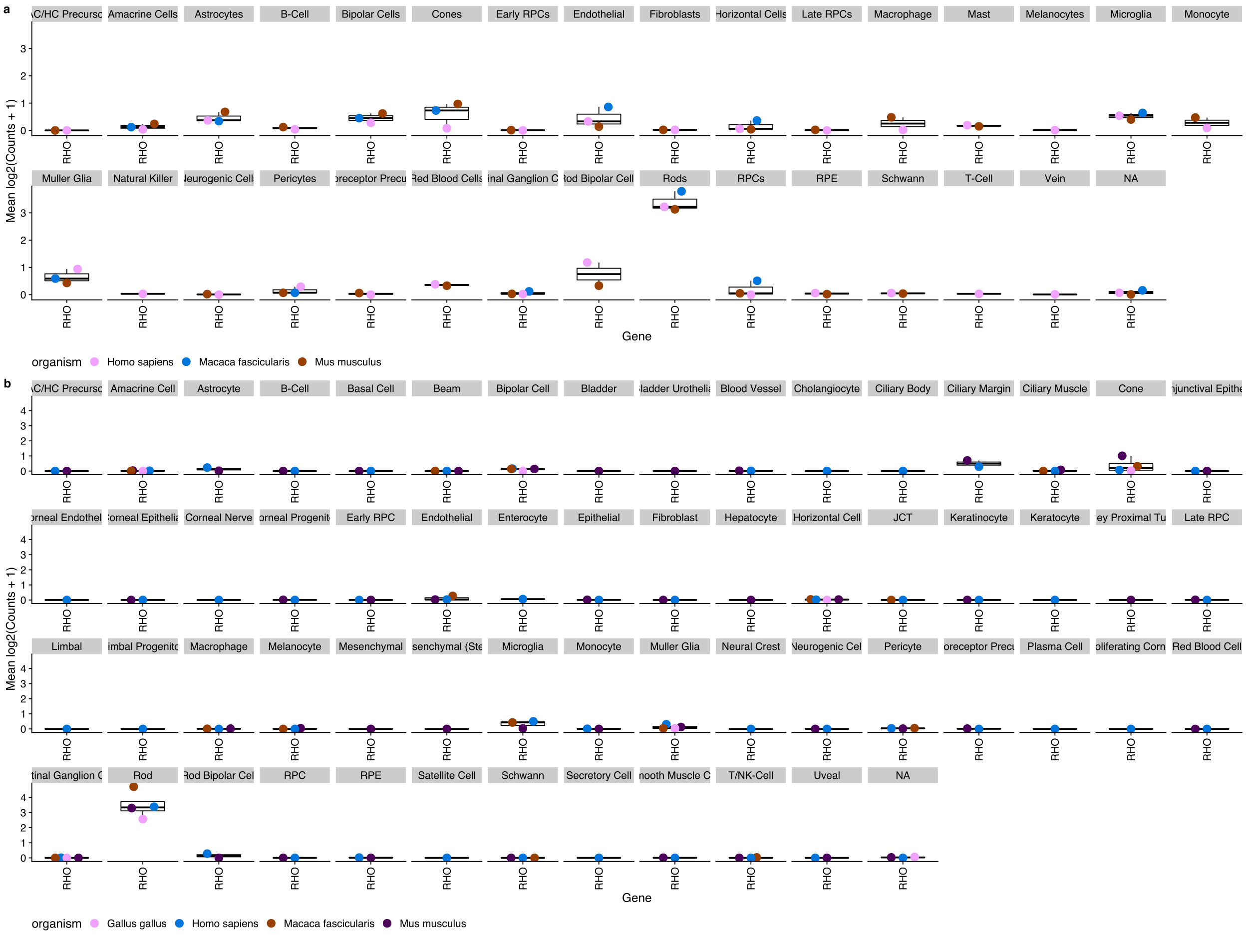

Supplemental Figure 3: DecontX in silico ambient RNA contamination tool substantially removes Rhodopsin expression in non-rod cells while retaining high expression rods. First shown (a) is Rhodopsin expression across the scEiaD v0 dataset, without DecontX optimization. Note Rhodopsin expression is noticeable in many cell types beyond the rods. Next (b) is the scEiaD v1 dataset with DecontX optimization. Rhodopsin is nearly exclusively expressed in labelled rod cells. Despite the computational ambient RNA removal, Rhodopsin expression remains high in the Rods.

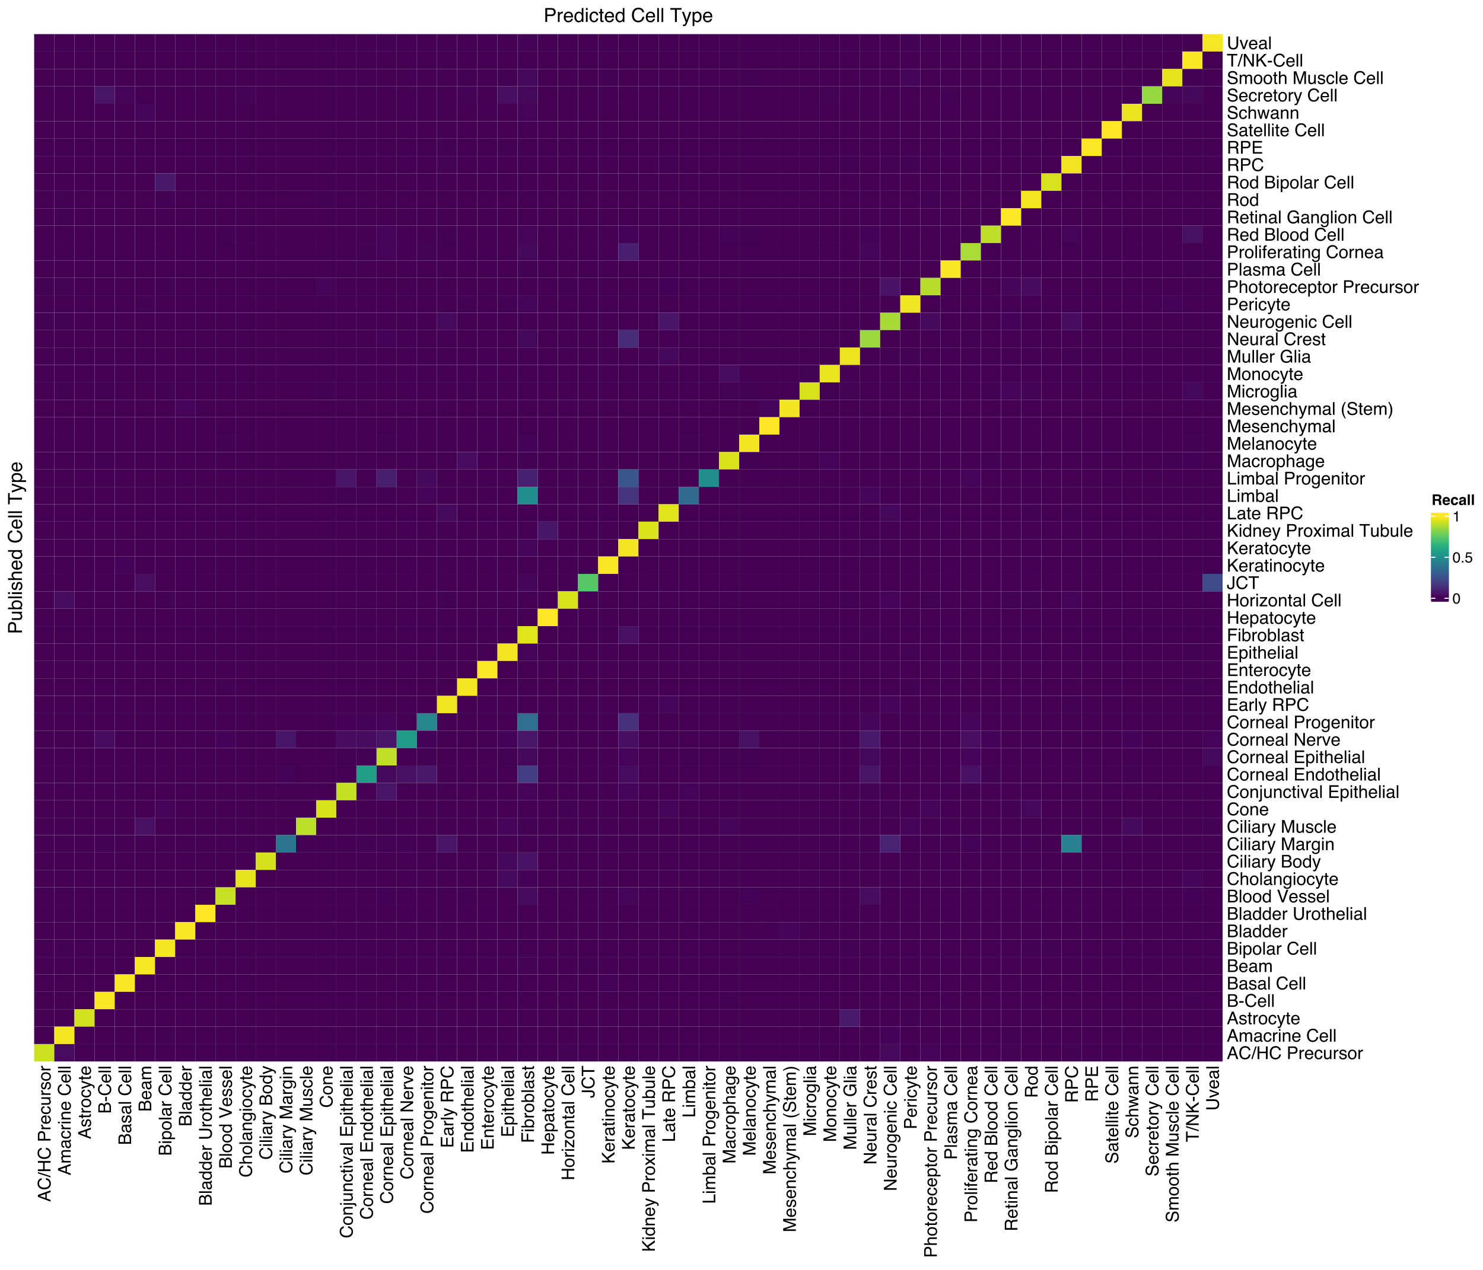

Supplemental Figure 4: Confusion matrix of cell type label consistency between predicted cell types (columns) and published cell types (rows).

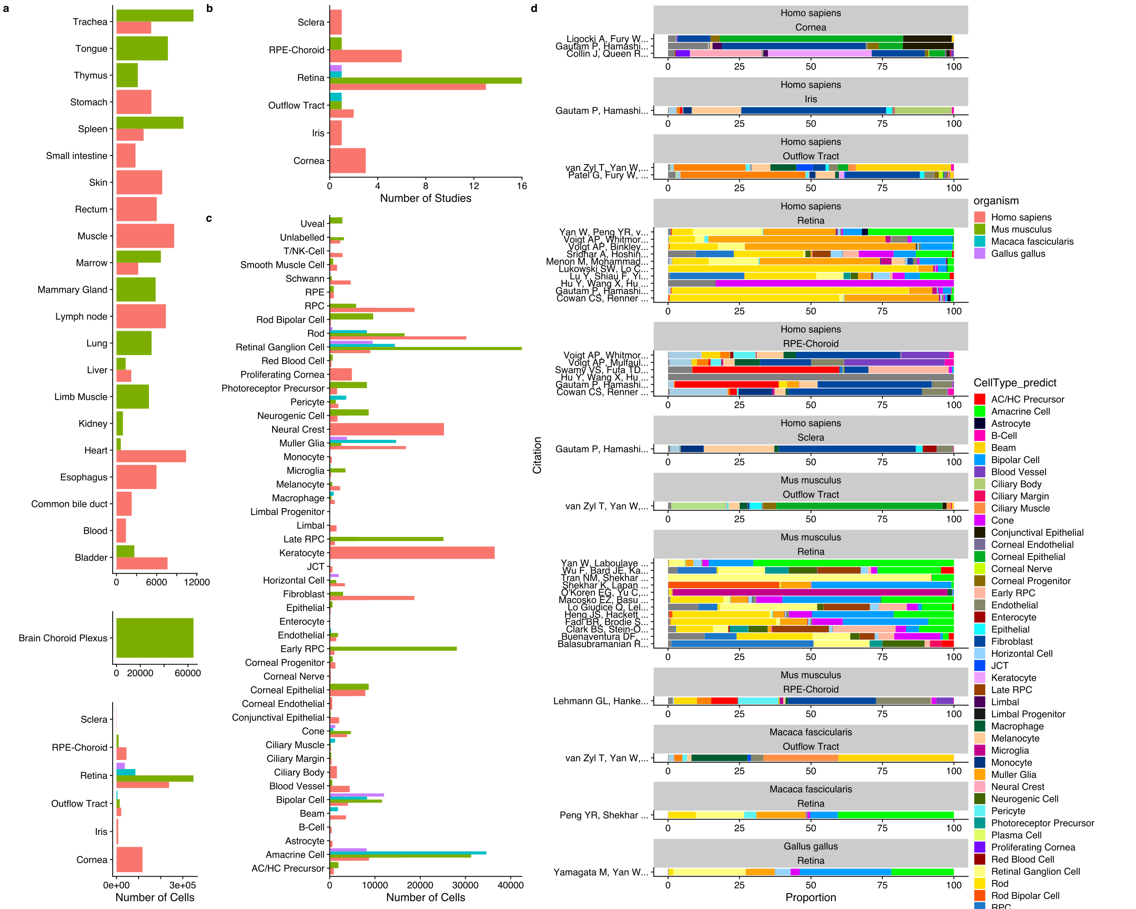

Supplemental Figure 5: Distribution of tissues and cell types in scEiaD. A. tabulation of the number of cells present across 6 ocular and 23 non-ocular tissues, B. Number of studies for each ocular tissue. C. Number of cells present across 53 curated ocular-derived cell types. D. Proportion of cell types (predicted) across each study (split by species and tissue).

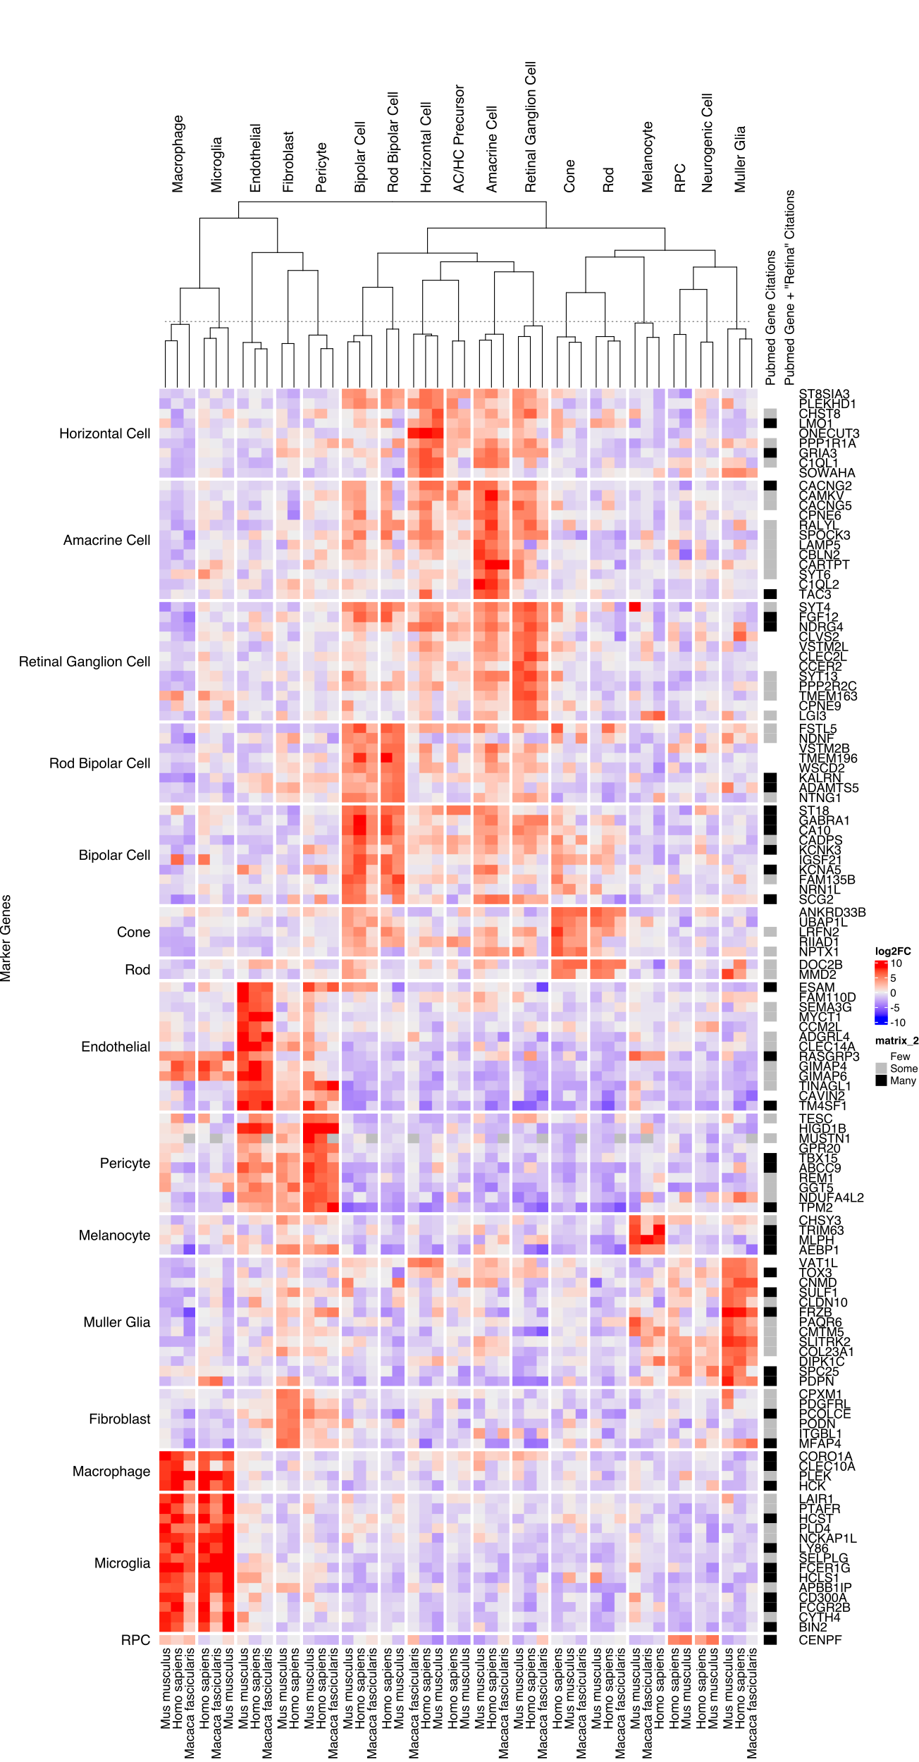

Supplemental Figure 6: Well supported genes with a mean log2FC > 5 and zero pubmed citation hits for [gene] AND Retina search.

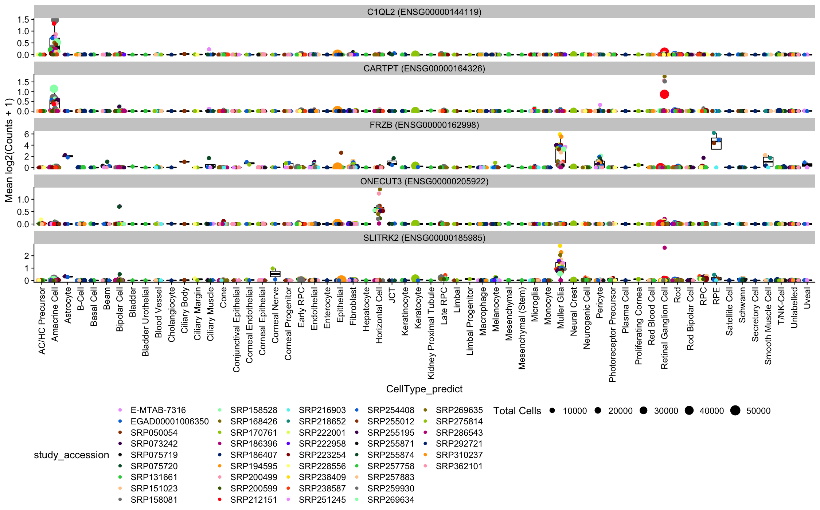

Supplemental Figure 7: Five hand-selected genes selected from Supplementary Figure 3 as having fairly unique expression to a celltype while having few pubmed citations. Plotted as expression/boxplots to confirm specificity at the study level.

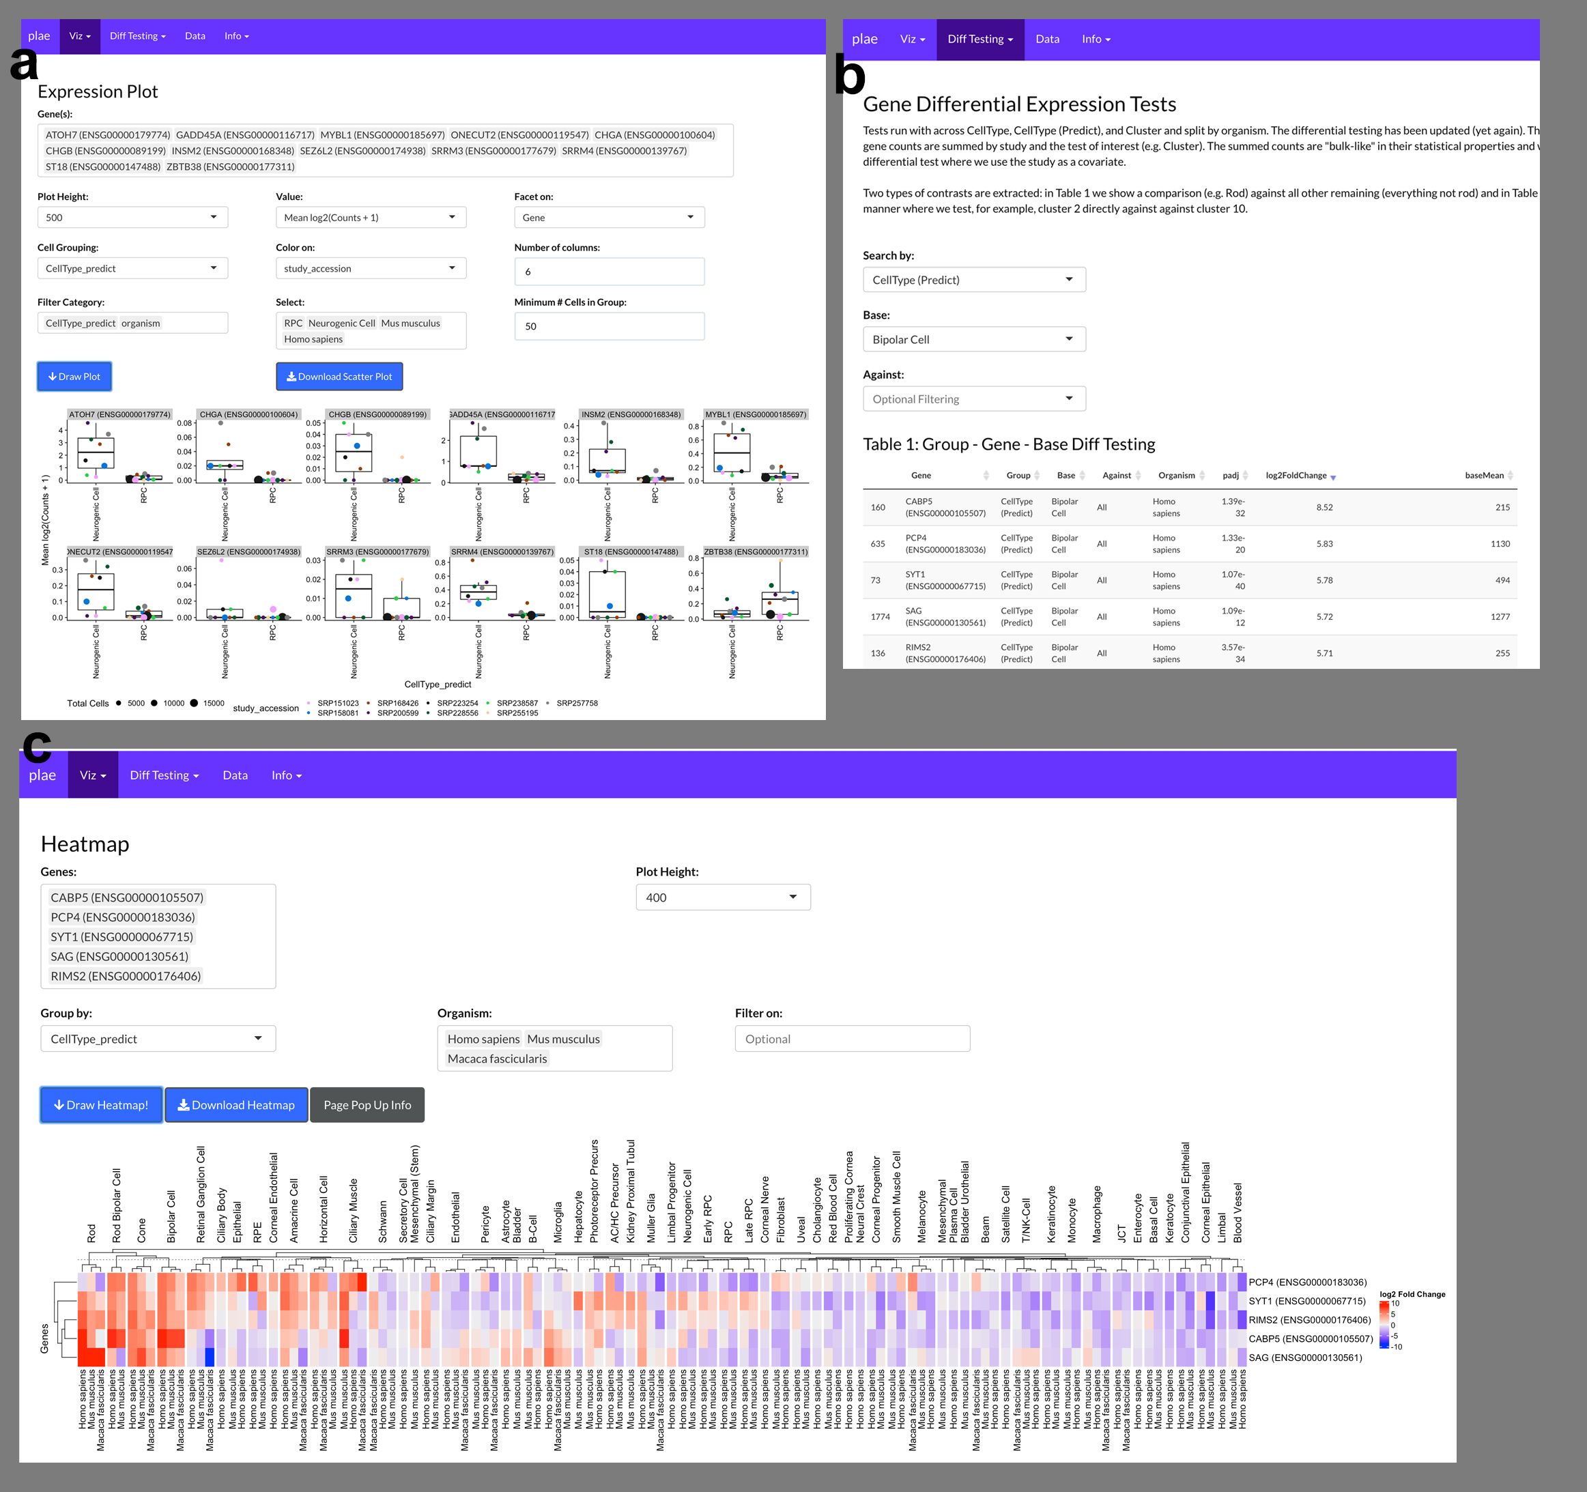

Supplemental Figure 8: a. Recreation of Figure 4 directly in the plae.nei.nih.gov web app. b. Identify potential bipolar cell markers with the precomputed differential testing and in c. visualize the top five genes with a Heatmap.

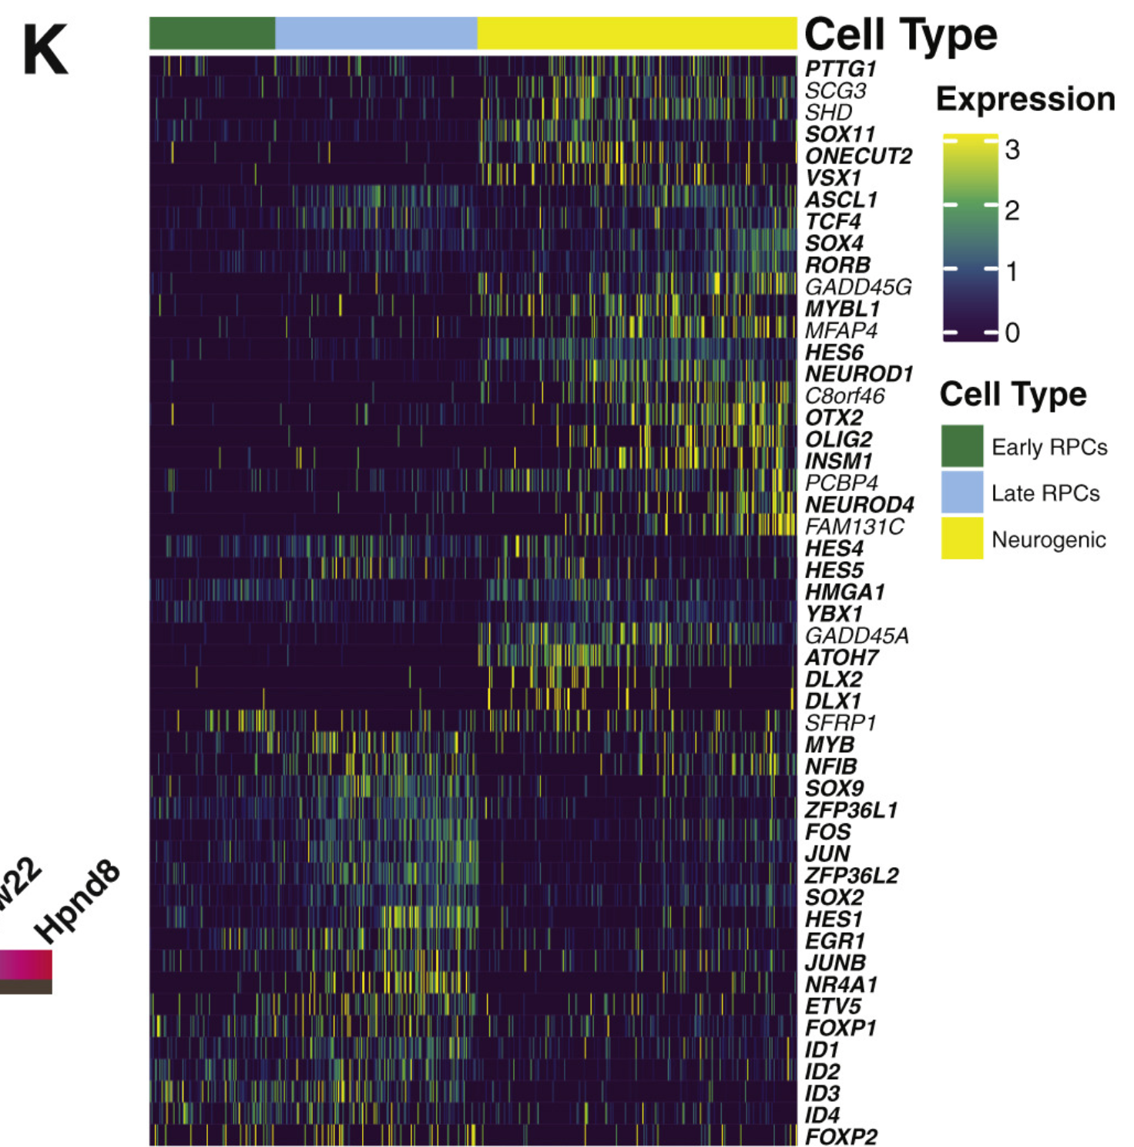

Supplemental Figure 9: Supplemental figure 2K from Lu et al showing their candidate RPC / Neurogenic differentially expressed genes

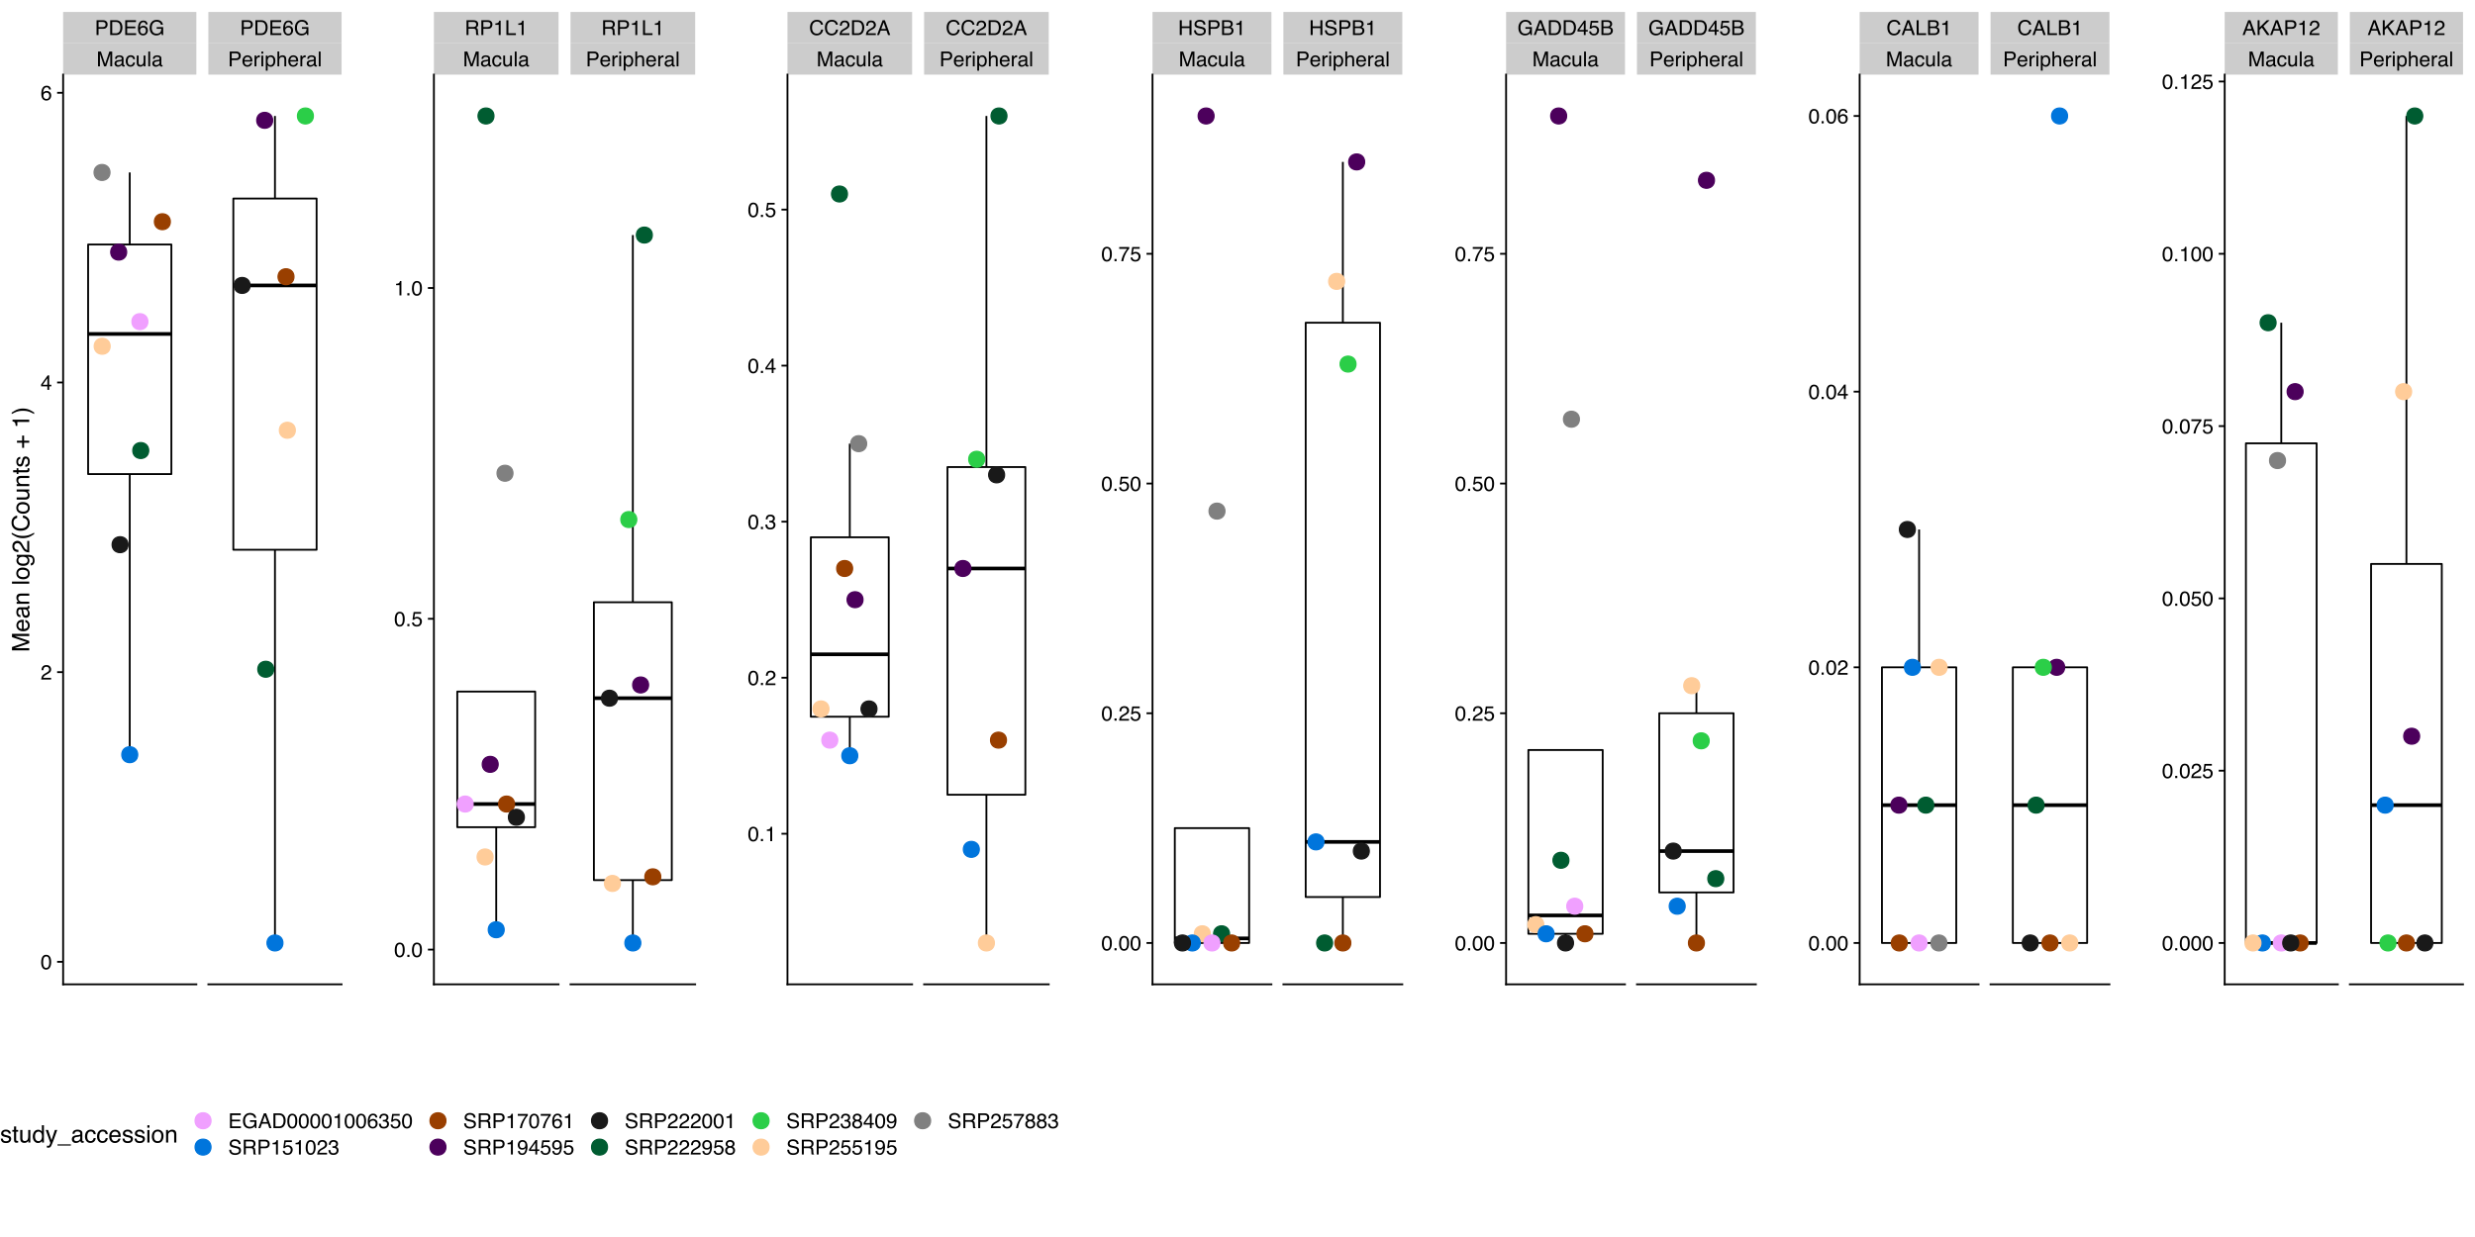

Supplemental Figure 10: Human cone fovea - peripheral differentially expressed genes are not differentially expressed in human rods.

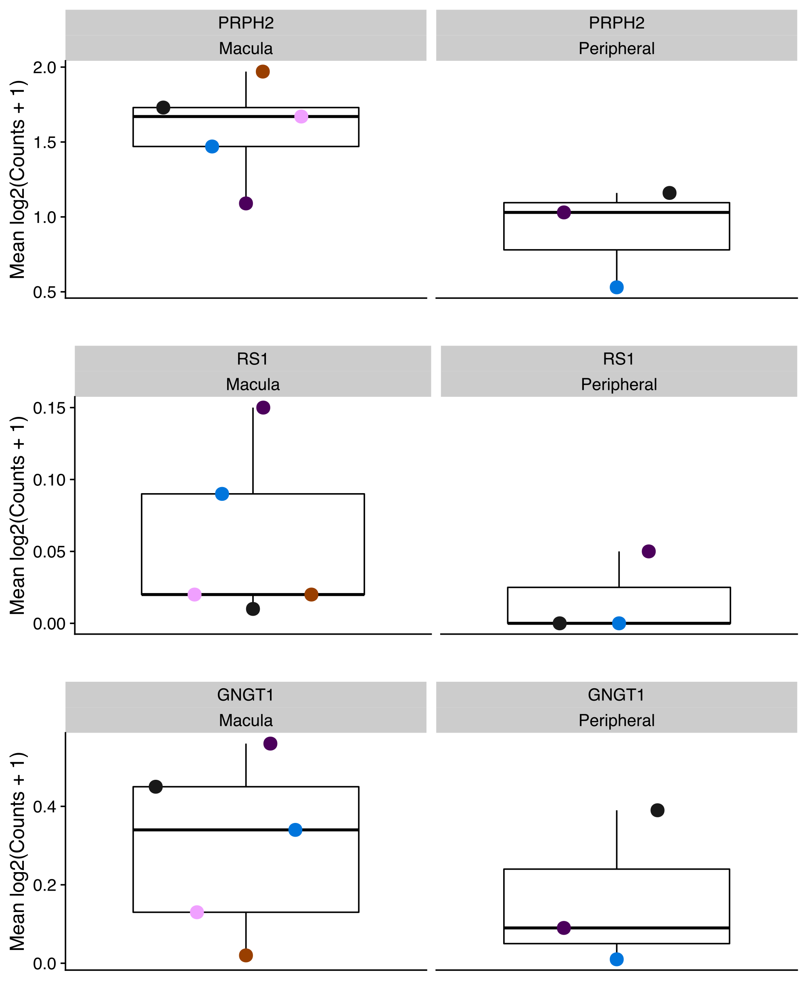

Supplemental Figure 11: Genes identified by Peng et al. and Yan et al. as macula / peripheral differentially expressed in cones.

| organism | CellType | CellType_predict | Count | Ratio |
| --- | --- | --- | --- | --- |
| Gallus gallus | Amacrine Cell | Amacrine Cell | 6,483 | 0.98750952 |
| Gallus gallus | Bipolar Cell | Bipolar Cell | 10,681 | 0.99636194 |
| Gallus gallus | Cone | Cone | 1,112 | 0.98407080 |
| Gallus gallus | Horizontal Cell | Amacrine Cell | 30 | 0.01723148 |
| Gallus gallus | Horizontal Cell | Horizontal Cell | 1,694 | 0.97300402 |
| Gallus gallus | Muller Glia | Muller Glia | 3,033 | 0.99835418 |
| Gallus gallus | Retinal Ganglion Cell | Retinal Ganglion Cell | 6,880 | 0.99811403 |
| Gallus gallus | Rod | Bipolar Cell | 26 | 0.04227642 |
| Gallus gallus | Rod | Cone | 14 | 0.02276423 |
| Gallus gallus | Rod | Rod | 575 | 0.93495935 |
| Homo sapiens | AC/HC Precursor | AC/HC Precursor | 1,307 | 0.91462561 |
| Homo sapiens | AC/HC Precursor | Amacrine Cell | 49 | 0.03428971 |
| Homo sapiens | AC/HC Precursor | Neurogenic Cell | 35 | 0.02449265 |
| Homo sapiens | AC/HC Precursor | Photoreceptor Precursor | 15 | 0.01049685 |
| Homo sapiens | Amacrine Cell | Amacrine Cell | 7,776 | 0.98517674 |
| Homo sapiens | Astrocyte | Astrocyte | 287 | 0.95348837 |
| Homo sapiens | Astrocyte | Muller Glia | 14 | 0.04651163 |
| Homo sapiens | B-Cell | B-Cell | 7,970 | 0.98589807 |
| Homo sapiens | Basal Cell | Basal Cell | 736 | 0.99459459 |
| Homo sapiens | Beam | Beam | 3,052 | 0.99348958 |
| Homo sapiens | Bipolar Cell | Bipolar Cell | 3,790 | 0.96807152 |
| Homo sapiens | Bipolar Cell | Muller Glia | 48 | 0.01226054 |
| Homo sapiens | Blood Vessel | Blood Vessel | 3,773 | 0.91733528 |
| Homo sapiens | Blood Vessel | Fibroblast | 108 | 0.02625821 |
| Homo sapiens | Blood Vessel | Keratocyte | 44 | 0.01069779 |
| Homo sapiens | Blood Vessel | Neural Crest | 112 | 0.02723073 |
| Homo sapiens | Cholangiocyte | Cholangiocyte | 235 | 0.96311475 |
| Homo sapiens | Cholangiocyte | Epithelial | 5 | 0.02049180 |
| Homo sapiens | Cholangiocyte | T/NK-Cell | 3 | 0.01229508 |
| Homo sapiens | Ciliary Body | Ciliary Body | 1,378 | 0.93487110 |
| Homo sapiens | Ciliary Body | Epithelial | 23 | 0.01560380 |
| Homo sapiens | Ciliary Body | Fibroblast | 69 | 0.04681140 |
| Homo sapiens | Ciliary Margin | B-Cell | 4 | 0.01104972 |
| Homo sapiens | Ciliary Margin | Ciliary Margin | 324 | 0.89502762 |
| Homo sapiens | Ciliary Margin | Corneal Epithelial | 11 | 0.03038674 |
| Homo sapiens | Ciliary Margin | Corneal Nerve | 5 | 0.01381215 |
| Homo sapiens | Ciliary Margin | Proliferating Cornea | 9 | 0.02486188 |
| Homo sapiens | Ciliary Muscle | Beam | 37 | 0.22155689 |
| Homo sapiens | Ciliary Muscle | Ciliary Muscle | 88 | 0.52694611 |
| Homo sapiens | Ciliary Muscle | Corneal Epithelial | 3 | 0.01796407 |
| Homo sapiens | Ciliary Muscle | Macrophage | 2 | 0.01197605 |
| Homo sapiens | Ciliary Muscle | Schwann | 33 | 0.19760479 |
| Homo sapiens | Cone | Cone | 3,737 | 0.97343058 |
| Homo sapiens | Conjunctival Epithelial | Conjunctival Epithelial | 824 | 0.91150442 |
| Homo sapiens | Conjunctival Epithelial | Corneal Epithelial | 47 | 0.05199115 |
| Homo sapiens | Corneal Endothelial | Corneal Endothelial | 490 | 0.55872292 |
| Homo sapiens | Corneal Endothelial | Corneal Epithelial | 18 | 0.02052452 |
| Homo sapiens | Corneal Endothelial | Corneal Nerve | 33 | 0.03762828 |
| Homo sapiens | Corneal Endothelial | Corneal Progenitor | 56 | 0.06385405 |
| Homo sapiens | Corneal Endothelial | Fibroblast | 159 | 0.18129989 |
| Homo sapiens | Corneal Endothelial | Keratocyte | 25 | 0.02850627 |
| Homo sapiens | Corneal Endothelial | Neural Crest | 45 | 0.05131129 |
| Homo sapiens | Corneal Endothelial | Proliferating Cornea | 39 | 0.04446978 |
| Homo sapiens | Corneal Epithelial | Corneal Epithelial | 1,689 | 0.93057851 |
| Homo sapiens | Corneal Epithelial | Fibroblast | 27 | 0.01487603 |
| Homo sapiens | Corneal Epithelial | Keratocyte | 20 | 0.01101928 |
| Homo sapiens | Corneal Epithelial | Neural Crest | 33 | 0.01818182 |
| Homo sapiens | Corneal Epithelial | Proliferating Cornea | 19 | 0.01046832 |
| Homo sapiens | Corneal Nerve | B-Cell | 6 | 0.02714932 |
| Homo sapiens | Corneal Nerve | Ciliary Margin | 12 | 0.05429864 |
| Homo sapiens | Corneal Nerve | Conjunctival Epithelial | 6 | 0.02714932 |
| Homo sapiens | Corneal Nerve | Corneal Endothelial | 6 | 0.02714932 |
| Homo sapiens | Corneal Nerve | Corneal Epithelial | 11 | 0.04977376 |
| Homo sapiens | Corneal Nerve | Corneal Nerve | 122 | 0.55203620 |
| Homo sapiens | Corneal Nerve | Fibroblast | 13 | 0.05882353 |
| Homo sapiens | Corneal Nerve | Keratocyte | 8 | 0.03619910 |
| Homo sapiens | Corneal Nerve | Melanocyte | 9 | 0.04072398 |
| Homo sapiens | Corneal Nerve | Neural Crest | 14 | 0.06334842 |
| Homo sapiens | Corneal Nerve | Proliferating Cornea | 7 | 0.03167421 |
| Homo sapiens | Corneal Progenitor | Corneal Progenitor | 1,021 | 0.46409091 |
| Homo sapiens | Corneal Progenitor | Fibroblast | 782 | 0.35545455 |
| Homo sapiens | Corneal Progenitor | Keratocyte | 305 | 0.13863636 |
| Homo sapiens | Corneal Progenitor | Neural Crest | 23 | 0.01045455 |
| Homo sapiens | Corneal Progenitor | Proliferating Cornea | 30 | 0.01363636 |
| Homo sapiens | Endothelial | Endothelial | 7,653 | 0.98583022 |
| Homo sapiens | Enterocyte | Enterocyte | 1,720 | 0.99710145 |
| Homo sapiens | Epithelial | B-Cell | 27 | 0.02119309 |
| Homo sapiens | Epithelial | Epithelial | 1,157 | 0.90816327 |
| Homo sapiens | Epithelial | T/NK-Cell | 77 | 0.06043956 |
| Homo sapiens | Fibroblast | Fibroblast | 42,564 | 0.95340919 |
| Homo sapiens | Fibroblast | Keratocyte | 1,770 | 0.03964699 |
| Homo sapiens | Horizontal Cell | Amacrine Cell | 69 | 0.01354269 |
| Homo sapiens | Horizontal Cell | Horizontal Cell | 4,880 | 0.95780177 |
| Homo sapiens | Horizontal Cell | RPC | 58 | 0.01138371 |
| Homo sapiens | JCT | Beam | 14 | 0.02451839 |
| Homo sapiens | JCT | JCT | 549 | 0.96147110 |
| Homo sapiens | JCT | Uveal | 6 | 0.01050788 |
| Homo sapiens | Keratinocyte | Keratinocyte | 3,352 | 0.99672911 |
| Homo sapiens | Keratocyte | Keratocyte | 31,131 | 0.98316700 |
| Homo sapiens | Limbal | Fibroblast | 953 | 0.48523422 |
| Homo sapiens | Limbal | Keratocyte | 283 | 0.14409369 |
| Homo sapiens | Limbal | Limbal | 667 | 0.33961303 |
| Homo sapiens | Limbal | Neural Crest | 28 | 0.01425662 |
| Homo sapiens | Limbal Progenitor | Conjunctival Epithelial | 6 | 0.05172414 |
| Homo sapiens | Limbal Progenitor | Corneal Epithelial | 9 | 0.07758621 |
| Homo sapiens | Limbal Progenitor | Corneal Progenitor | 2 | 0.01724138 |
| Homo sapiens | Limbal Progenitor | Fibroblast | 10 | 0.08620690 |
| Homo sapiens | Limbal Progenitor | Keratocyte | 31 | 0.26724138 |
| Homo sapiens | Limbal Progenitor | Limbal Progenitor | 57 | 0.49137931 |
| Homo sapiens | Macrophage | Endothelial | 216 | 0.04655172 |
| Homo sapiens | Macrophage | Macrophage | 4,288 | 0.92413793 |
| Homo sapiens | Melanocyte | Melanocyte | 5,404 | 0.97827661 |
| Homo sapiens | Microglia | Microglia | 477 | 0.93164062 |
| Homo sapiens | Microglia | T/NK-Cell | 11 | 0.02148438 |
| Homo sapiens | Monocyte | Macrophage | 71 | 0.03338035 |
| Homo sapiens | Monocyte | Monocyte | 2,046 | 0.96191819 |
| Homo sapiens | Muller Glia | Muller Glia | 17,335 | 0.99746821 |
| Homo sapiens | Neural Crest | Fibroblast | 57 | 0.01477067 |
| Homo sapiens | Neural Crest | Keratocyte | 477 | 0.12360715 |
| Homo sapiens | Neural Crest | Neural Crest | 3,288 | 0.85203421 |
| Homo sapiens | Neurogenic Cell | Neurogenic Cell | 1,764 | 0.86217009 |
| Homo sapiens | Neurogenic Cell | Photoreceptor Precursor | 52 | 0.02541544 |
| Homo sapiens | Neurogenic Cell | RPC | 173 | 0.08455523 |
| Homo sapiens | Pericyte | Fibroblast | 41 | 0.01894640 |
| Homo sapiens | Pericyte | Pericyte | 2,084 | 0.96303142 |
| Homo sapiens | Pericyte | Smooth Muscle Cell | 25 | 0.01155268 |
| Homo sapiens | Photoreceptor Precursor | Cone | 34 | 0.01726765 |
| Homo sapiens | Photoreceptor Precursor | Neurogenic Cell | 53 | 0.02691722 |
| Homo sapiens | Photoreceptor Precursor | Photoreceptor Precursor | 1,750 | 0.88877603 |
| Homo sapiens | Photoreceptor Precursor | Rod | 98 | 0.04977146 |
| Homo sapiens | Plasma Cell | Plasma Cell | 1,582 | 0.99434318 |
| Homo sapiens | Proliferating Cornea | Fibroblast | 79 | 0.01932958 |
| Homo sapiens | Proliferating Cornea | Keratocyte | 332 | 0.08123318 |
| Homo sapiens | Proliferating Cornea | Neural Crest | 41 | 0.01003181 |
| Homo sapiens | Proliferating Cornea | Proliferating Cornea | 3,556 | 0.87007585 |
| Homo sapiens | Red Blood Cell | Corneal Epithelial | 22 | 0.03001364 |
| Homo sapiens | Red Blood Cell | Fibroblast | 21 | 0.02864939 |
| Homo sapiens | Red Blood Cell | Keratocyte | 17 | 0.02319236 |
| Homo sapiens | Red Blood Cell | Neural Crest | 11 | 0.01500682 |
| Homo sapiens | Red Blood Cell | Proliferating Cornea | 9 | 0.01227831 |
| Homo sapiens | Red Blood Cell | Red Blood Cell | 523 | 0.71350614 |
| Homo sapiens | Red Blood Cell | RPC | 22 | 0.03001364 |
| Homo sapiens | Red Blood Cell | T/NK-Cell | 84 | 0.11459754 |
| Homo sapiens | Retinal Ganglion Cell | Amacrine Cell | 86 | 0.01112549 |
| Homo sapiens | Retinal Ganglion Cell | Retinal Ganglion Cell | 7,598 | 0.98292367 |
| Homo sapiens | Rod | Rod | 40,144 | 0.99501797 |
| Homo sapiens | Rod Bipolar Cell | Rod Bipolar Cell | 210 | 0.99056604 |
| Homo sapiens | RPC | RPC | 17,180 | 0.97663578 |
| Homo sapiens | RPE | RPE | 661 | 0.99698341 |
| Homo sapiens | Satellite Cell | Satellite Cell | 2,293 | 0.99956408 |
| Homo sapiens | Schwann | Beam | 38 | 0.01230969 |
| Homo sapiens | Schwann | Schwann | 2,994 | 0.96987366 |
| Homo sapiens | Secretory Cell | B-Cell | 17 | 0.04829545 |
| Homo sapiens | Secretory Cell | Epithelial | 12 | 0.03409091 |
| Homo sapiens | Secretory Cell | Fibroblast | 6 | 0.01704545 |
| Homo sapiens | Secretory Cell | Secretory Cell | 297 | 0.84375000 |
| Homo sapiens | Secretory Cell | Smooth Muscle Cell | 4 | 0.01136364 |
| Homo sapiens | Secretory Cell | T/NK-Cell | 6 | 0.01704545 |
| Homo sapiens | Smooth Muscle Cell | Fibroblast | 63 | 0.01567554 |
| Homo sapiens | Smooth Muscle Cell | Smooth Muscle Cell | 3,879 | 0.96516546 |
| Homo sapiens | T/NK-Cell | T/NK-Cell | 23,825 | 0.99424112 |
| Macaca fascicularis | Amacrine Cell | Amacrine Cell | 18,926 | 0.99799620 |
| Macaca fascicularis | Beam | Beam | 1,766 | 0.99774011 |
| Macaca fascicularis | Bipolar Cell | Bipolar Cell | 6,029 | 0.99603502 |
| Macaca fascicularis | Ciliary Muscle | Beam | 16 | 0.01328904 |
| Macaca fascicularis | Ciliary Muscle | Ciliary Muscle | 1,170 | 0.97176080 |
| Macaca fascicularis | Ciliary Muscle | Macrophage | 14 | 0.01162791 |
| Macaca fascicularis | Cone | Bipolar Cell | 15 | 0.02846300 |
| Macaca fascicularis | Cone | Cone | 505 | 0.95825427 |
| Macaca fascicularis | Cone | Rod | 7 | 0.01328273 |
| Macaca fascicularis | Endothelial | Beam | 4 | 0.01133144 |
| Macaca fascicularis | Endothelial | Endothelial | 337 | 0.95467422 |
| Macaca fascicularis | Endothelial | Pericyte | 6 | 0.01699717 |
| Macaca fascicularis | Horizontal Cell | Amacrine Cell | 4 | 0.03278689 |
| Macaca fascicularis | Horizontal Cell | Horizontal Cell | 116 | 0.95081967 |
| Macaca fascicularis | JCT | Beam | 12 | 0.17142857 |
| Macaca fascicularis | JCT | Fibroblast | 3 | 0.04285714 |
| Macaca fascicularis | JCT | JCT | 54 | 0.77142857 |
| Macaca fascicularis | JCT | Uveal | 1 | 0.01428571 |
| Macaca fascicularis | Macrophage | Macrophage | 821 | 0.99878345 |
| Macaca fascicularis | Melanocyte | Melanocyte | 68 | 1.00000000 |
| Macaca fascicularis | Microglia | Microglia | 125 | 0.96899225 |
| Macaca fascicularis | Microglia | Muller Glia | 2 | 0.01550388 |
| Macaca fascicularis | Muller Glia | Muller Glia | 10,584 | 0.99380282 |
| Macaca fascicularis | Pericyte | Pericyte | 2,521 | 0.99723101 |
| Macaca fascicularis | Retinal Ganglion Cell | Retinal Ganglion Cell | 11,631 | 0.99939852 |
| Macaca fascicularis | Rod | Amacrine Cell | 20 | 0.01587302 |
| Macaca fascicularis | Rod | Bipolar Cell | 28 | 0.02222222 |
| Macaca fascicularis | Rod | Muller Glia | 13 | 0.01031746 |
| Macaca fascicularis | Rod | Rod | 1,185 | 0.94047619 |
| Macaca fascicularis | Schwann | Beam | 3 | 0.02238806 |
| Macaca fascicularis | Schwann | Schwann | 129 | 0.96268657 |
| Macaca fascicularis | T/NK-Cell | Macrophage | 39 | 0.31967213 |
| Macaca fascicularis | T/NK-Cell | T/NK-Cell | 82 | 0.67213115 |
| Mus musculus | AC/HC Precursor | AC/HC Precursor | 355 | 0.95687332 |
| Mus musculus | AC/HC Precursor | Neurogenic Cell | 6 | 0.01617251 |
| Mus musculus | AC/HC Precursor | Retinal Ganglion Cell | 6 | 0.01617251 |
| Mus musculus | Amacrine Cell | Amacrine Cell | 8,350 | 0.95943927 |
| Mus musculus | Amacrine Cell | Bipolar Cell | 92 | 0.01057107 |
| Mus musculus | Amacrine Cell | Neurogenic Cell | 181 | 0.02079743 |
| Mus musculus | Astrocyte | Astrocyte | 12 | 0.60000000 |
| Mus musculus | Astrocyte | Muller Glia | 7 | 0.35000000 |
| Mus musculus | Astrocyte | Pericyte | 1 | 0.05000000 |
| Mus musculus | B-Cell | B-Cell | 8,135 | 0.99926299 |
| Mus musculus | Basal Cell | Basal Cell | 4,391 | 0.99501473 |
| Mus musculus | Beam | Beam | 84 | 0.75675676 |
| Mus musculus | Beam | Fibroblast | 24 | 0.21621622 |
| Mus musculus | Beam | Uveal | 2 | 0.01801802 |
| Mus musculus | Bipolar Cell | Bipolar Cell | 12,847 | 0.98166119 |
| Mus musculus | Bladder | Bladder | 1,165 | 0.99148936 |
| Mus musculus | Bladder Urothelial | Bladder Urothelial | 1,145 | 0.99912740 |
| Mus musculus | Ciliary Margin | Ciliary Margin | 339 | 0.25260805 |
| Mus musculus | Ciliary Margin | Early RPC | 90 | 0.06706408 |
| Mus musculus | Ciliary Margin | Neurogenic Cell | 164 | 0.12220566 |
| Mus musculus | Ciliary Margin | RPC | 748 | 0.55737705 |
| Mus musculus | Ciliary Muscle | Corneal Endothelial | 1 | 0.03846154 |
| Mus musculus | Ciliary Muscle | Epithelial | 10 | 0.38461538 |
| Mus musculus | Ciliary Muscle | Fibroblast | 1 | 0.03846154 |
| Mus musculus | Ciliary Muscle | Pericyte | 9 | 0.34615385 |
| Mus musculus | Ciliary Muscle | Uveal | 5 | 0.19230769 |
| Mus musculus | Cone | Bipolar Cell | 53 | 0.02059852 |
| Mus musculus | Cone | Cone | 2,245 | 0.87252235 |
| Mus musculus | Cone | Late RPC | 100 | 0.03886514 |
| Mus musculus | Cone | Neurogenic Cell | 45 | 0.01748931 |
| Mus musculus | Cone | Photoreceptor Precursor | 32 | 0.01243684 |
| Mus musculus | Cone | Rod | 79 | 0.03070346 |
| Mus musculus | Corneal Epithelial | Corneal Epithelial | 223 | 0.75337838 |
| Mus musculus | Corneal Epithelial | Epithelial | 5 | 0.01689189 |
| Mus musculus | Corneal Epithelial | Fibroblast | 13 | 0.04391892 |
| Mus musculus | Corneal Epithelial | Macrophage | 3 | 0.01013514 |
| Mus musculus | Corneal Epithelial | Melanocyte | 7 | 0.02364865 |
| Mus musculus | Corneal Epithelial | Uveal | 41 | 0.13851351 |
| Mus musculus | Early RPC | Early RPC | 24,730 | 0.97689117 |
| Mus musculus | Endothelial | Endothelial | 3,117 | 0.99046711 |
| Mus musculus | Epithelial | Epithelial | 33,584 | 0.98541709 |
| Mus musculus | Fibroblast | Epithelial | 10 | 0.01683502 |
| Mus musculus | Fibroblast | Fibroblast | 561 | 0.94444444 |
| Mus musculus | Fibroblast | Pericyte | 10 | 0.01683502 |
| Mus musculus | Hepatocyte | Hepatocyte | 1,015 | 0.99901575 |
| Mus musculus | Horizontal Cell | Amacrine Cell | 146 | 0.11764706 |
| Mus musculus | Horizontal Cell | Horizontal Cell | 1,013 | 0.81627720 |
| Mus musculus | Horizontal Cell | Neurogenic Cell | 41 | 0.03303787 |
| Mus musculus | Horizontal Cell | Retinal Ganglion Cell | 24 | 0.01933924 |
| Mus musculus | JCT | Fibroblast | 4 | 0.02259887 |
| Mus musculus | JCT | Uveal | 173 | 0.97740113 |
| Mus musculus | Keratinocyte | Basal Cell | 35 | 0.01203576 |
| Mus musculus | Keratinocyte | Keratinocyte | 2,873 | 0.98796424 |
| Mus musculus | Kidney Proximal Tubule | Hepatocyte | 3 | 0.05454545 |
| Mus musculus | Kidney Proximal Tubule | Kidney Proximal Tubule | 52 | 0.94545455 |
| Mus musculus | Late RPC | Early RPC | 412 | 0.02351598 |
| Mus musculus | Late RPC | Late RPC | 16,726 | 0.95468037 |
| Mus musculus | Late RPC | Neurogenic Cell | 256 | 0.01461187 |
| Mus musculus | Macrophage | Macrophage | 1,629 | 0.97079857 |
| Mus musculus | Macrophage | Monocyte | 19 | 0.01132300 |
| Mus musculus | Melanocyte | Melanocyte | 538 | 0.99445471 |
| Mus musculus | Mesenchymal | Mesenchymal | 7,813 | 0.99948829 |
| Mus musculus | Mesenchymal (Stem) | Mesenchymal (Stem) | 1,082 | 0.98096102 |
| Mus musculus | Microglia | Cone | 1 | 0.07692308 |
| Mus musculus | Microglia | Microglia | 12 | 0.92307692 |
| Mus musculus | Monocyte | Monocyte | 509 | 0.99220273 |
| Mus musculus | Muller Glia | Late RPC | 601 | 0.16349293 |
| Mus musculus | Muller Glia | Muller Glia | 2,878 | 0.78291621 |
| Mus musculus | Muller Glia | Neurogenic Cell | 84 | 0.02285092 |
| Mus musculus | Muller Glia | RPC | 38 | 0.01033732 |
| Mus musculus | Neurogenic Cell | Early RPC | 183 | 0.02606466 |
| Mus musculus | Neurogenic Cell | Late RPC | 435 | 0.06195699 |
| Mus musculus | Neurogenic Cell | Neurogenic Cell | 6,102 | 0.86910696 |
| Mus musculus | Neurogenic Cell | Photoreceptor Precursor | 154 | 0.02193420 |
| Mus musculus | Neurogenic Cell | RPC | 87 | 0.01239140 |
| Mus musculus | Pericyte | Endothelial | 9 | 0.01080432 |
| Mus musculus | Pericyte | Fibroblast | 17 | 0.02040816 |
| Mus musculus | Pericyte | Pericyte | 797 | 0.95678271 |
| Mus musculus | Photoreceptor Precursor | Neurogenic Cell | 261 | 0.05683798 |
| Mus musculus | Photoreceptor Precursor | Photoreceptor Precursor | 4,079 | 0.88828397 |
| Mus musculus | Photoreceptor Precursor | Retinal Ganglion Cell | 59 | 0.01284843 |
| Mus musculus | Photoreceptor Precursor | Rod | 72 | 0.01567944 |
| Mus musculus | Red Blood Cell | Red Blood Cell | 1,742 | 0.98085586 |
| Mus musculus | Retinal Ganglion Cell | Retinal Ganglion Cell | 41,670 | 0.99770148 |
| Mus musculus | Rod | Bipolar Cell | 85 | 0.01017720 |
| Mus musculus | Rod | Photoreceptor Precursor | 117 | 0.01400862 |
| Mus musculus | Rod | Rod | 7,975 | 0.95486111 |
| Mus musculus | Rod Bipolar Cell | Bipolar Cell | 567 | 0.06406056 |
| Mus musculus | Rod Bipolar Cell | Rod Bipolar Cell | 8,284 | 0.93593944 |
| Mus musculus | RPC | Neurogenic Cell | 33 | 0.01022622 |
| Mus musculus | RPC | RPC | 3,185 | 0.98698482 |
| Mus musculus | Schwann | Schwann | 27 | 1.00000000 |
| Mus musculus | Smooth Muscle Cell | Fibroblast | 2 | 0.10000000 |
| Mus musculus | Smooth Muscle Cell | Pericyte | 17 | 0.85000000 |
| Mus musculus | Smooth Muscle Cell | Smooth Muscle Cell | 1 | 0.05000000 |
| Mus musculus | T/NK-Cell | T/NK-Cell | 5,373 | 0.99888455 |
| Mus musculus | Uveal | Uveal | 2,548 | 0.98951456 |

*Supplemental Table 1: Count and ratio of cell type and predicted cell type labelling assignments split by organisms shows overall strong labelling performance. Cell type to predicted cell type comparisons with a ratio less than 0.01 were filtered out.*

| Citation | PMID | organism | study_accession | Count | Tissues |
| --- | --- | --- | --- | --- | --- |
| Balasubramanian R, Min X, Quinn P, Lo Giuduce Q, Tao C et al. Phase transition specified by a binary code patterns the vertebrate eye cup Sci Adv. 2021 Nov 12;7(46) | 34757798 | Mus musculus | SRP228556 | 8,463 | Retina |
| Buenaventura DF, Corseri A, Emerson MM. Identification of Genes With Enriched Expression in Early Developing Mouse Cone Photoreceptors. Invest Ophthalmol Vis Sci 2019 Jul 1;60(8):2787-2799 | 31260032 | Mus musculus | SRP200599 | 8,207 | Retina |
| Clark BS, Stein-O'Brien GL, Shiau F, Cannon GH et al. Single-Cell RNA-Seq Analysis of Retinal Development Identifies NFI Factors as Regulating Mitotic Exit and Late-Born Cell Specification. Neuron 2019 Jun 19;102(6):1111-1126.e5 | 31128945 | Mus musculus | SRP158081 | 127,939 | Retina |
| Collin J, Queen R, Zerti D, Bojic S et al. A single cell atlas of human cornea that defines its development, limbal progenitor cells and their interactions with the immune cells. Ocul Surf 2021 Jul;21:279-298 | 33865984 | Homo sapiens | SRP275814 | 100,472 | Cornea |
| Cowan CS, Renner M, De Gennaro M, Gross-Sherf B et al. Cell Types of the Human Retina and Its Organoids at Single-Cell Resolution Cell Press 2020 Sep 17;182(6):1623-1640 | 32946783 | Homo sapiens | EGAD00001006350 | 55,018 | Retina, RPE-Choroid |
| Dani N, Herbst RH, McCabe C, Green GS et al. A cellular and spatial map of the choroid plexus across brain ventricles and ages. Cell 2021 May 27;184(11):3056-3074.e21 | 33932339 | Mus musculus | SRP310237 | 64,671 | Brain Choroid Plexus |
| Fadl BR, Brodie SA, Malasky M, Boland JF et al. An optimized protocol for retina single-cell RNA sequencing. Mol Vis 2020;26:705-717 | 33088174 | Mus musculus | SRP269634 | 358 | Retina |
| Fadl BR, Brodie SA, Malasky M, Boland JF et al. An optimized protocol for retina single-cell RNA sequencing. Mol Vis 2020;26:705-717 | 33088174 | Mus musculus | SRP269635 | 8,516 | Retina |
| Gautam P, Hamashima K, Chen Y, Zeng Y et al. Multi-species single-cell transcriptomic analysis of ocular compartment regulons. Nat Commun 2021 Sep 28;12(1):5675. | 34584087 | Homo sapiens | SRP255012 | 23,610 | Cornea, Iris, RPE-Choroid, Retina, Sclera |
| He S, Wang LH, Liu Y, Li YQ et al. Single-cell transcriptome profiling of an adult human cell atlas of 15 major organs. Genome Biol 2020 Dec 7;21(1):294. | 33287869 | Homo sapiens | SRP292721 | 79,245 | Trachea, Stomach, Spleen, Small.intestine, Skin, Rectum, Muscle, Marrow, Lymph.node, Liver, Heart, Esophagus, Common.bile.duct, Blood, Bladder |
| Heng JS, Hackett SF, Stein-O'Brien GL, Winer BL et al. Comprehensive analysis of a mouse model of spontaneous uveoretinitis using single-cell RNA sequencing. Proc Natl Acad Sci U S A 2019 Dec 16. | 31843893 | Mus musculus | SRP200499 | 15,461 | Retina |
| Hu Y, Wang X, Hu B, Mao Y et al. Dissecting the transcriptome landscape of the human fetal neural retina and retinal pigment epithelium by single-cell RNA-seq analysis. PLoS Biol 2019 Jul;17(7):e3000365 | 31269016 | Homo sapiens | SRP125998 | 8 | Retina, RPE-Choroid |
| Lehmann GL, Hanke-Gogokhia C, Hu Y, Bareja R et al. Single-cell profiling reveals an endothelium-mediated immunomodulatory pathway in the eye choroid. J Exp Med 2020 Jun 1;217(6) | 32196081 | Mus musculus | SRP216903 | 9,607 | RPE-Choroid |
| Ligocki A, Fury W, Gutierrez C, Adler, C, et al. Molecular characteristics and spatial distribution of adult human corneal cell subtypes Sci Rep. 2021 Aug 11;11(1):16323 | 34381080 | Homo sapiens | SRP362101 | 12,289 | Cornea |
| Lo Giudice Q, Leleu M, La Manno G, Fabre PJ. Single-cell transcriptional logic of cell-fate specification and axon guidance in early-born retinal neurons. | 31399471 | Mus musculus | SRP168426 | 5,040 | Retina |
| Lo Giudice Q, Leleu M, La Manno G, Fabre PJ. Single-cell transcriptional logic of cell-fate specification and axon guidance in early-born retinal neurons. Development 2019 Sep 9;146(17) | 31399471 | Mus musculus | SRP186396 | 599 | Retina |
| Lu Y, Shiau F, Yi W, Lu S et al. Single-Cell Analysis of Human Retina Identifies Evolutionarily Conserved and Species-Specific Mechanisms Controlling Development. Dev Cell 2020 May 18;53(4):473-491.e9 | 32386599 | Homo sapiens | SRP151023 | 42,827 | Retina |
| Lu Y, Shiau F, Yi W, Lu S et al. Single-Cell Analysis of Human Retina Identifies Evolutionarily Conserved and Species-Specific Mechanisms Controlling Development. Dev Cell 2020 May 18;53(4):473-491.e9 | 32386599 | Homo sapiens | SRP223254 | 64,425 | Retina |
| Lu Y, Shiau F, Yi W, Lu S et al. Single-Cell Analysis of Human Retina Identifies Evolutionarily Conserved and Species-Specific Mechanisms Controlling Development. Dev Cell 2020 May 18;53(4):473-491.e9. | 32386599 | Homo sapiens | SRP170761 | 5,002 | Retina |
| Lukowski SW, Lo CY, Sharov AA et al. A single-cell transcriptome atlas of the adult human retina:e100811 (2019) | 31436334 | Homo sapiens | E-MTAB-7316 | 9,725 | Retina |
| Macosko EZ, Basu A, Satija R, Nemesh J et al. Highly Parallel Genome-wide Expression Profiling of Individual Cells Using Nanoliter Droplets. Cell 2015 May 21;161(5):1202-1214 | 26000488 | Mus musculus | SRP050054 | 12,092 | Retina |
| Menon M, Mohammadi S, Davila-Velderrain J, Goods BA, Cadwell TD, Xing Y, Rachamimov AS, Shalek AK, Love JC, Kellis K, Hafler BP. Single-cell transcriptomic atlas of the human retina identifies cell types associated with age-related macular degeneration. Nature Communications 2019 Oct 25;10-4902 | 31653841 | Homo sapiens | SRP222001 | 1,273 | Retina |
| Menon M, Mohammadi S, Davila-Velderrain J, Goods BA, Cadwell TD, Xing Y, Rachamimov AS, Shalek AK, Love JC, Kellis K, Hafler BP. Single-cell transcriptomic atlas of the human retina identifies cell types associated with age-related macular degeneration. Nature Communications 2019 Oct 25;10-4902 | 31653841 | Homo sapiens | SRP222958 | 3,894 | Retina |
| O'Koren EG, Yu C, Klingeborn M, Wong AYW et al. Microglial Function Is Distinct in Different Anatomical Locations during Retinal Homeostasis and Degeneration. Immunity 2019 Mar 19;50(3):723-737.e7 | 30850344 | Mus musculus | SRP186407 | 3,621 | Retina |
| Patel G, Fury W, Yang H, et al. Molecular taxonomy of human ocular outflow tissues defined by single-cell transcriptomics Proc Natl Acad Sci U S A. 2020 Jun 9;117(23):12856-12867 | 32439707 | Homo sapiens | SRP254408 | 10,618 | Outflow Tract |
| Peng YR, Shekhar K, Yan W, Herrmann D et al. Molecular Classification and Comparative Taxonomics of Foveal and Peripheral Cells in Primate Retina. Cell2019 Feb 21;176(5):1222-1237.e22 | 30712875 | Macaca fascicularis | SRP158528 | 85,327 | Retina |
| Shekhar K, Lapan SW, Whitney IE, Tran NM et al. Comprehensive Classification of Retinal Bipolar Neurons by Single-Cell Transcriptomics. Cell 2016 Aug 25;166(5):1308-1323.e30 | 27565351 | Mus musculus | SRP073242 | 246 | Retina |
| Shekhar K, Lapan SW, Whitney IE, Tran NM et al. Comprehensive Classification of Retinal Bipolar Neurons by Single-Cell Transcriptomics. Cell 2016 Aug 25;166(5):1308-1323.e30 | 27565351 | Mus musculus | SRP075719 | 24,158 | Retina |
| Shekhar K, Lapan SW, Whitney IE, Tran NM et al. Comprehensive Classification of Retinal Bipolar Neurons by Single-Cell Transcriptomics. Cell 2016 Aug 25;166(5):1308-1323.e30 | 27565351 | Mus musculus | SRP075720 | 337 | Retina |
| Sridhar A, Hoshino A, Finkbeiner CR, Chitsazan A et al. Single-Cell Transcriptomic Comparison of Human Fetal Retina, hPSC-Derived Retinal Organoids, and Long-Term Retinal Cultures. Cell Rep 2020 Feb 4;30(5):1644-1659.e4 | 32023475 | Homo sapiens | SRP238587 | 18,575 | Retina |
| Swamy VS, Fufa TD, Hufnagel RB, McGaughey DM Building the Mega Single Cell Transcriptome Ocular Meta-Atlas Gigascience 2021 Oct 13;10(10) | 34651173 | Homo sapiens | SRP329495 | 1,544 | RPE-Choroid |
| Tabula Muris Consortium., Overall coordination., Logistical coordination., Organ collection and processing. et al. Single-cell transcriptomics of 20 mouse organs creates a Tabula Muris. Nature 2018 Oct;562(7727):367-372 | 30283141 | Mus musculus | SRP131661 | 60,587 | Trachea, Lung, Limb_Muscle, Mammary_Gland, Thymus, Tongue, Bladder, Spleen, Kidney, Heart_and_Aorta, Marrow, Liver |
| Tran NM, Shekhar K, Whitney IE, Jacobi A et al. Single-Cell Profiles of Retinal Ganglion Cells Differing in Resilience to Injury Reveal Neuroprotective Genes. Neuron 2019 Dec 18;104(6):1039-1055.e12 | 31784286 | Mus musculus | SRP212151 | 46,175 | Retina |
| van Zyl T, Yan W, McAdams A, Peng YR et al. Cell atlas of aqueous humor outflow pathways in eyes of humans and four model species provides insight into glaucoma pathogenesis. Proc Natl Acad Sci U S A 2020 May 12;117(19):10339-10349 | 32341164 | Homo sapiens | SRP255871 | 10,858 | Outflow Tract |
| van Zyl T, Yan W, McAdams A, Peng YR et al. Cell atlas of aqueous humor outflow pathways in eyes of humans and four model species provides insight into glaucoma pathogenesis. Proc Natl Acad Sci U S A 2020 May 12;117(19):10339-10349 | 32341164 | Mus musculus | SRP251245 | 14,827 | Outflow Tract |
| van Zyl T, Yan W, McAdams A, Peng YR et al. Cell atlas of aqueous humor outflow pathways in eyes of humans and four model species provides insight into glaucoma pathogenesis. Proc Natl Acad Sci U S A 2020 May 12;117(19):10339-10349 | 32341164 | Macaca fascicularis | SRP255874 | 4,499 | Outflow Tract |
| Voigt AP, Binkley E, Flamme-Wiese MJ, Zeng S et al. Single-Cell RNA Sequencing in Human Retinal Degeneration Reveals Distinct Glial Cell Populations. Cells 2020 Feb 13;9(2):438 | 32069977 | Homo sapiens | SRP238409 | 1,195 | Retina |
| Voigt AP, Mulfaul K, Mullin NK, Flamme-Wiese MJ et al. Single-cell transcriptomics of the human retinal pigment epithelium and choroid in health and macular degeneration. Proc Natl Acad Sci U S A 2019 Nov 26;116(48):24100-24107 | 31712411 | Homo sapiens | SRP218652 | 12,634 | RPE-Choroid |
| Voigt AP, Whitmore SS, Flamme-Wiese MJ, Riker MJ et al. Molecular characterization of foveal versus peripheral human retina by single-cell RNA sequencing. Exp Eye Res 2019 Jul;184:234-242 | 31075224 | Homo sapiens | SRP194595 | 3,645 | Retina |
| Voigt AP, Whitmore SS, Mulfaul K, Chirco KR et al. Bulk and single-cell gene expression analyses reveal aging human choriocapillaris has pro-inflammatory phenotype. Microvasc Res 2020 Sep;131:104031. | 32531351 | Homo sapiens | SRP257883 | 24,780 | RPE-Choroid |
| Wu F, Bard JE, Kann J, Yergeau D et al. Single cell transcriptomics reveals lineage trajectory of retinal ganglion cells in wild-type and Atoh7-null retinas. Nat Commun 2021 Mar 5;12(1):1465 | 33674582 | Mus musculus | SRP257758 | 42,692 | Retina |
| Yamagata M, Yan W, Sanes JR. A cell atlas of the chick retina based on single-cell transcriptomics. Elife 2021 Jan 4;10 | 33393903 | Gallus gallus | SRP286543 | 37,498 | Retina |
| Yan W, Laboulaye MA, Tran NM, Whitney IE et al. Mouse Retinal Cell Atlas: Molecular Identification of over Sixty Amacrine Cell Types. J Neurosci 2020 Jul 1;40(27):5177-5195 | 32457074 | Mus musculus | SRP259930 | 44,560 | Retina |
| Yan W, Peng YR, van Zyl T, Regev A et al. Cell Atlas of The Human Fovea and Peripheral Retina. Sci Rep 2020 Jun 17;10(1):9802 | 32555229 | Homo sapiens | SRP255195 | 28,924 | Retina |

*Supplemental Table 2: Studies, tissues, and number of cells across scEiaD*

| CellType (Predict) | Homo sapiens | Mus musculus | Macaca fascicularis |
| --- | --- | --- | --- |
| AC/HC Precursor | 134 | 106 | 0 |
| Amacrine Cell | 1,238 | 1,169 | 27 |
| Astrocyte | 134 | 0 | 0 |
| B-Cell | 718 | 48 | 0 |
| Beam | 43 | 2 | 72 |
| Bipolar Cell | 1,101 | 932 | 18 |
| Blood Vessel | 479 | 35 | 0 |
| Ciliary Body | 16 | 0 | 0 |
| Ciliary Margin | 62 | 0 | 0 |
| Ciliary Muscle | 48 | 94 | 95 |
| Cone | 949 | 661 | 75 |
| Conjunctival Epithelial | 197 | 27 | 0 |
| Corneal Epithelial | 285 | 15 | 0 |
| Corneal Nerve | 51 | 0 | 0 |
| Corneal Progenitor | 28 | 9 | 0 |
| Early RPC | 123 | 260 | 0 |
| Endothelial | 1,028 | 1,215 | 393 |
| Epithelial | 204 | 49 | 0 |
| Fibroblast | 867 | 209 | 0 |
| Horizontal Cell | 685 | 726 | 23 |
| JCT | 5 | 0 | 83 |
| Keratocyte | 3 | 0 | 0 |
| Late RPC | 145 | 315 | 0 |
| Limbal | 115 | 0 | 0 |
| Macrophage | 1,109 | 596 | 166 |
| Melanocyte | 453 | 97 | 63 |
| Microglia | 1,081 | 758 | 234 |
| Monocyte | 1,026 | 38 | 0 |
| Muller Glia | 1,060 | 927 | 95 |
| Neurogenic Cell | 71 | 340 | 0 |
| Pericyte | 565 | 752 | 337 |
| Photoreceptor Precursor | 43 | 75 | 0 |
| Proliferating Cornea | 4 | 0 | 0 |
| Red Blood Cell | 280 | 260 | 0 |
| Retinal Ganglion Cell | 1,244 | 1,285 | 56 |
| Rod | 995 | 612 | 64 |
| Rod Bipolar Cell | 414 | 154 | 0 |
| RPC | 151 | 463 | 0 |
| RPE | 628 | 10 | 0 |
| Schwann | 629 | 36 | 85 |
| Smooth Muscle Cell | 340 | 40 | 0 |
| T/NK-Cell | 837 | 43 | 95 |
| Corneal Endothelial | 0 | 0 | 0 |
| Limbal Progenitor | 0 | 0 | 0 |
| Neural Crest | 0 | 0 | 0 |
| Uveal | 0 | 0 | 0 |

*Supplemental Table 3: Counts of significantly differentially expressed genes for each cell type across the organisms*

| CellType (Predict) | Gallus gallus | Homo sapiens | Macaca fascicularis | Mus musculus | Well Supported |
| --- | --- | --- | --- | --- | --- |
| AC/HC Precursor | 0 | 3 | 0 | 3 | Yes |
| Amacrine Cell | 1 | 8 | 1 | 11 | Yes |
| Astrocyte | 0 | 2 | 0 | 0 | No |
| B-Cell | 0 | 5 | 0 | 0 | No |
| Beam | 0 | 3 | 1 | 1 | No |
| Bipolar Cell | 1 | 11 | 1 | 12 | Yes |
| Blood Vessel | 0 | 3 | 0 | 1 | No |
| Ciliary Body | 0 | 1 | 0 | 0 | No |
| Ciliary Margin | 0 | 1 | 0 | 1 | No |
| Ciliary Muscle | 0 | 2 | 1 | 1 | No |
| Cone | 1 | 8 | 1 | 9 | Yes |
| Conjunctival Epithelial | 0 | 3 | 0 | 1 | No |
| Corneal Endothelial | 0 | 2 | 0 | 0 | No |
| Corneal Epithelial | 0 | 4 | 0 | 1 | No |
| Corneal Nerve | 0 | 2 | 0 | 0 | No |
| Corneal Progenitor | 0 | 4 | 0 | 1 | No |
| Early RPC | 0 | 4 | 0 | 5 | Yes |
| Endothelial | 0 | 10 | 2 | 7 | Yes |
| Epithelial | 0 | 3 | 0 | 1 | No |
| Fibroblast | 0 | 10 | 0 | 3 | Yes |
| Horizontal Cell | 1 | 5 | 1 | 8 | Yes |
| JCT | 0 | 2 | 1 | 0 | No |
| Keratocyte | 0 | 2 | 0 | 0 | No |
| Late RPC | 0 | 3 | 0 | 4 | Yes |
| Limbal | 0 | 2 | 0 | 0 | No |
| Limbal Progenitor | 0 | 1 | 0 | 0 | No |
| Macrophage | 0 | 5 | 1 | 3 | Yes |
| Melanocyte | 0 | 8 | 1 | 2 | Yes |
| Microglia | 0 | 11 | 1 | 5 | Yes |
| Monocyte | 0 | 4 | 0 | 0 | No |
| Muller Glia | 1 | 12 | 1 | 6 | Yes |
| Neural Crest | 0 | 1 | 0 | 0 | No |
| Neurogenic Cell | 0 | 3 | 0 | 5 | Yes |
| Pericyte | 0 | 7 | 2 | 5 | Yes |
| Photoreceptor Precursor | 0 | 2 | 0 | 3 | Yes |
| Proliferating Cornea | 0 | 1 | 0 | 0 | No |
| Red Blood Cell | 0 | 2 | 0 | 1 | No |
| Retinal Ganglion Cell | 1 | 8 | 1 | 11 | Yes |
| Rod | 1 | 11 | 1 | 9 | Yes |
| Rod Bipolar Cell | 0 | 3 | 0 | 2 | Yes |
| RPC | 0 | 4 | 0 | 5 | Yes |
| RPE | 0 | 4 | 0 | 1 | No |
| Schwann | 0 | 5 | 1 | 1 | No |
| Smooth Muscle Cell | 0 | 2 | 0 | 1 | No |
| T/NK-Cell | 0 | 7 | 1 | 0 | No |
| Uveal | 0 | 1 | 0 | 1 | No |

*Supplemental Table 4: Counts of independent studies for each cell type across the organisms*

| Gene | baseMean | log2FoldChange | lfcSE | stat | pvalue | padj | Against | Group | Base | Organism | Gene Name |
| --- | --- | --- | --- | --- | --- | --- | --- | --- | --- | --- | --- |
| GPX3 (ENSG00000211445) | 1,543.579242 | -7.8634099 | 1.1863587 | -6.628189 | 0.00000000003398297 | 0.0000004292049 | RPC | CellType (Predict) | Neurogenic Cell | Homo sapiens | glutathione peroxidase 3 |
| GDAP1L1 (ENSG00000124194) | 96.212726 | 4.9984093 | 0.7737079 | 6.460331 | 0.00000000010447410 | 0.0000014505184 | RPC | CellType (Predict) | Neurogenic Cell | Mus musculus | ganglioside induced differentiation associated protein 1 like 1 |
| ANKS1A (ENSG00000064999) | 70.520457 | 3.2606928 | 0.5253277 | 6.206969 | 0.00000000054016102 | 0.0000037497978 | RPC | CellType (Predict) | Neurogenic Cell | Mus musculus | ankyrin repeat and sterile alpha motif domain containing 1A |
| SRRM4 (ENSG00000139767) | 205.964623 | 3.4039678 | 0.5795381 | 5.873588 | 0.00000000426463363 | 0.0000197367244 | RPC | CellType (Predict) | Neurogenic Cell | Mus musculus | serine/arginine repetitive matrix 4 |
| IFI16 (ENSG00000163565) | 323.574830 | -4.2790163 | 0.7300608 | -5.861178 | 0.00000000459594801 | 0.0000290234117 | RPC | CellType (Predict) | Neurogenic Cell | Homo sapiens | interferon gamma inducible protein 16 |
| AOC2 (ENSG00000131480) | 11.972124 | -7.1836169 | 1.2428473 | -5.779967 | 0.00000000747150637 | 0.0000291444078 | RPC | CellType (Predict) | Neurogenic Cell | Homo sapiens | amine oxidase copper containing 2 |
| CRYAB (ENSG00000109846) | 3,547.895029 | -6.0958525 | 1.0612656 | -5.743946 | 0.00000000924951861 | 0.0000291444078 | RPC | CellType (Predict) | Neurogenic Cell | Homo sapiens | crystallin alpha B |
| GSN (ENSG00000148180) | 1,499.714724 | -5.3396975 | 0.9357352 | -5.706419 | 0.00000001153777029 | 0.0000291444078 | RPC | CellType (Predict) | Neurogenic Cell | Homo sapiens | gelsolin |
| KLHL35 (ENSG00000149243) | 18.847041 | 4.6798418 | 0.8440797 | 5.544313 | 0.00000002951111950 | 0.0000621209065 | RPC | CellType (Predict) | Neurogenic Cell | Homo sapiens | kelch like family member 35 |
| SERPINE1 (ENSG00000106366) | 98.631353 | -7.0564314 | 1.3087530 | -5.391721 | 0.00000006978590340 | 0.0001259137086 | RPC | CellType (Predict) | Neurogenic Cell | Homo sapiens | serpin family E member 1 |
| AIG1 (ENSG00000146416) | 205.234584 | -1.8688703 | 0.3487790 | -5.358322 | 0.00000008399837293 | 0.0002063093259 | RPC | CellType (Predict) | Neurogenic Cell | Mus musculus | androgen induced 1 |
| STXBP1 (ENSG00000136854) | 457.770439 | 2.6000846 | 0.4848393 | 5.362776 | 0.00000008195263853 | 0.0002063093259 | RPC | CellType (Predict) | Neurogenic Cell | Mus musculus | syntaxin binding protein 1 |
| SCG3 (ENSG00000104112) | 331.050757 | 4.2925292 | 0.8045932 | 5.335030 | 0.00000009552851636 | 0.0002063093259 | RPC | CellType (Predict) | Neurogenic Cell | Mus musculus | secretogranin III |
| GADD45A (ENSG00000116717) | 436.064864 | 3.4618691 | 0.6507807 | 5.319563 | 0.00000010401651408 | 0.0002063093259 | RPC | CellType (Predict) | Neurogenic Cell | Mus musculus | growth arrest and DNA damage inducible alpha |
| HES6 (ENSG00000144485) | 715.102105 | 2.2577388 | 0.4281041 | 5.273807 | 0.00000013362226717 | 0.0002319014447 | RPC | CellType (Predict) | Neurogenic Cell | Mus musculus | hes family bHLH transcription factor 6 |
| TCIM (ENSG00000176907) | 208.253555 | -7.1537012 | 1.3730531 | -5.210069 | 0.00000018877043430 | 0.0002980213231 | RPC | CellType (Predict) | Neurogenic Cell | Homo sapiens | transcriptional and immune response regulator |
| CHGB (ENSG00000089199) | 987.626445 | 4.7736436 | 0.9282670 | 5.142533 | 0.00000027105905905 | 0.0004181537751 | RPC | CellType (Predict) | Neurogenic Cell | Mus musculus | chromogranin B |
| BCL9L (ENSG00000186174) | 68.770819 | -1.8429966 | 0.3599105 | -5.120708 | 0.00000030439008959 | 0.0004226152004 | RPC | CellType (Predict) | Neurogenic Cell | Mus musculus | BCL9 like |
| EMP1 (ENSG00000134531) | 490.383491 | -6.3546118 | 1.2454585 | -5.102227 | 0.00000033567972644 | 0.0004239634945 | RPC | CellType (Predict) | Neurogenic Cell | Homo sapiens | epithelial membrane protein 1 |
| PCBP4 (ENSG00000090097) | 441.078660 | 3.1538110 | 0.6176134 | 5.106448 | 0.00000032827061024 | 0.0004239634945 | RPC | CellType (Predict) | Neurogenic Cell | Homo sapiens | poly(rC) binding protein 4 |
| SERPINB6 (ENSG00000124570) | 234.810919 | -1.7487510 | 0.3515971 | -4.973736 | 0.00000065674806284 | 0.0006382466210 | RPC | CellType (Predict) | Neurogenic Cell | Homo sapiens | serpin family B member 6 |
| GPRC5A (ENSG00000013588) | 155.047295 | -5.3365968 | 1.0729679 | -4.973678 | 0.00000065694426551 | 0.0006382466210 | RPC | CellType (Predict) | Neurogenic Cell | Homo sapiens | G protein-coupled receptor class C group 5 member A |
| GRK5 (ENSG00000198873) | 10.111810 | 3.4265832 | 0.6908065 | 4.960265 | 0.00000070397090072 | 0.0007518409220 | RPC | CellType (Predict) | Neurogenic Cell | Mus musculus | G protein-coupled receptor kinase 5 |
| PLEK (ENSG00000115956) | 153.752137 | -4.0364385 | 0.8130899 | -4.964320 | 0.00000068942197462 | 0.0007518409220 | RPC | CellType (Predict) | Neurogenic Cell | Mus musculus | pleckstrin |
| TNFRSF25 (ENSG00000215788) | 7.703349 | -3.5558162 | 0.7152974 | -4.971102 | 0.00000066573553795 | 0.0007518409220 | RPC | CellType (Predict) | Neurogenic Cell | Mus musculus | TNF receptor superfamily member 25 |
| MYT1 (ENSG00000196132) | 44.185177 | 4.5537335 | 0.9262155 | 4.916495 | 0.00000088107523021 | 0.0008155232331 | RPC | CellType (Predict) | Neurogenic Cell | Mus musculus | myelin transcription factor 1 |
| BTG2 (ENSG00000159388) | 2,720.906214 | 2.6477991 | 0.5378421 | 4.923004 | 0.00000085225576222 | 0.0008155232331 | RPC | CellType (Predict) | Neurogenic Cell | Mus musculus | BTG anti-proliferation factor 2 |
| CHGA (ENSG00000100604) | 44.645711 | 5.0309733 | 1.0258146 | 4.904369 | 0.00000093728125657 | 0.0008455615907 | RPC | CellType (Predict) | Neurogenic Cell | Homo sapiens | chromogranin A |
| SPARCL1 (ENSG00000152583) | 1,155.226527 | -6.6972516 | 1.3703503 | -4.887255 | 0.00000102251570413 | 0.0008609582229 | RPC | CellType (Predict) | Neurogenic Cell | Homo sapiens | SPARC like 1 |
| PILRA (ENSG00000085514) | 25.756732 | 5.0411466 | 1.0386350 | 4.853627 | 0.00000121223888922 | 0.0010519202961 | RPC | CellType (Predict) | Neurogenic Cell | Mus musculus | paired immunoglobin like type 2 receptor alpha |
| CEBPD (ENSG00000221869) | 1,749.339800 | -4.3402632 | 0.9056345 | -4.792511 | 0.00000164706884585 | 0.0013001549702 | RPC | CellType (Predict) | Neurogenic Cell | Homo sapiens | CCAAT enhancer binding protein delta |
| INSM2 (ENSG00000168348) | 44.455221 | 3.9033233 | 0.8254155 | 4.728920 | 0.00000225717715040 | 0.0018434498562 | RPC | CellType (Predict) | Neurogenic Cell | Mus musculus | INSM transcriptional repressor 2 |
| PMM1 (ENSG00000100417) | 379.302793 | -1.8521459 | 0.3946545 | -4.693082 | 0.00000269119837049 | 0.0020758110098 | RPC | CellType (Predict) | Neurogenic Cell | Mus musculus | phosphomannomutase 1 |
| RXYLT1 (ENSG00000118600) | 173.769263 | -1.0295474 | 0.2200599 | -4.678487 | 0.00000288999591861 | 0.0021118264913 | RPC | CellType (Predict) | Neurogenic Cell | Mus musculus | ribitol xylosyltransferase 1 |
| CHGA (ENSG00000100604) | 255.241221 | 3.5807162 | 0.7690454 | 4.656053 | 0.00000322329107499 | 0.0021310558707 | RPC | CellType (Predict) | Neurogenic Cell | Mus musculus | chromogranin A |
| ANKRD33B (ENSG00000164236) | 94.428956 | 4.2610185 | 0.9264188 | 4.599452 | 0.00000423604003016 | 0.0026733263536 | RPC | CellType (Predict) | Neurogenic Cell | Mus musculus | ankyrin repeat domain 33B |
| SOGA3 (ENSG00000214338) | 152.478683 | 2.0619477 | 0.4502024 | 4.580046 | 0.00000464873191964 | 0.0026892914155 | RPC | CellType (Predict) | Neurogenic Cell | Mus musculus | SOGA family member 3 |
| GRHL3 (ENSG00000158055) | 20.507443 | 4.7998241 | 1.0464785 | 4.586644 | 0.00000450428356185 | 0.0026892914155 | RPC | CellType (Predict) | Neurogenic Cell | Mus musculus | grainyhead like transcription factor 3 |
| ONECUT2 (ENSG00000119547) | 91.917237 | 5.0799142 | 1.0968651 | 4.631303 | 0.00000363372072212 | 0.0026996407483 | RPC | CellType (Predict) | Neurogenic Cell | Homo sapiens | one cut homeobox 2 |
| IGFBP3 (ENSG00000146674) | 162.874737 | -5.6083391 | 1.2298900 | -4.560033 | 0.00000511455864809 | 0.0035514962958 | RPC | CellType (Predict) | Neurogenic Cell | Homo sapiens | insulin like growth factor binding protein 3 |
| SPHK1 (ENSG00000176170) | 80.964013 | -4.1703168 | 0.9163799 | -4.550860 | 0.00000534271018378 | 0.0035514962958 | RPC | CellType (Predict) | Neurogenic Cell | Homo sapiens | sphingosine kinase 1 |
| CSRNP1 (ENSG00000144655) | 250.347172 | -3.4058561 | 0.7515300 | -4.531896 | 0.00000584565283947 | 0.0036915297681 | RPC | CellType (Predict) | Neurogenic Cell | Homo sapiens | cysteine and serine rich nuclear protein 1 |
| CRX (ENSG00000105392) | 400.843584 | 4.1897375 | 0.9328786 | 4.491192 | 0.00000708255132805 | 0.0036921722787 | RPC | CellType (Predict) | Neurogenic Cell | Mus musculus | cone-rod homeobox |
| LRP11 (ENSG00000120256) | 114.362456 | 2.7036561 | 0.6005283 | 4.502130 | 0.00000672759252516 | 0.0036921722787 | RPC | CellType (Predict) | Neurogenic Cell | Mus musculus | LDL receptor related protein 11 |
| GADD45G (ENSG00000130222) | 747.860185 | 2.8614795 | 0.6427064 | 4.452235 | 0.00000849812768709 | 0.0039586361741 | RPC | CellType (Predict) | Neurogenic Cell | Mus musculus | growth arrest and DNA damage inducible gamma |
| SLC37A4 (ENSG00000137700) | 70.156679 | -1.3104561 | 0.2944292 | -4.450836 | 0.00000855366502607 | 0.0039586361741 | RPC | CellType (Predict) | Neurogenic Cell | Mus musculus | solute carrier family 37 member 4 |
| SHF (ENSG00000138606) | 49.731352 | 2.4726314 | 0.5573668 | 4.436273 | 0.00000915295848001 | 0.0040993443721 | RPC | CellType (Predict) | Neurogenic Cell | Mus musculus | Src homology 2 domain containing F |
| TRIM9 (ENSG00000100505) | 58.106325 | 3.2013787 | 0.7229587 | 4.428163 | 0.00000950391772470 | 0.0041235123028 | RPC | CellType (Predict) | Neurogenic Cell | Mus musculus | tripartite motif containing 9 |
| NDST2 (ENSG00000272916) | 30.763896 | -1.1686684 | 0.2656311 | -4.399592 | 0.00001084545747197 | 0.0045629797437 | RPC | CellType (Predict) | Neurogenic Cell | Mus musculus | N-deacetylase and N-sulfotransferase 2 |
| SRRM3 (ENSG00000177679) | 134.162569 | 3.4893988 | 0.7948832 | 4.389826 | 0.00001134413238884 | 0.0046324098261 | RPC | CellType (Predict) | Neurogenic Cell | Mus musculus | serine/arginine repetitive matrix 3 |
| FLT1 (ENSG00000102755) | 306.585477 | -4.9796609 | 1.1459777 | -4.345338 | 0.00001390611800621 | 0.0053447384519 | RPC | CellType (Predict) | Neurogenic Cell | Mus musculus | fms related receptor tyrosine kinase 1 |
| IGFBP6 (ENSG00000167779) | 830.712689 | -4.7133998 | 1.0611410 | -4.441822 | 0.00000892002363700 | 0.0053647570731 | RPC | CellType (Predict) | Neurogenic Cell | Homo sapiens | insulin like growth factor binding protein 6 |
| ZBTB18 (ENSG00000179456) | 89.654314 | 2.0442196 | 0.4739395 | 4.313250 | 0.00001608720769496 | 0.0058241768751 | RPC | CellType (Predict) | Neurogenic Cell | Mus musculus | zinc finger and BTB domain containing 18 |
| ME1 (ENSG00000065833) | 66.870750 | -3.9214464 | 0.8884530 | -4.413792 | 0.00001015757330253 | 0.0058313704914 | RPC | CellType (Predict) | Neurogenic Cell | Homo sapiens | malic enzyme 1 |
| CHPF (ENSG00000123989) | 122.886290 | -2.6342927 | 0.5984122 | -4.402137 | 0.00001071896261228 | 0.0058861085997 | RPC | CellType (Predict) | Neurogenic Cell | Homo sapiens | chondroitin polymerizing factor |
| HELZ2 (ENSG00000130589) | 15.351333 | -5.4745691 | 1.2759702 | -4.290515 | 0.00001782594566511 | 0.0058927483242 | RPC | CellType (Predict) | Neurogenic Cell | Mus musculus | helicase with zinc finger 2 |
| MYO1D (ENSG00000176658) | 32.230821 | 3.4772694 | 0.8085009 | 4.300885 | 0.00001701174930842 | 0.0058927483242 | RPC | CellType (Predict) | Neurogenic Cell | Mus musculus | myosin ID |
| YPEL2 (ENSG00000175155) | 75.893847 | 2.5707234 | 0.5868596 | 4.380475 | 0.00001184210907063 | 0.0061212964182 | RPC | CellType (Predict) | Neurogenic Cell | Homo sapiens | yippee like 2 |
| IFI44L (ENSG00000137959) | 76.237136 | -5.5873362 | 1.2769654 | -4.375480 | 0.00001211658040014 | 0.0061212964182 | RPC | CellType (Predict) | Neurogenic Cell | Homo sapiens | interferon induced protein 44 like |
| GADD45A (ENSG00000116717) | 400.777542 | 2.5260166 | 0.5814156 | 4.344597 | 0.00001395313867247 | 0.0067780054397 | RPC | CellType (Predict) | Neurogenic Cell | Homo sapiens | growth arrest and DNA damage inducible alpha |
| IGFBP7 (ENSG00000163453) | 2,236.313934 | -4.7692655 | 1.1082039 | -4.303599 | 0.00001680455439845 | 0.0071470227933 | RPC | CellType (Predict) | Neurogenic Cell | Homo sapiens | insulin like growth factor binding protein 7 |
| MYC (ENSG00000136997) | 207.043729 | -4.1462357 | 0.9641771 | -4.300284 | 0.00001705790030821 | 0.0071470227933 | RPC | CellType (Predict) | Neurogenic Cell | Homo sapiens | MYC proto-oncogene, bHLH transcription factor |
| GADD45B (ENSG00000099860) | 2,366.919075 | -3.6594368 | 0.8489452 | -4.310569 | 0.00001628349886260 | 0.0071470227933 | RPC | CellType (Predict) | Neurogenic Cell | Homo sapiens | growth arrest and DNA damage inducible beta |
| NHLH1 (ENSG00000171786) | 18.291318 | 4.6315532 | 1.0753664 | 4.306954 | 0.00001655182190704 | 0.0071470227933 | RPC | CellType (Predict) | Neurogenic Cell | Homo sapiens | nescient helix-loop-helix 1 |
| ZNF331 (ENSG00000130844) | 274.988445 | -3.0725719 | 0.7155373 | -4.294077 | 0.00001754217787748 | 0.0071470227933 | RPC | CellType (Predict) | Neurogenic Cell | Homo sapiens | zinc finger protein 331 |
| TTC30B (ENSG00000196659) | 29.682515 | -1.6789354 | 0.3978933 | -4.219562 | 0.00002447776352481 | 0.0079034713669 | RPC | CellType (Predict) | Neurogenic Cell | Mus musculus | tetratricopeptide repeat domain 30B |
| PRDM1 (ENSG00000057657) | 143.314724 | 3.8188439 | 0.9074056 | 4.208530 | 0.00002570373568557 | 0.0079304592502 | RPC | CellType (Predict) | Neurogenic Cell | Mus musculus | PR/SET domain 1 |
| CELF3 (ENSG00000159409) | 355.991577 | 3.3173986 | 0.7878978 | 4.210443 | 0.00002548705160780 | 0.0079304592502 | RPC | CellType (Predict) | Neurogenic Cell | Mus musculus | CUGBP Elav-like family member 3 |
| NEK6 (ENSG00000119408) | 42.293283 | -2.6831035 | 0.6316641 | -4.247674 | 0.00002160010623883 | 0.0085252919311 | RPC | CellType (Predict) | Neurogenic Cell | Homo sapiens | NIMA related kinase 6 |
| CAMKK1 (ENSG00000004660) | 40.688541 | 3.0787115 | 0.7361866 | 4.181971 | 0.00002889923457462 | 0.0085815492694 | RPC | CellType (Predict) | Neurogenic Cell | Mus musculus | calcium/calmodulin dependent protein kinase kinase 1 |
| HTRA1 (ENSG00000166033) | 18.793325 | 5.2185837 | 1.2482300 | 4.180787 | 0.00002905018839409 | 0.0085815492694 | RPC | CellType (Predict) | Neurogenic Cell | Mus musculus | HtrA serine peptidase 1 |
| RGCC (ENSG00000102760) | 622.417782 | -4.7501096 | 1.1223631 | -4.232240 | 0.00002313756855521 | 0.0088553785107 | RPC | CellType (Predict) | Neurogenic Cell | Homo sapiens | regulator of cell cycle |
| PTGDS (ENSG00000107317) | 3,340.130519 | -5.8720853 | 1.3930413 | -4.215299 | 0.00002494476327631 | 0.0090014960051 | RPC | CellType (Predict) | Neurogenic Cell | Homo sapiens | prostaglandin D2 synthase |
| ZBTB38 (ENSG00000177311) | 216.704372 | -2.1134652 | 0.5012369 | -4.216499 | 0.00002481240759094 | 0.0090014960051 | RPC | CellType (Predict) | Neurogenic Cell | Homo sapiens | zinc finger and BTB domain containing 38 |
| GPRIN3 (ENSG00000185477) | 58.544286 | 3.8857757 | 0.9282008 | 4.186353 | 0.00002834728895257 | 0.0092358506248 | RPC | CellType (Predict) | Neurogenic Cell | Homo sapiens | GPRIN family member 3 |
| SRRM3 (ENSG00000177679) | 57.377466 | 3.2513693 | 0.7757799 | 4.191097 | 0.00002776083640121 | 0.0092358506248 | RPC | CellType (Predict) | Neurogenic Cell | Homo sapiens | serine/arginine repetitive matrix 3 |
| ATOH7 (ENSG00000179774) | 104.981119 | 4.9838271 | 1.1866980 | 4.199743 | 0.00002672176902843 | 0.0092358506248 | RPC | CellType (Predict) | Neurogenic Cell | Homo sapiens | atonal bHLH transcription factor 7 |
| COL9A2 (ENSG00000049089) | 71.435788 | -4.2266804 | 1.0099646 | -4.184979 | 0.00002851925371079 | 0.0092358506248 | RPC | CellType (Predict) | Neurogenic Cell | Homo sapiens | collagen type IX alpha 2 chain |
| SPSB1 (ENSG00000171621) | 51.284454 | -3.6950720 | 0.8899020 | -4.152224 | 0.00003292601520826 | 0.0103963893020 | RPC | CellType (Predict) | Neurogenic Cell | Homo sapiens | splA/ryanodine receptor domain and SOCS box containing 1 |
| - (ENSG00000281938) | 153.006412 | 2.6247962 | 0.6371897 | 4.119333 | 0.00003799712306654 | 0.0109906678470 | RPC | CellType (Predict) | Neurogenic Cell | Mus musculus | novel transcript |
| LNX1 (ENSG00000072201) | 6.424873 | 6.9003826 | 1.6770704 | 4.114546 | 0.00003879427240087 | 0.0109922383268 | RPC | CellType (Predict) | Neurogenic Cell | Mus musculus | ligand of numb-protein X 1 |
| SV2B (ENSG00000185518) | 142.274138 | 3.5026509 | 0.8538292 | 4.102285 | 0.00004090891844518 | 0.0113595884739 | RPC | CellType (Predict) | Neurogenic Cell | Mus musculus | synaptic vesicle glycoprotein 2B |
| SCN3A (ENSG00000153253) | 78.030668 | 4.0349221 | 0.9862964 | 4.090983 | 0.00004295483617689 | 0.0114642704727 | RPC | CellType (Predict) | Neurogenic Cell | Mus musculus | sodium voltage-gated channel alpha subunit 3 |
| PCDH9 (ENSG00000184226) | 150.002675 | -3.7861038 | 0.9187883 | -4.120757 | 0.00003776289710777 | 0.0116328144017 | RPC | CellType (Predict) | Neurogenic Cell | Homo sapiens | protocadherin 9 |
| ANXA1 (ENSG00000135046) | 1,347.359780 | -4.9995585 | 1.2212710 | -4.093734 | 0.00004244811717481 | 0.0127647552361 | RPC | CellType (Predict) | Neurogenic Cell | Homo sapiens | annexin A1 |
| CEBPB (ENSG00000172216) | 804.159563 | -3.3061336 | 0.8095733 | -4.083798 | 0.00004430556661957 | 0.0130134722420 | RPC | CellType (Predict) | Neurogenic Cell | Homo sapiens | CCAAT enhancer binding protein beta |
| ELK3 (ENSG00000111145) | 70.723941 | -2.9650249 | 0.7285727 | -4.069635 | 0.00004708692071839 | 0.0133805954784 | RPC | CellType (Predict) | Neurogenic Cell | Homo sapiens | ETS transcription factor ELK3 |
| ANXA2 (ENSG00000182718) | 1,079.199646 | -3.0637493 | 0.7533664 | -4.066745 | 0.00004767433068322 | 0.0133805954784 | RPC | CellType (Predict) | Neurogenic Cell | Homo sapiens | annexin A2 |
| FAM78B (ENSG00000188859) | 30.783853 | 3.2623335 | 0.8091750 | 4.031678 | 0.00005537993523816 | 0.0135415924121 | RPC | CellType (Predict) | Neurogenic Cell | Mus musculus | family with sequence similarity 78 member B |
| KCNH6 (ENSG00000173826) | 41.707964 | 4.7032205 | 1.1644710 | 4.038933 | 0.00005369488594946 | 0.0135415924121 | RPC | CellType (Predict) | Neurogenic Cell | Mus musculus | potassium voltage-gated channel subfamily H member 6 |
| NA (ENSMUSG00000090963) | 14.603091 | -2.6752125 | 0.6636975 | -4.030771 | 0.00005559426444044 | 0.0135415924121 | RPC | CellType (Predict) | Neurogenic Cell | Mus musculus |  |
| SOD3 (ENSG00000109610) | 420.805491 | -5.1442034 | 1.2714358 | -4.045980 | 0.00005210477559933 | 0.0137566110216 | RPC | CellType (Predict) | Neurogenic Cell | Homo sapiens | superoxide dismutase 3 |
| PPP1R3B (ENSG00000173281) | 33.039321 | -3.4189608 | 0.8446358 | -4.047852 | 0.00005168982350646 | 0.0137566110216 | RPC | CellType (Predict) | Neurogenic Cell | Homo sapiens | protein phosphatase 1 regulatory subunit 3B |
| C1R (ENSG00000159403) | 347.963747 | -4.1941307 | 1.0368203 | -4.045186 | 0.00005228165708926 | 0.0137566110216 | RPC | CellType (Predict) | Neurogenic Cell | Homo sapiens | complement C1r |
| ZFP36 (ENSG00000128016) | 2,733.574637 | -3.4081142 | 0.8452887 | -4.031894 | 0.00005532915558783 | 0.0142613721444 | RPC | CellType (Predict) | Neurogenic Cell | Homo sapiens | ZFP36 ring finger protein |
| PPEF2 (ENSG00000156194) | 62.026356 | 3.7636074 | 0.9410795 | 3.999245 | 0.00006354488992424 | 0.0149535127408 | RPC | CellType (Predict) | Neurogenic Cell | Mus musculus | protein phosphatase with EF-hand domain 2 |
| PKIB (ENSG00000135549) | 86.356415 | 3.3727536 | 0.8446689 | 3.992989 | 0.00006524563599553 | 0.0149742364651 | RPC | CellType (Predict) | Neurogenic Cell | Mus musculus | cAMP-dependent protein kinase inhibitor beta |
| POMK (ENSG00000185900) | 36.790940 | -1.6757005 | 0.4202741 | -3.987161 | 0.00006686852930263 | 0.0149742364651 | RPC | CellType (Predict) | Neurogenic Cell | Mus musculus | protein O-mannose kinase |
| ST18 (ENSG00000147488) | 60.786237 | 5.2162995 | 1.3072183 | 3.990381 | 0.00006596714630923 | 0.0149742364651 | RPC | CellType (Predict) | Neurogenic Cell | Mus musculus | ST18 C2H2C-type zinc finger transcription factor |
| CELSR3 (ENSG00000008300) | 32.965899 | 3.2133080 | 0.8092571 | 3.970689 | 0.00007166517133556 | 0.0157936387115 | RPC | CellType (Predict) | Neurogenic Cell | Mus musculus | cadherin EGF LAG seven-pass G-type receptor 3 |
| ADAMTSL1 (ENSG00000178031) | 30.755739 | -4.3098947 | 1.0911133 | -3.949998 | 0.00007815199777773 | 0.0166932667253 | RPC | CellType (Predict) | Neurogenic Cell | Mus musculus | ADAMTS like 1 |
| ONECUT2 (ENSG00000119547) | 495.036537 | 3.2343345 | 0.8199489 | 3.944556 | 0.00007994793221750 | 0.0167609605206 | RPC | CellType (Predict) | Neurogenic Cell | Mus musculus | one cut homeobox 2 |
| HDAC9 (ENSG00000048052) | 26.951160 | 3.1703315 | 0.8042918 | 3.941768 | 0.00008088334448878 | 0.0167609605206 | RPC | CellType (Predict) | Neurogenic Cell | Mus musculus | histone deacetylase 9 |
| MT1M (ENSG00000205364) | 344.943045 | -5.1574291 | 1.2949613 | -3.982690 | 0.00006813963284409 | 0.0168745796632 | RPC | CellType (Predict) | Neurogenic Cell | Homo sapiens | metallothionein 1M |
| LMF2 (ENSG00000100258) | 58.416833 | -1.4217762 | 0.3614879 | -3.933123 | 0.00008384937527336 | 0.0169183718122 | RPC | CellType (Predict) | Neurogenic Cell | Mus musculus | lipase maturation factor 2 |
| TMEM35A (ENSG00000126950) | 101.493983 | 2.5461594 | 0.6474720 | 3.932463 | 0.00008408006734669 | 0.0169183718122 | RPC | CellType (Predict) | Neurogenic Cell | Mus musculus | transmembrane protein 35A |
| GPR155 (ENSG00000163328) | 26.014611 | 2.3967303 | 0.6111300 | 3.921801 | 0.00008788956325393 | 0.0174322670888 | RPC | CellType (Predict) | Neurogenic Cell | Mus musculus | G protein-coupled receptor 155 |
| TTBK1 (ENSG00000146216) | 7.719667 | 3.5221296 | 0.8998985 | 3.913919 | 0.00009081014754617 | 0.0176306878726 | RPC | CellType (Predict) | Neurogenic Cell | Mus musculus | tau tubulin kinase 1 |
| GPR135 (ENSG00000181619) | 18.009806 | -2.8301810 | 0.7245253 | -3.906255 | 0.00009373745689464 | 0.0178280938565 | RPC | CellType (Predict) | Neurogenic Cell | Mus musculus | G protein-coupled receptor 135 |
| CDKL3 (ENSG00000006837) | 35.322778 | -1.9267412 | 0.4953523 | -3.889638 | 0.00010039395795860 | 0.0179537064107 | RPC | CellType (Predict) | Neurogenic Cell | Mus musculus | cyclin dependent kinase like 3 |
| OTX2 (ENSG00000165588) | 863.287850 | 3.4148771 | 0.8773747 | 3.892154 | 0.00009935830744223 | 0.0179537064107 | RPC | CellType (Predict) | Neurogenic Cell | Mus musculus | orthodenticle homeobox 2 |
| TRIM45 (ENSG00000134253) | 14.160191 | -1.7102323 | 0.4390027 | -3.895722 | 0.00009790675135041 | 0.0179537064107 | RPC | CellType (Predict) | Neurogenic Cell | Mus musculus | tripartite motif containing 45 |
| ZXDB (ENSG00000198455) | 20.951127 | -1.9825941 | 0.5092771 | -3.892958 | 0.00009902940461382 | 0.0179537064107 | RPC | CellType (Predict) | Neurogenic Cell | Mus musculus | zinc finger X-linked duplicated B |
| KIF3A (ENSG00000131437) | 285.222828 | -1.0492452 | 0.2706323 | -3.877014 | 0.00010574641479788 | 0.0185845977602 | RPC | CellType (Predict) | Neurogenic Cell | Mus musculus | kinesin family member 3A |
| APOE (ENSG00000130203) | 2,331.316088 | -5.2872253 | 1.3375767 | -3.952839 | 0.00007722935924004 | 0.0187578232154 | RPC | CellType (Predict) | Neurogenic Cell | Homo sapiens | apolipoprotein E |
| PPP1R15A (ENSG00000087074) | 1,717.974599 | -2.1280615 | 0.5397288 | -3.942835 | 0.00008052421205121 | 0.0191890716643 | RPC | CellType (Predict) | Neurogenic Cell | Homo sapiens | protein phosphatase 1 regulatory subunit 15A |
| ADAMTSL5 (ENSG00000185761) | 29.294406 | -3.9111374 | 1.0129097 | -3.861289 | 0.00011279025413167 | 0.0195747486046 | RPC | CellType (Predict) | Neurogenic Cell | Mus musculus | ADAMTS like 5 |
| EFNA1 (ENSG00000169242) | 165.116640 | -3.0379542 | 0.7741099 | -3.924448 | 0.00008692866520954 | 0.0200605726929 | RPC | CellType (Predict) | Neurogenic Cell | Homo sapiens | ephrin A1 |
| RHOC (ENSG00000155366) | 503.831115 | -2.3664980 | 0.6031965 | -3.923262 | 0.00008735799668334 | 0.0200605726929 | RPC | CellType (Predict) | Neurogenic Cell | Homo sapiens | ras homolog family member C |
| HEPACAM2 (ENSG00000188175) | 11.669113 | 5.7577323 | 1.4973596 | 3.845257 | 0.00012042626779446 | 0.0203125918280 | RPC | CellType (Predict) | Neurogenic Cell | Mus musculus | HEPACAM family member 2 |
| CHRNB4 (ENSG00000117971) | 39.233215 | 3.6959513 | 0.9616810 | 3.843219 | 0.00012143079240324 | 0.0203125918280 | RPC | CellType (Predict) | Neurogenic Cell | Mus musculus | cholinergic receptor nicotinic beta 4 subunit |
| MARCHF4 (ENSG00000144583) | 14.481572 | 4.4955617 | 1.1681827 | 3.848338 | 0.00011892202460256 | 0.0203125918280 | RPC | CellType (Predict) | Neurogenic Cell | Mus musculus | membrane associated ring-CH-type finger 4 |
| RAB26 (ENSG00000167964) | 16.684910 | 3.4352254 | 0.8781897 | 3.911712 | 0.00009164404942101 | 0.0206690061462 | RPC | CellType (Predict) | Neurogenic Cell | Homo sapiens | RAB26, member RAS oncogene family |
| MYBL1 (ENSG00000185697) | 57.339297 | 2.7614465 | 0.7235448 | 3.816552 | 0.00013532934298065 | 0.0223680071184 | RPC | CellType (Predict) | Neurogenic Cell | Mus musculus | MYB proto-oncogene like 1 |
| CHGB (ENSG00000089199) | 94.989386 | 4.1030509 | 1.0566784 | 3.882970 | 0.00010318810132270 | 0.0228643108720 | RPC | CellType (Predict) | Neurogenic Cell | Homo sapiens | chromogranin B |
| GDAP1 (ENSG00000104381) | 117.158255 | 2.1049124 | 0.5535557 | 3.802530 | 0.00014322568661034 | 0.0231226213128 | RPC | CellType (Predict) | Neurogenic Cell | Mus musculus | ganglioside induced differentiation associated protein 1 |
| LGALS3 (ENSG00000131981) | 939.567176 | -3.7546143 | 0.9693210 | -3.873448 | 0.00010730640929841 | 0.0233668956800 | RPC | CellType (Predict) | Neurogenic Cell | Homo sapiens | galectin 3 |
| CAPN2 (ENSG00000162909) | 160.054283 | -1.5979634 | 0.4141792 | -3.858145 | 0.00011425071716115 | 0.0244521009537 | RPC | CellType (Predict) | Neurogenic Cell | Homo sapiens | calpain 2 |
| BHLHE41 (ENSG00000123095) | 226.942950 | -4.3849207 | 1.1377325 | -3.854088 | 0.00011616199977994 | 0.0244521009537 | RPC | CellType (Predict) | Neurogenic Cell | Homo sapiens | basic helix-loop-helix family member e41 |
| CA12 (ENSG00000074410) | 55.519063 | -4.7217719 | 1.2286802 | -3.842963 | 0.00012155804536903 | 0.0251684936559 | RPC | CellType (Predict) | Neurogenic Cell | Homo sapiens | carbonic anhydrase 12 |
| SH3BP2 (ENSG00000087266) | 54.641722 | -2.7759075 | 0.7246078 | -3.830910 | 0.00012767006176953 | 0.0255948076214 | RPC | CellType (Predict) | Neurogenic Cell | Homo sapiens | SH3 domain binding protein 2 |
| SOCS3 (ENSG00000184557) | 823.473930 | -3.6402926 | 0.9495421 | -3.833735 | 0.00012621229594833 | 0.0255948076214 | RPC | CellType (Predict) | Neurogenic Cell | Homo sapiens | suppressor of cytokine signaling 3 |
| LHX4 (ENSG00000121454) | 149.652484 | 4.2884330 | 1.1383150 | 3.767352 | 0.00016498846036789 | 0.0257685148269 | RPC | CellType (Predict) | Neurogenic Cell | Mus musculus | LIM homeobox 4 |
| PLD2 (ENSG00000129219) | 22.120611 | -2.6545994 | 0.7046877 | -3.767058 | 0.00016518278735186 | 0.0257685148269 | RPC | CellType (Predict) | Neurogenic Cell | Mus musculus | phospholipase D2 |
| FBXW4 (ENSG00000107829) | 10.174283 | -2.3538810 | 0.6263778 | -3.757926 | 0.00017132782371129 | 0.0261397308177 | RPC | CellType (Predict) | Neurogenic Cell | Mus musculus | F-box and WD repeat domain containing 4 |
| LYVE1 (ENSG00000133800) | 76.766417 | 5.1445941 | 1.3688486 | 3.758337 | 0.00017104651803253 | 0.0261397308177 | RPC | CellType (Predict) | Neurogenic Cell | Mus musculus | lymphatic vessel endothelial hyaluronan receptor 1 |
| EOMES (ENSG00000163508) | 15.147312 | 5.3396233 | 1.4243468 | 3.748823 | 0.00017766671037535 | 0.0263054407400 | RPC | CellType (Predict) | Neurogenic Cell | Mus musculus | eomesodermin |
| SCAP (ENSG00000114650) | 101.043380 | -1.0944047 | 0.2919803 | -3.748215 | 0.00017809791339365 | 0.0263054407400 | RPC | CellType (Predict) | Neurogenic Cell | Mus musculus | SREBF chaperone |
| HNRNPUL2 (ENSG00000214753) | 85.293614 | -1.0270408 | 0.2738827 | -3.749930 | 0.00017688400546503 | 0.0263054407400 | RPC | CellType (Predict) | Neurogenic Cell | Mus musculus | heterogeneous nuclear ribonucleoprotein U like 2 |
| ZNF583 (ENSG00000198440) | 13.662769 | -2.1679557 | 0.5788487 | -3.745289 | 0.00018018606129278 | 0.0263337186841 | RPC | CellType (Predict) | Neurogenic Cell | Mus musculus | zinc finger protein 583 |
| YIPF1 (ENSG00000058799) | 162.335752 | -0.6877391 | 0.1838068 | -3.741641 | 0.00018282243722519 | 0.0264406949837 | RPC | CellType (Predict) | Neurogenic Cell | Mus musculus | Yip1 domain family member 1 |
| MT2A (ENSG00000125148) | 3,398.990718 | -3.1948049 | 0.8368274 | -3.817759 | 0.00013466955397047 | 0.0265761947914 | RPC | CellType (Predict) | Neurogenic Cell | Homo sapiens | metallothionein 2A |
| ATOH7 (ENSG00000179774) | 839.162658 | 3.7229446 | 0.9972052 | 3.733379 | 0.00018892820212316 | 0.0270420531781 | RPC | CellType (Predict) | Neurogenic Cell | Mus musculus | atonal bHLH transcription factor 7 |
| ZNF641 (ENSG00000167528) | 14.027331 | -2.5715751 | 0.6905843 | -3.723767 | 0.00019627184643987 | 0.0278065134283 | RPC | CellType (Predict) | Neurogenic Cell | Mus musculus | zinc finger protein 641 |
| GMIP (ENSG00000089639) | 15.053778 | 2.3791833 | 0.6284545 | 3.785768 | 0.00015323436793246 | 0.0281298592132 | RPC | CellType (Predict) | Neurogenic Cell | Homo sapiens | GEM interacting protein |
| SRRM4 (ENSG00000139767) | 104.837256 | 3.4820825 | 0.9176671 | 3.794494 | 0.00014794473709695 | 0.0281298592132 | RPC | CellType (Predict) | Neurogenic Cell | Homo sapiens | serine/arginine repetitive matrix 4 |
| GYPC (ENSG00000136732) | 420.669155 | -3.4235419 | 0.9037889 | -3.787988 | 0.00015187188989816 | 0.0281298592132 | RPC | CellType (Predict) | Neurogenic Cell | Homo sapiens | glycophorin C (Gerbich blood group) |
| CCL2 (ENSG00000108691) | 752.460061 | -5.1991496 | 1.3736018 | -3.785049 | 0.00015367856577309 | 0.0281298592132 | RPC | CellType (Predict) | Neurogenic Cell | Homo sapiens | C-C motif chemokine ligand 2 |
| ZFAND1 (ENSG00000104231) | 114.305909 | -0.8857533 | 0.2387060 | -3.710646 | 0.00020673126301056 | 0.0284183847093 | RPC | CellType (Predict) | Neurogenic Cell | Mus musculus | zinc finger AN1-type containing 1 |
| LIMA1 (ENSG00000050405) | 15.869651 | -3.0573055 | 0.8238437 | -3.711026 | 0.00020642065461962 | 0.0284183847093 | RPC | CellType (Predict) | Neurogenic Cell | Mus musculus | LIM domain and actin binding 1 |
| COL9A3 (ENSG00000092758) | 94.172878 | -3.3340934 | 0.8825248 | -3.777903 | 0.00015815415547589 | 0.0285355283380 | RPC | CellType (Predict) | Neurogenic Cell | Homo sapiens | collagen type IX alpha 3 chain |
| DNAJC3 (ENSG00000102580) | 289.486335 | -1.2369582 | 0.3282771 | -3.768031 | 0.00016454043418002 | 0.0292696575168 | RPC | CellType (Predict) | Neurogenic Cell | Homo sapiens | DnaJ heat shock protein family (Hsp40) member C3 |
| JRK (ENSG00000234616) | 18.292895 | -1.4468878 | 0.3929648 | -3.681978 | 0.00023143131957179 | 0.0315018866758 | RPC | CellType (Predict) | Neurogenic Cell | Mus musculus | Jrk helix-turn-helix protein |
| SNAP25 (ENSG00000132639) | 2,046.603757 | 3.1259941 | 0.8504986 | 3.675484 | 0.00023739866170582 | 0.0317384360802 | RPC | CellType (Predict) | Neurogenic Cell | Mus musculus | synaptosome associated protein 25 |
| BBS10 (ENSG00000179941) | 18.842056 | -1.8061364 | 0.4914501 | -3.675116 | 0.00023774109423338 | 0.0317384360802 | RPC | CellType (Predict) | Neurogenic Cell | Mus musculus | Bardet-Biedl syndrome 10 |
| SEZ6L2 (ENSG00000174938) | 48.289735 | 3.2788696 | 0.8933446 | 3.670330 | 0.00024223740920315 | 0.0318396127501 | RPC | CellType (Predict) | Neurogenic Cell | Mus musculus | seizure related 6 homolog like 2 |
| PHLDA1 (ENSG00000139289) | 774.977376 | 2.6803470 | 0.7304519 | 3.669437 | 0.00024308549060139 | 0.0318396127501 | RPC | CellType (Predict) | Neurogenic Cell | Mus musculus | pleckstrin homology like domain family A member 1 |
| NA (ENSMUSG00000071302) | 34.267731 | -0.9085127 | 0.2479251 | -3.664464 | 0.00024785731919150 | 0.0318748157724 | RPC | CellType (Predict) | Neurogenic Cell | Mus musculus |  |
| TMEM63A (ENSG00000196187) | 44.362184 | -3.5192078 | 0.9631576 | -3.653823 | 0.00025836400205088 | 0.0329094110502 | RPC | CellType (Predict) | Neurogenic Cell | Mus musculus | transmembrane protein 63A |
| FBLIM1 (ENSG00000162458) | 47.457591 | 2.8176183 | 0.7558628 | 3.727685 | 0.00019324704450965 | 0.0334343859200 | RPC | CellType (Predict) | Neurogenic Cell | Homo sapiens | filamin binding LIM protein 1 |
| GLUL (ENSG00000135821) | 2,391.084014 | -2.7168912 | 0.7282911 | -3.730502 | 0.00019109899591720 | 0.0334343859200 | RPC | CellType (Predict) | Neurogenic Cell | Homo sapiens | glutamate-ammonia ligase |
| CPLX2 (ENSG00000145920) | 30.121980 | 4.8574122 | 1.3072480 | 3.715754 | 0.00020259842868528 | 0.0345786237067 | RPC | CellType (Predict) | Neurogenic Cell | Homo sapiens | complexin 2 |
| NAGK (ENSG00000124357) | 135.717864 | -0.9735057 | 0.2679027 | -3.633803 | 0.00027927407445220 | 0.0349319031504 | RPC | CellType (Predict) | Neurogenic Cell | Mus musculus | N-acetylglucosamine kinase |
| COCH (ENSG00000100473) | 35.471650 | -3.2367904 | 0.8913702 | -3.631253 | 0.00028204895627722 | 0.0349639974014 | RPC | CellType (Predict) | Neurogenic Cell | Mus musculus | cochlin |
| MYBL1 (ENSG00000185697) | 17.294167 | 2.2926101 | 0.6191916 | 3.702586 | 0.00021341308713524 | 0.0359387638736 | RPC | CellType (Predict) | Neurogenic Cell | Homo sapiens | MYB proto-oncogene like 1 |
| ACTL6B (ENSG00000077080) | 99.737466 | 3.0906425 | 0.8549259 | 3.615100 | 0.00030023194645300 | 0.0362471334309 | RPC | CellType (Predict) | Neurogenic Cell | Mus musculus | actin like 6B |
| PPP1R14A (ENSG00000167641) | 178.507565 | 3.2168963 | 0.8893654 | 3.617069 | 0.00029795744219601 | 0.0362471334309 | RPC | CellType (Predict) | Neurogenic Cell | Mus musculus | protein phosphatase 1 regulatory inhibitor subunit 14A |
| TRIP6 (ENSG00000087077) | 121.207385 | -1.9173204 | 0.5187799 | -3.695827 | 0.00021917247444955 | 0.0364230046355 | RPC | CellType (Predict) | Neurogenic Cell | Homo sapiens | thyroid hormone receptor interactor 6 |
| SAT1 (ENSG00000130066) | 3,782.497089 | -2.1956462 | 0.5947243 | -3.691872 | 0.00022260937192001 | 0.0365137190565 | RPC | CellType (Predict) | Neurogenic Cell | Homo sapiens | spermidine/spermine N1-acetyltransferase 1 |
| NA (ENSG00000148671) | 1,029.384794 | -4.5908617 | 1.2454763 | -3.686029 | 0.00022778051447417 | 0.0368829217668 | RPC | CellType (Predict) | Neurogenic Cell | Homo sapiens |  |
| RNPEPL1 (ENSG00000142327) | 91.243803 | -0.9428048 | 0.2618931 | -3.599960 | 0.00031826567831379 | 0.0380931092906 | RPC | CellType (Predict) | Neurogenic Cell | Mus musculus | arginyl aminopeptidase like 1 |
| HS3ST1 (ENSG00000002587) | 64.096938 | 2.6824408 | 0.7464154 | 3.593764 | 0.00032593528813751 | 0.0386776541923 | RPC | CellType (Predict) | Neurogenic Cell | Mus musculus | heparan sulfate-glucosamine 3-sulfotransferase 1 |
| PER1 (ENSG00000179094) | 106.646978 | -2.0588353 | 0.5609041 | -3.670566 | 0.00024201440264409 | 0.0386916696885 | RPC | CellType (Predict) | Neurogenic Cell | Homo sapiens | period circadian regulator 1 |
| RFC2 (ENSG00000049541) | 215.063699 | -0.6788928 | 0.1890753 | -3.590596 | 0.00032992296554987 | 0.0387861600051 | RPC | CellType (Predict) | Neurogenic Cell | Mus musculus | replication factor C subunit 2 |
| BIVM (ENSG00000134897) | 39.561127 | -1.0703473 | 0.2982618 | -3.588617 | 0.00033243683669038 | 0.0387861600051 | RPC | CellType (Predict) | Neurogenic Cell | Mus musculus | basic, immunoglobulin-like variable motif containing |
| DCC (ENSG00000187323) | 120.925589 | 3.3903083 | 0.9475984 | 3.577790 | 0.00034651120691824 | 0.0397600131971 | RPC | CellType (Predict) | Neurogenic Cell | Mus musculus | DCC netrin 1 receptor |
| MAP2K3 (ENSG00000034152) | 154.537096 | -2.1018436 | 0.5743753 | -3.659356 | 0.00025284977163793 | 0.0399186576973 | RPC | CellType (Predict) | Neurogenic Cell | Homo sapiens | mitogen-activated protein kinase kinase 3 |
| PROZ (ENSG00000126231) | 9.135586 | 2.8016246 | 0.7907756 | 3.542882 | 0.00039577962095397 | 0.0406019340611 | RPC | CellType (Predict) | Neurogenic Cell | Mus musculus | protein Z, vitamin K dependent plasma glycoprotein |
| CARMIL2 (ENSG00000159753) | 17.424027 | 3.5094179 | 0.9885156 | 3.550190 | 0.00038495345597958 | 0.0406019340611 | RPC | CellType (Predict) | Neurogenic Cell | Mus musculus | capping protein regulator and myosin 1 linker 2 |
| INPP1 (ENSG00000151689) | 103.565536 | -1.4125653 | 0.3981189 | -3.548099 | 0.00038802232132340 | 0.0406019340611 | RPC | CellType (Predict) | Neurogenic Cell | Mus musculus | inositol polyphosphate-1-phosphatase |
| ABCD2 (ENSG00000173208) | 93.300488 | 2.0191519 | 0.5686299 | 3.550907 | 0.00038390602669197 | 0.0406019340611 | RPC | CellType (Predict) | Neurogenic Cell | Mus musculus | ATP binding cassette subfamily D member 2 |
| ELAVL3 (ENSG00000196361) | 248.724180 | 3.4359102 | 0.9669907 | 3.553199 | 0.00038057687423562 | 0.0406019340611 | RPC | CellType (Predict) | Neurogenic Cell | Mus musculus | ELAV like RNA binding protein 3 |
| COL11A2 (ENSG00000204248) | 32.637860 | -2.9028764 | 0.8161957 | -3.556594 | 0.00037569478659711 | 0.0406019340611 | RPC | CellType (Predict) | Neurogenic Cell | Mus musculus | collagen type XI alpha 2 chain |
| ATXN1L (ENSG00000224470) | 35.601819 | -1.1410700 | 0.3221909 | -3.541596 | 0.00039771413370149 | 0.0406019340611 | RPC | CellType (Predict) | Neurogenic Cell | Mus musculus | ataxin 1 like |
| NEUROD4 (ENSG00000123307) | 509.923549 | 4.5102932 | 1.2723061 | 3.544975 | 0.00039265054906460 | 0.0406019340611 | RPC | CellType (Predict) | Neurogenic Cell | Mus musculus | neuronal differentiation 4 |
| GET1 (ENSG00000182093) | 211.501437 | -0.7637907 | 0.2155263 | -3.543840 | 0.00039434405196984 | 0.0406019340611 | RPC | CellType (Predict) | Neurogenic Cell | Mus musculus | guided entry of tail-anchored proteins factor 1 |
| STOM (ENSG00000148175) | 215.412995 | -2.9848952 | 0.8183517 | -3.647448 | 0.00026485781846468 | 0.0411197908558 | RPC | CellType (Predict) | Neurogenic Cell | Homo sapiens | stomatin |
| PSD4 (ENSG00000125637) | 27.520452 | -3.3571448 | 0.9209247 | -3.645407 | 0.00026696934680701 | 0.0411197908558 | RPC | CellType (Predict) | Neurogenic Cell | Homo sapiens | pleckstrin and Sec7 domain containing 4 |
| ILVBL (ENSG00000105135) | 112.137075 | -0.8525961 | 0.2412917 | -3.533466 | 0.00041014912905921 | 0.0412645688975 | RPC | CellType (Predict) | Neurogenic Cell | Mus musculus | ilvB acetolactate synthase like |
| CARD6 (ENSG00000132357) | 10.071514 | -3.1612188 | 0.8960795 | -3.527833 | 0.00041897623746470 | 0.0415504720069 | RPC | CellType (Predict) | Neurogenic Cell | Mus musculus | caspase recruitment domain family member 6 |
| LMO4 (ENSG00000143013) | 372.622075 | -1.9872287 | 0.5465186 | -3.636159 | 0.00027673334513478 | 0.0421101463741 | RPC | CellType (Predict) | Neurogenic Cell | Homo sapiens | LIM domain only 4 |
| CHRNA3 (ENSG00000080644) | 106.614471 | 3.1148261 | 0.8876977 | 3.508881 | 0.00044999549643786 | 0.0433373058857 | RPC | CellType (Predict) | Neurogenic Cell | Mus musculus | cholinergic receptor nicotinic alpha 3 subunit |
| IFNGR1 (ENSG00000027697) | 339.055504 | -1.0913266 | 0.3108679 | -3.510580 | 0.00044713011213040 | 0.0433373058857 | RPC | CellType (Predict) | Neurogenic Cell | Mus musculus | interferon gamma receptor 1 |
| NYAP2 (ENSG00000144460) | 60.409074 | 3.9179208 | 1.1154575 | 3.512389 | 0.00044409723245668 | 0.0433373058857 | RPC | CellType (Predict) | Neurogenic Cell | Mus musculus | neuronal tyrosine-phosphorylated phosphoinositide-3-kinase adaptor 2 |
| MAFB (ENSG00000204103) | 496.703031 | -3.0821436 | 0.8517637 | -3.618543 | 0.00029626645794772 | 0.0437802564090 | RPC | CellType (Predict) | Neurogenic Cell | Homo sapiens | MAF bZIP transcription factor B |
| SLCO1C1 (ENSG00000139155) | 15.318924 | -5.6359893 | 1.5582208 | -3.616939 | 0.00029810784253167 | 0.0437802564090 | RPC | CellType (Predict) | Neurogenic Cell | Homo sapiens | solute carrier organic anion transporter family member 1C1 |
| SUMF2 (ENSG00000129103) | 71.135580 | -1.0845751 | 0.3102651 | -3.495640 | 0.00047292664828837 | 0.0443656323300 | RPC | CellType (Predict) | Neurogenic Cell | Mus musculus | sulfatase modifying factor 2 |
| ARL6IP5 (ENSG00000144746) | 550.303598 | -0.7294707 | 0.2086207 | -3.496637 | 0.00047116268338640 | 0.0443656323300 | RPC | CellType (Predict) | Neurogenic Cell | Mus musculus | ADP ribosylation factor like GTPase 6 interacting protein 5 |
| QSOX1 (ENSG00000116260) | 167.737100 | 2.1218892 | 0.6065441 | 3.498326 | 0.00046818768231648 | 0.0443656323300 | RPC | CellType (Predict) | Neurogenic Cell | Mus musculus | quiescin sulfhydryl oxidase 1 |
| PPP1R3G (ENSG00000219607) | 8.130249 | -3.4218412 | 0.9489414 | -3.605956 | 0.00031100548874574 | 0.0451494175041 | RPC | CellType (Predict) | Neurogenic Cell | Homo sapiens | protein phosphatase 1 regulatory subunit 3G |
| STAT6 (ENSG00000166888) | 59.932524 | 2.0819011 | 0.5782254 | 3.600501 | 0.00031760460391627 | 0.0455834789484 | RPC | CellType (Predict) | Neurogenic Cell | Homo sapiens | signal transducer and activator of transcription 6 |
| SEZ6L2 (ENSG00000174938) | 156.246116 | 3.6558234 | 1.0162084 | 3.597513 | 0.00032127385352681 | 0.0455920086522 | RPC | CellType (Predict) | Neurogenic Cell | Homo sapiens | seizure related 6 homolog like 2 |
| PMEPA1 (ENSG00000124225) | 364.979005 | -2.0802726 | 0.5967557 | -3.485970 | 0.00049035519902603 | 0.0456918898207 | RPC | CellType (Predict) | Neurogenic Cell | Mus musculus | prostate transmembrane protein, androgen induced 1 |
| FGFBP3 (ENSG00000174721) | 42.972710 | -1.8189079 | 0.5061537 | -3.593588 | 0.00032615502723011 | 0.0457704221546 | RPC | CellType (Predict) | Neurogenic Cell | Homo sapiens | fibroblast growth factor binding protein 3 |
| MLC1 (ENSG00000100427) | 14.225327 | -5.2161160 | 1.4582554 | -3.576956 | 0.00034761822489901 | 0.0482463536316 | RPC | CellType (Predict) | Neurogenic Cell | Homo sapiens | modulator of VRAC current 1 |
| RARA (ENSG00000131759) | 97.828308 | -1.3039503 | 0.3763754 | -3.464494 | 0.00053122966856478 | 0.0485236363050 | RPC | CellType (Predict) | Neurogenic Cell | Mus musculus | retinoic acid receptor alpha |
| SCRT2 (ENSG00000215397) | 39.334643 | 3.4903785 | 1.0082684 | 3.461755 | 0.00053666514277380 | 0.0486294325808 | RPC | CellType (Predict) | Neurogenic Cell | Mus musculus | scratch family transcriptional repressor 2 |
| PWWP2B (ENSG00000171813) | 41.324210 | 2.0722097 | 0.5994391 | 3.456915 | 0.00054639811888510 | 0.0486294325808 | RPC | CellType (Predict) | Neurogenic Cell | Mus musculus | PWWP domain containing 2B |
| ABCG4 (ENSG00000172350) | 38.094129 | -2.1533415 | 0.6224765 | -3.459314 | 0.00054155386699652 | 0.0486294325808 | RPC | CellType (Predict) | Neurogenic Cell | Mus musculus | ATP binding cassette subfamily G member 4 |
| TRIM62 (ENSG00000116525) | 23.069509 | 2.4587519 | 0.7111733 | 3.457317 | 0.00054558198324721 | 0.0486294325808 | RPC | CellType (Predict) | Neurogenic Cell | Mus musculus | tripartite motif containing 62 |
| PMP22 (ENSG00000109099) | 447.125671 | -3.3870277 | 0.9491726 | -3.568400 | 0.00035916756251928 | 0.0487772722002 | RPC | CellType (Predict) | Neurogenic Cell | Homo sapiens | peripheral myelin protein 22 |
| NA (ENSG00000133321) | 173.282438 | -4.1667608 | 1.1674365 | -3.569154 | 0.00035813558668590 | 0.0487772722002 | RPC | CellType (Predict) | Neurogenic Cell | Homo sapiens |  |
| ARID5B (ENSG00000150347) | 522.120429 | -2.6624348 | 0.7485977 | -3.556563 | 0.00037573858543111 | 0.0489885413743 | RPC | CellType (Predict) | Neurogenic Cell | Homo sapiens | AT-rich interaction domain 5B |
| ASAH1 (ENSG00000104763) | 405.710670 | -1.4604737 | 0.4105371 | -3.557471 | 0.00037444269876531 | 0.0489885413743 | RPC | CellType (Predict) | Neurogenic Cell | Homo sapiens | N-acylsphingosine amidohydrolase 1 |
| PRELP (ENSG00000188783) | 239.486722 | -4.6333944 | 1.3048707 | -3.550846 | 0.00038399569248283 | 0.0489885413743 | RPC | CellType (Predict) | Neurogenic Cell | Homo sapiens | proline and arginine rich end leucine rich repeat protein |
| SYTL2 (ENSG00000137501) | 41.885793 | -3.1140905 | 0.8768627 | -3.551400 | 0.00038318689469553 | 0.0489885413743 | RPC | CellType (Predict) | Neurogenic Cell | Homo sapiens | synaptotagmin like 2 |
| CYRIA (ENSG00000197872) | 11.627584 | 3.9168659 | 1.1010078 | 3.557528 | 0.00037436140897300 | 0.0489885413743 | RPC | CellType (Predict) | Neurogenic Cell | Homo sapiens | CYFIP related Rac1 interactor A |
| PDPN (ENSG00000162493) | 120.834219 | -4.4270558 | 1.2450339 | -3.555771 | 0.00037687187235611 | 0.0489885413743 | RPC | CellType (Predict) | Neurogenic Cell | Homo sapiens | podoplanin |

*Supplemental Table 5: Differentially expressed genes between RPC and neurogenic cells in human and mouse. Genes filtered with a abs(log2FoldChange) > 2 and a padj < 0.01.*

| Gene | Ensembl | baseMean | log2FoldChange | lfcSE | stat | pvalue | padj |
| --- | --- | --- | --- | --- | --- | --- | --- |
| PDE6G | ENSG00000185527 | 66.333277 | -2.3441678 | 0.4168273 | -5.623835 | 0.00000001867637 | 0.0000490068 |
| AKAP12 | ENSG00000131016 | 16.211349 | 3.2204333 | 0.6509519 | 4.947268 | 0.00000075262380 | 0.0005739686 |
| HSPB1 | ENSG00000106211 | 33.905799 | 2.7358265 | 0.5443945 | 5.025449 | 0.00000050225706 | 0.0005739686 |
| GADD45B | ENSG00000099860 | 10.407572 | 2.7951199 | 0.5683610 | 4.917861 | 0.00000087495220 | 0.0005739686 |
| CC2D2A | ENSG00000048342 | 65.778406 | -1.8123582 | 0.4122057 | -4.396733 | 0.00001098925099 | 0.0057671589 |
| CALB1 | ENSG00000104327 | 18.454365 | 2.8703664 | 0.6662940 | 4.307958 | 0.00001647686745 | 0.0072058834 |
| RP1L1 | ENSG00000183638 | 27.760158 | -2.0706619 | 0.4881859 | -4.241544 | 0.00002219871789 | 0.0083213480 |
| RRAD | ENSG00000166592 | 10.848913 | 2.8671937 | 0.6933500 | 4.135276 | 0.00003545284876 | 0.0116285344 |
| H2AJ | ENSG00000246705 | 14.256520 | -1.7133388 | 0.4374781 | -3.916399 | 0.00008988147974 | 0.0262054448 |
| GNGT2 | ENSG00000167083 | 21.586045 | -1.8518370 | 0.4832323 | -3.832188 | 0.00012700851355 | 0.0333270340 |
| SLC24A4 | ENSG00000140090 | 12.091555 | -2.3479519 | 0.6275797 | -3.741281 | 0.00018308493710 | 0.0391603991 |
| EIF3E | ENSG00000104408 | 25.640591 | 1.7284801 | 0.4593680 | 3.762735 | 0.00016806515137 | 0.0391603991 |
| GPM6A | ENSG00000150625 | 14.342849 | 2.0169193 | 0.5412094 | 3.726690 | 0.00019401112370 | 0.0391603991 |
| SLC6A8 | ENSG00000130821 | 18.194596 | -1.5484910 | 0.4190325 | -3.695395 | 0.00021954477814 | 0.0411489641 |
| ATP8 | ENSG00000228253 | 24.808372 | -2.3805564 | 0.6505116 | -3.659514 | 0.00025269395502 | 0.0414418086 |
| JUN | ENSG00000177606 | 103.963097 | 2.0746674 | 0.5646982 | 3.673940 | 0.00023883868696 | 0.0414418086 |
| LBH | ENSG00000213626 | 22.178216 | -1.5820553 | 0.4438071 | -3.564736 | 0.00036422213745 | 0.0562187582 |
| MARCKS | ENSG00000277443 | 38.040849 | 1.4382002 | 0.4104345 | 3.504092 | 0.00045816776633 | 0.0632753799 |
| ATP8A2 | ENSG00000132932 | 15.822891 | -1.7063362 | 0.4867345 | -3.505681 | 0.00045543997512 | 0.0632753799 |
| SORL1 | ENSG00000137642 | 9.295426 | -2.0038012 | 0.5777338 | -3.468382 | 0.00052360288684 | 0.0654254274 |
| IGF1R | ENSG00000140443 | 10.280407 | 1.6259991 | 0.4675512 | 3.477692 | 0.00050575055876 | 0.0654254274 |
| PSIP1 | ENSG00000164985 | 10.390270 | 1.6926238 | 0.4991538 | 3.390987 | 0.00069641472693 | 0.0730080016 |
| AP1S2 | ENSG00000182287 | 15.468753 | 1.3309232 | 0.3949131 | 3.370167 | 0.00075122562584 | 0.0730080016 |
| PDLIM1 | ENSG00000107438 | 18.097895 | -1.6983405 | 0.5009208 | -3.390437 | 0.00069781251494 | 0.0730080016 |
| MCF2 | ENSG00000101977 | 7.817816 | -2.5509416 | 0.7532575 | -3.386546 | 0.00070778317976 | 0.0730080016 |
| ANKRD33 | ENSG00000167612 | 31.069622 | -1.6982079 | 0.4976874 | -3.412198 | 0.00064441375827 | 0.0730080016 |
| TRAC | ENSG00000277734 | 37.916861 | -1.4915835 | 0.4413536 | -3.379566 | 0.00072600465462 | 0.0730080016 |
| RIMS2 | ENSG00000176406 | 178.998521 | -0.9930176 | 0.2976702 | -3.335966 | 0.00085003661447 | 0.0796605742 |
| DNAJB1 | ENSG00000132002 | 44.874704 | 1.1598484 | 0.3504145 | 3.309933 | 0.00093318389388 | 0.0844370530 |
| FBL | ENSG00000105202 | 7.563700 | 1.9835304 | 0.6023149 | 3.293178 | 0.00099061590154 | 0.0866458709 |
| FOS | ENSG00000170345 | 65.413599 | 2.2598093 | 0.7217566 | 3.130985 | 0.00174220778280 | 0.0982445521 |
| UCKL1 | ENSG00000198276 | 21.260475 | -1.4652520 | 0.4673063 | -3.135528 | 0.00171544977959 | 0.0982445521 |
| DHRS11 | ENSG00000278535 | 27.726544 | -1.4295704 | 0.4514196 | -3.166832 | 0.00154109089340 | 0.0982445521 |
| PFKP | ENSG00000067057 | 9.676249 | -2.0719797 | 0.6594725 | -3.141874 | 0.00167870055349 | 0.0982445521 |
| NR1D2 | ENSG00000174738 | 15.146679 | 1.5612863 | 0.4908196 | 3.180978 | 0.00146778954795 | 0.0982445521 |
| ELOVL6 | ENSG00000170522 | 7.849669 | -1.8862844 | 0.5887784 | -3.203726 | 0.00135661747463 | 0.0982445521 |
| RAC1 | ENSG00000136238 | 17.670474 | 1.3239688 | 0.4090086 | 3.237019 | 0.00120785235883 | 0.0982445521 |
| BAMBI | ENSG00000095739 | 7.614820 | 2.6095010 | 0.8164728 | 3.196066 | 0.00139315244017 | 0.0982445521 |
| C12orf57 | ENSG00000111678 | 29.288427 | 1.0680875 | 0.3410052 | 3.132174 | 0.00173517129937 | 0.0982445521 |
| SGK1 | ENSG00000118515 | 15.018077 | -1.6407528 | 0.5122446 | -3.203065 | 0.00135973340152 | 0.0982445521 |
| KBTBD11 | ENSG00000176595 | 9.955960 | -1.8440108 | 0.5833912 | -3.160848 | 0.00157310538747 | 0.0982445521 |
| NSA2 | ENSG00000164346 | 13.607928 | 1.2706136 | 0.3961188 | 3.207658 | 0.00133820604225 | 0.0982445521 |
| RPL6 | ENSG00000089009 | 42.284446 | 1.1969586 | 0.3826535 | 3.128048 | 0.00175971568145 | 0.0982445521 |
| LIMA1 | ENSG00000050405 | 29.288181 | -1.4856845 | 0.4719500 | -3.147970 | 0.00164408359061 | 0.0982445521 |
| MCL1 | ENSG00000143384 | 11.135773 | 1.3862735 | 0.4282330 | 3.237195 | 0.00120711049749 | 0.0982445521 |
| TMEM14B | ENSG00000137210 | 20.558167 | -1.3397530 | 0.4279596 | -3.130559 | 0.00174473827329 | 0.0982445521 |
| USP32 | ENSG00000170832 | 17.570164 | -1.4198796 | 0.4481899 | -3.168031 | 0.00153474949030 | 0.0982445521 |

*Supplemental Table 6: Macula versus peripheral cone differential gene testing table*

# Works Cited

1. Masland RH. Cell Populations of the Retina: The Proctor Lecture. *Investigative Ophthalmology & Visual Science*. 2011;52(7):4581-4591. doi:[10.1167/iovs.10-7083](https://doi.org/10.1167/iovs.10-7083)

2. Yan W, Peng YR, van Zyl T, et al. Cell Atlas of The Human Fovea and Peripheral Retina. *Scientific Reports*. 2020;10(1):9802. doi:[10.1038/s41598-020-66092-9](https://doi.org/10.1038/s41598-020-66092-9)

3. Hagstrom SA, Neitz M, Neitz J. Cone pigment gene expression in individual photoreceptors and the chromatic topography of the retina. *JOSA A*. 2000;17(3):527-537. doi:[10.1364/JOSAA.17.000527](https://doi.org/10.1364/JOSAA.17.000527)

4. Jabs R, Guenther E, Marquordt K, Wheeler-Schilling TH. Evidence for P2X(3), P2X(4), P2X(5) but not for P2X(7) containing purinergic receptors in Müller cells of the rat retina. *Brain Research Molecular Brain Research*. 2000;76(2):205-210. doi:[10.1016/s0169-328x(99)00339-3](https://doi.org/10.1016/s0169-328x(99)00339-3)

5. Li H, Gaughwin P, Li N, He S. Localization of dopamine D1-receptor to A-type horizontal cells in the rabbit retina by single cell RT-PCR. *Neuroscience Letters*. 2004;355(1-2):146-148. doi:[10.1016/j.neulet.2003.10.042](https://doi.org/10.1016/j.neulet.2003.10.042)

6. Lindqvist N, Vidal-Sanz M, Hallböök F. Single cell RT-PCR analysis of tyrosine kinase receptor expression in adult rat retinal ganglion cells isolated by retinal sandwiching. *Brain Research Protocols*. 2002;10(2):75-83. doi:[10.1016/S1385-299X(02)00184-8](https://doi.org/10.1016/S1385-299X(02)00184-8)

7. Reid SNM, Yamashita C, Farber DB. Retinoschisin, a photoreceptor-secreted protein, and its interaction with bipolar and muller cells. *The Journal of Neuroscience: The Official Journal of the Society for Neuroscience*. 2003;23(14):6030-6040.

8. Cherry TJ, Trimarchi JM, Stadler MB, Cepko CL. Development and diversification of retinal amacrine interneurons at single cell resolution. *Proceedings of the National Academy of Sciences*. 2009;106(23):9495-9500. doi:[10.1073/pnas.0903264106](https://doi.org/10.1073/pnas.0903264106)

9. Gustincich S, Contini M, Gariboldi M, et al. Gene discovery in genetically labeled single dopaminergic neurons of the retina. *Proceedings of the National Academy of Sciences of the United States of America*. 2004;101(14):5069-5074. doi:[10.1073/pnas.0400913101](https://doi.org/10.1073/pnas.0400913101)

10. Kim DS, Ross SE, Trimarchi JM, Aach J, Greenberg ME, Cepko CL. Identification of molecular markers of bipolar cells in the murine retina. *Journal of Comparative Neurology*. 2008;507(5):1795-1810. doi:[10.1002/cne.21639](https://doi.org/10.1002/cne.21639)

11. Roesch K, Jadhav AP, Trimarchi JM, et al. The transcriptome of retinal Müller glial cells. *The Journal of Comparative Neurology*. 2008;509(2):225-238. doi:[10.1002/cne.21730](https://doi.org/10.1002/cne.21730)

12. Trimarchi JM, Stadler MB, Cepko CL. Individual Retinal Progenitor Cells Display Extensive Heterogeneity of Gene Expression. *PLOS ONE*. 2008;3(2):e1588. doi:[10.1371/journal.pone.0001588](https://doi.org/10.1371/journal.pone.0001588)

13. Trimarchi JM, Stadler MB, Roska B, et al. Molecular heterogeneity of developing retinal ganglion and amacrine cells revealed through single cell gene expression profiling. *Journal of Comparative Neurology*. 2007;502(6):1047-1065. doi:[10.1002/cne.21368](https://doi.org/10.1002/cne.21368)

14. Wahlin KJ, Lim L, Grice EA, Campochiaro PA, Zack DJ, Adler R. A method for analysis of gene expression in isolated mouse photoreceptor and Müller cells. *Molecular Vision*. 2004;10:366-375.

15. Klein AM, Mazutis L, Akartuna I, et al. Droplet Barcoding for Single-Cell Transcriptomics Applied to Embryonic Stem Cells. *Cell*. 2015;161(5):1187-1201. doi:[10.1016/j.cell.2015.04.044](https://doi.org/10.1016/j.cell.2015.04.044)

16. Macosko EZ, Basu A, Satija R, et al. Highly Parallel Genome-wide Expression Profiling of Individual Cells Using Nanoliter Droplets. *Cell*. 2015;161(5):1202-1214. doi:[10.1016/j.cell.2015.05.002](https://doi.org/10.1016/j.cell.2015.05.002)

17. Nieuwenhuis TO, Yang SY, Verma RX, et al. Consistent RNA sequencing contamination in GTEx and other data sets. *Nature Communications*. 2020;11(1):1933. doi:[10.1038/s41467-020-15821-9](https://doi.org/10.1038/s41467-020-15821-9)

18. Consortium TTS, Quake SR. The Tabula Sapiens: A single cell transcriptomic atlas of multiple organs from individual human donors. Published online July 2021:2021.07.19.452956. doi:[10.1101/2021.07.19.452956](https://doi.org/10.1101/2021.07.19.452956)

19. Franzén O, Gan LM, Björkegren JLM. PanglaoDB: A web server for exploration of mouse and human single-cell RNA sequencing data. *Database*. 2019;2019(baz046). doi:[10.1093/database/baz046](https://doi.org/10.1093/database/baz046)

20. Karlsson M, Zhang C, Méar L, et al. A singlecell type transcriptomics map of human tissues. *Science Advances*. Published online July 2021. doi:[10.1126/sciadv.abh2169](https://doi.org/10.1126/sciadv.abh2169)

21. Speir ML, Bhaduri A, Markov NS, et al. UCSC Cell Browser: Visualize your single-cell data. *Bioinformatics*. 2021;37(23):4578-4580. doi:[10.1093/bioinformatics/btab503](https://doi.org/10.1093/bioinformatics/btab503)

22. Voigt AP, Whitmore SS, Lessing ND, et al. Spectacle: An interactive resource for ocular single-cell RNA sequencing data analysis. *Experimental Eye Research*. 2020;200:108204. doi:[10.1016/j.exer.2020.108204](https://doi.org/10.1016/j.exer.2020.108204)

23. Swamy VS, Fufa TD, Hufnagel RB, McGaughey DM. Building the mega single-cell transcriptome ocular meta-atlas. *GigaScience*. 2021;10(giab061). doi:[10.1093/gigascience/giab061](https://doi.org/10.1093/gigascience/giab061)

24. Mölder F, Jablonski KP, Letcher B, et al. Sustainable data analysis with Snakemake. Published online April 2021. doi:[10.12688/f1000research.29032.2](https://doi.org/10.12688/f1000research.29032.2)

25. Melsted P, Ntranos V, Pachter L. The barcode, UMI, set format and BUStools. *Bioinformatics*. 2019;35(21):4472-4473. doi:[10.1093/bioinformatics/btz279](https://doi.org/10.1093/bioinformatics/btz279)

26. Melsted P, Booeshaghi AS, Gao F, et al. Modular and efficient pre-processing of single-cell RNA-seq. *bioRxiv*. Published online July 2019:673285. doi:[10.1101/673285](https://doi.org/10.1101/673285)

27. Lun ATL, Riesenfeld S, Andrews T, et al. EmptyDrops: Distinguishing cells from empty droplets in droplet-based single-cell RNA sequencing data. *Genome Biology*. 2019;20(1):63. doi:[10.1186/s13059-019-1662-y](https://doi.org/10.1186/s13059-019-1662-y)

28. Wolock SL, Lopez R, Klein AM. Scrublet: Computational Identification of Cell Doublets in Single-Cell Transcriptomic Data. *Cell Systems*. 2019;8(4):281-291.e9. doi:[10.1016/j.cels.2018.11.005](https://doi.org/10.1016/j.cels.2018.11.005)

29. Lun ATL, McCarthy DJ, Marioni JC. A step-by-step workflow for low-level analysis of single-cell RNA-seq data with Bioconductor. *F1000Research*. 2016;5:2122. doi:[10.12688/f1000research.9501.2](https://doi.org/10.12688/f1000research.9501.2)

30. Yang S, Corbett SE, Koga Y, et al. Decontamination of ambient RNA in single-cell RNA-seq with DecontX. *Genome Biology*. 2020;21(1):57. doi:[10.1186/s13059-020-1950-6](https://doi.org/10.1186/s13059-020-1950-6)

31. Xu C, Lopez R, Mehlman E, Regier J, Jordan MI, Yosef N. Probabilistic harmonization and annotation of single-cell transcriptomics data with deep generative models. *Molecular Systems Biology*. 2021;17(1):e9620. doi:[10.15252/msb.20209620](https://doi.org/10.15252/msb.20209620)

32. McCarthy DJ, Campbell KR, Lun ATL, Wills QF. Scater: Pre-processing, quality control, normalization and visualization of single-cell RNA-seq data in R. *Bioinformatics*. 2017;33(8):1179-1186. doi:[10.1093/bioinformatics/btw777](https://doi.org/10.1093/bioinformatics/btw777)

33. Squair JW, Gautier M, Kathe C, et al. Confronting false discoveries in single-cell differential expression. *Nature Communications*. 2021;12(1):5692. doi:[10.1038/s41467-021-25960-2](https://doi.org/10.1038/s41467-021-25960-2)

34. Love MI, Huber W, Anders S. Moderated estimation of fold change and dispersion for RNA-seq data with DESeq2. *Genome Biology*. 2014;15(12):550. doi:[10.1186/s13059-014-0550-8](https://doi.org/10.1186/s13059-014-0550-8)

35. Swamy V, McGaughey D. Eye in a Disk: eyeIntegration Human Pan-Eye and Body Transcriptome Database Version 1.0. *Investigative Ophthalmology & Visual Science*. 2019;60(8):3236-3246. doi:[10.1167/iovs.19-27106](https://doi.org/10.1167/iovs.19-27106)

36. Yamagata M, Yan W, Sanes JR. A cell atlas of the chick retina based on single-cell transcriptomics. Desplan C, Bronner ME, Baden T, eds. *eLife*. 2021;10:e63907. doi:[10.7554/eLife.63907](https://doi.org/10.7554/eLife.63907)

37. Collin J, Queen R, Zerti D, et al. A single cell atlas of human cornea that defines its development, limbal progenitor cells and their interactions with the immune cells. *The Ocular Surface*. 2021;21:279-298. doi:[10.1016/j.jtos.2021.03.010](https://doi.org/10.1016/j.jtos.2021.03.010)

38. Gautam P, Hamashima K, Chen Y, et al. Multi-species single-cell transcriptomic analysis of ocular compartment regulons. *Nature Communications*. 2021;12(1):5675. doi:[10.1038/s41467-021-25968-8](https://doi.org/10.1038/s41467-021-25968-8)

39. Dani N, Herbst RH, McCabe C, et al. A cellular and spatial map of the choroid plexus across brain ventricles and ages. *Cell*. 2021;184(11):3056-3074.e21. doi:[10.1016/j.cell.2021.04.003](https://doi.org/10.1016/j.cell.2021.04.003)

40. Ligocki AJ, Fury W, Gutierrez C, et al. Molecular characteristics and spatial distribution of adult human corneal cell subtypes. *Scientific Reports*. 2021;11(1):16323. doi:[10.1038/s41598-021-94933-8](https://doi.org/10.1038/s41598-021-94933-8)

41. Patel G, Fury W, Yang H, et al. Molecular taxonomy of human ocular outflow tissues defined by single-cell transcriptomics. *Proceedings of the National Academy of Sciences*. 2020;117(23):12856-12867. doi:[10.1073/pnas.2001896117](https://doi.org/10.1073/pnas.2001896117)

42. van Zyl T, Yan W, McAdams A, et al. Cell atlas of aqueous humor outflow pathways in eyes of humans and four model species provides insight into glaucoma pathogenesis. *Proceedings of the National Academy of Sciences*. 2020;117(19):10339-10349. doi:[10.1073/pnas.2001250117](https://doi.org/10.1073/pnas.2001250117)

43. He S, Wang LH, Liu Y, et al. Single-cell transcriptome profiling of an adult human cell atlas of 15 major organs. *Genome Biology*. 2020;21(1):294. doi:[10.1186/s13059-020-02210-0](https://doi.org/10.1186/s13059-020-02210-0)

44. Single-cell transcriptomics of 20 mouse organs creates a Tabula Muris | Nature.

45. Lu Y, Shiau F, Yi W, et al. Single-Cell Analysis of Human Retina Identifies Evolutionarily Conserved and Species-Specific Mechanisms Controlling Development. *Developmental Cell*. 2020;53(4):473-491.e9. doi:[10.1016/j.devcel.2020.04.009](https://doi.org/10.1016/j.devcel.2020.04.009)

46. Peng YR, Shekhar K, Yan W, et al. Molecular Classification and Comparative Taxonomics of Foveal and Peripheral Cells in Primate Retina. *Cell*. 2019;176(5):1222-1237.e22. doi:[10.1016/j.cell.2019.01.004](https://doi.org/10.1016/j.cell.2019.01.004)

47. Yan W, Laboulaye MA, Tran NM, Whitney IE, Benhar I, Sanes JR. Mouse Retinal Cell Atlas: Molecular Identification of over Sixty Amacrine Cell Types. *Journal of Neuroscience*. 2020;40(27):5177-5195. doi:[10.1523/JNEUROSCI.0471-20.2020](https://doi.org/10.1523/JNEUROSCI.0471-20.2020)

48. Tran NM, Shekhar K, Whitney IE, et al. Single-Cell Profiles of Retinal Ganglion Cells Differing in Resilience to Injury Reveal Neuroprotective Genes. *Neuron*. 2019;104(6):1039-1055.e12. doi:[10.1016/j.neuron.2019.11.006](https://doi.org/10.1016/j.neuron.2019.11.006)